Guide Notes on the use of Calculators in Exams – Academic Year 1718
The current guidelines for the use of calculators in examinations are as follows.

CALCULATOR RUBRICS
Standard rubrics (updated October 2001)
- No calculators are permitted in this examination.
- Only silent, self-contained calculators with a Single-Line Display are permitted in this examination.
- Only silent, self-contained calculators with a Single-Line Display or Dual-Line Display are permitted in this examination.

Guidelines
- Candidates may use electronic calculators in module examinations, unless their use is prohibited by the rubric, provided they comply with the restrictions on the rubric. Calculators with facilities for storing and retrieving text, graphical calculators, personal organisers, dictionaries, thesauruses, language translators and computers, and other devices capable of communicating directly with other similar devices are not permitted in examinations. Exceptionally students registered as dyslexic may use specified electronic dictionaries, if they have been assessed by the University as requiring them.
- Programmable calculators are permitted provided they conform with the restrictions.
- Exceptionally the restriction of single/dual line display in the rubric may be relaxed for any specialist modules to include graphical or further capabilities; however supplementary restrictions on functionality must be provided by the module convenor.
- The use of an inappropriate calculator will be considered as misconduct. Visual checks to ensure that calculators satisfy these requirements will be undertaken by the invigilators during the examination. In the case of relaxation of the restriction implied by 3 the module convenor will ensure that a suitable check on compliance with the supplementary restrictions is provided during the examination.

Only in the case of specific instructions from module convenors (see guideline 3) can the following be over-ridden

Calculators which satisfy rubric 2 “Only silent, self-contained calculators with a Single-Line Display are permitted in this examination.” looks like these
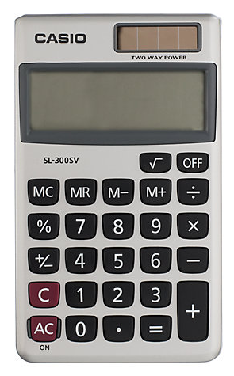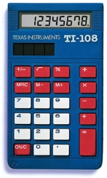

Examples would be the Casio SL1000, Casio HS85TE, Casio SL-300, Texas Ti-5018, HP Easycalc models.
Calculators which satisfy rubric 3 “Only silent, self-contained calculators with a Single-Line Display or Dual-Line Display are permitted in this examination.” are more sophisticated and will look like these
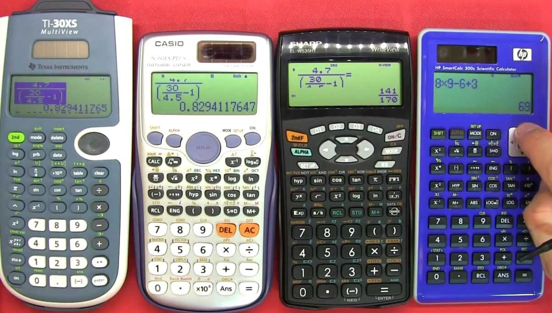
Examples would be Casio FX85, Casio FX-991, Texas TI 30, HP10S, HP300S models.

Graphical calculators, i.e. those that look like
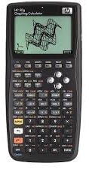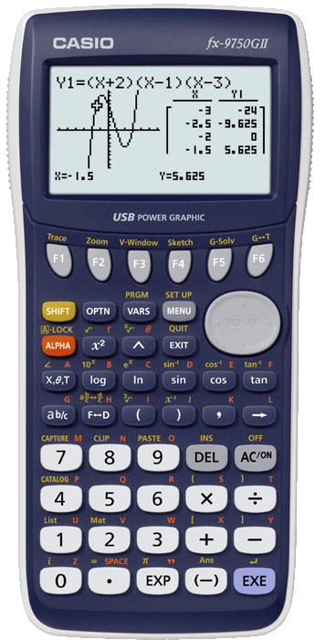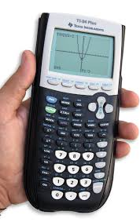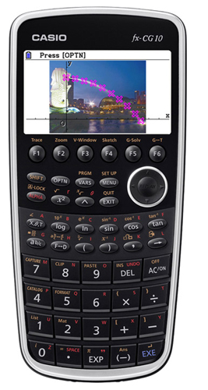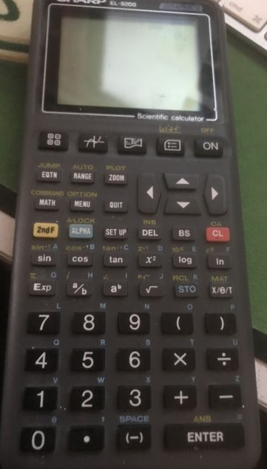
are not allowed by any current standard rubrics. Examples would be Casio FX-CG-50, Casio FX-9750, Casio 9860, Casio CG50, Texas TI-82, Texas TI84, Texas NSpire, HP 50G

The Texas TI-92 and HP Prime models are certainly prohibited on multiple grounds as they include a computer algebra system.
