
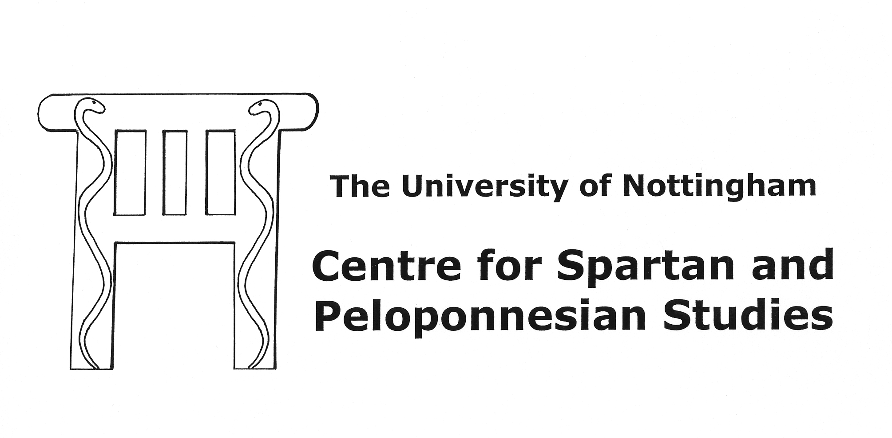

1st CSPS POSTGRADUATE CONFERENCE
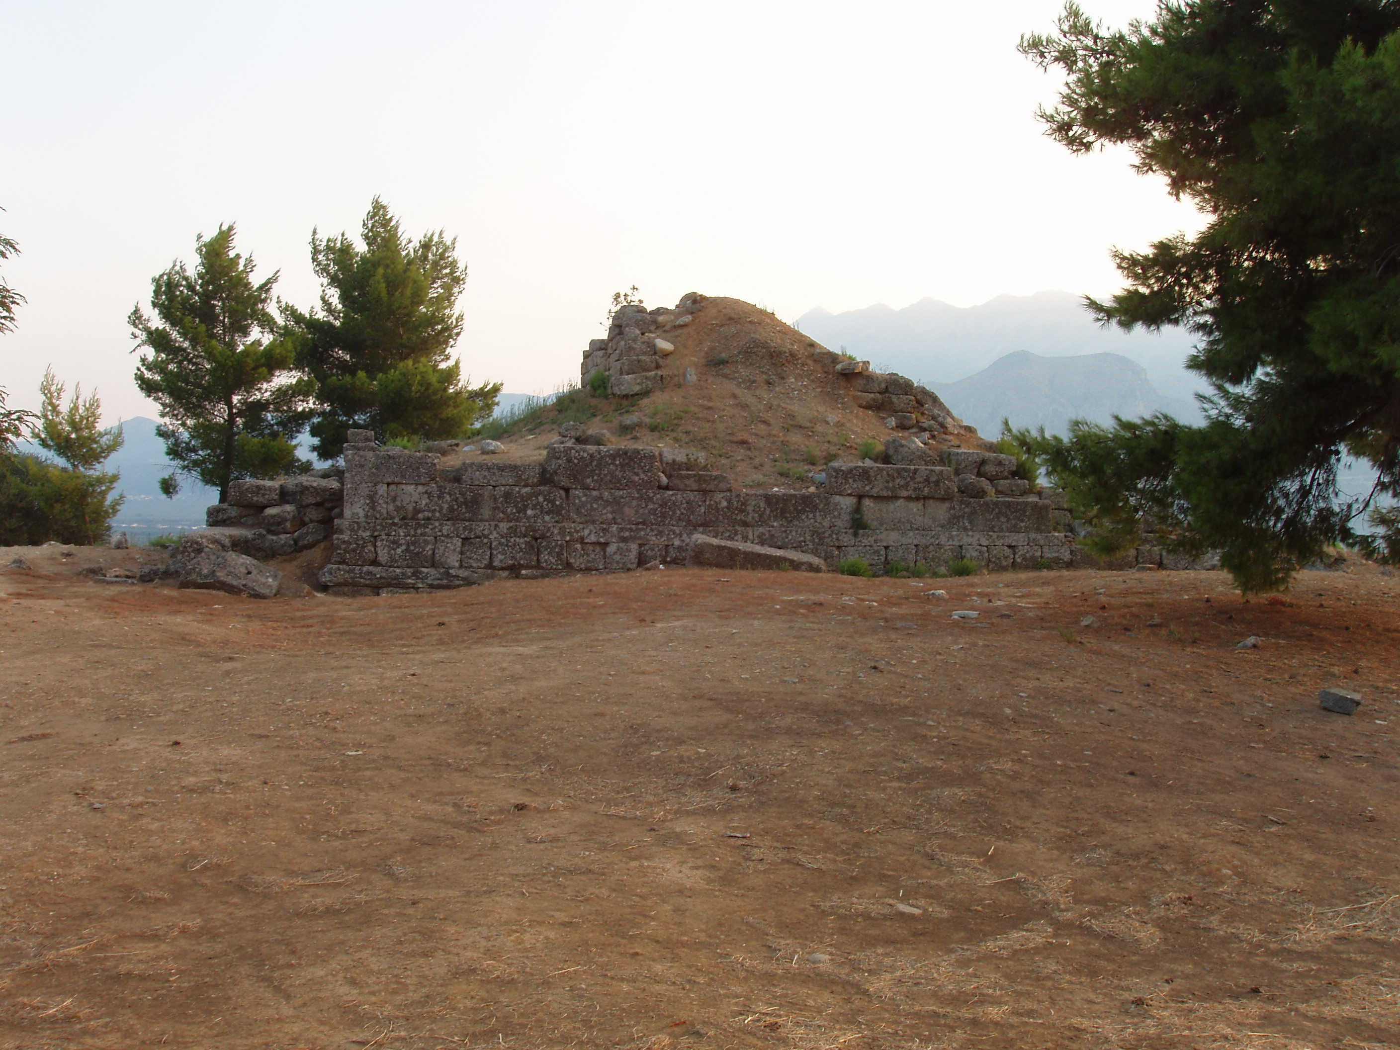
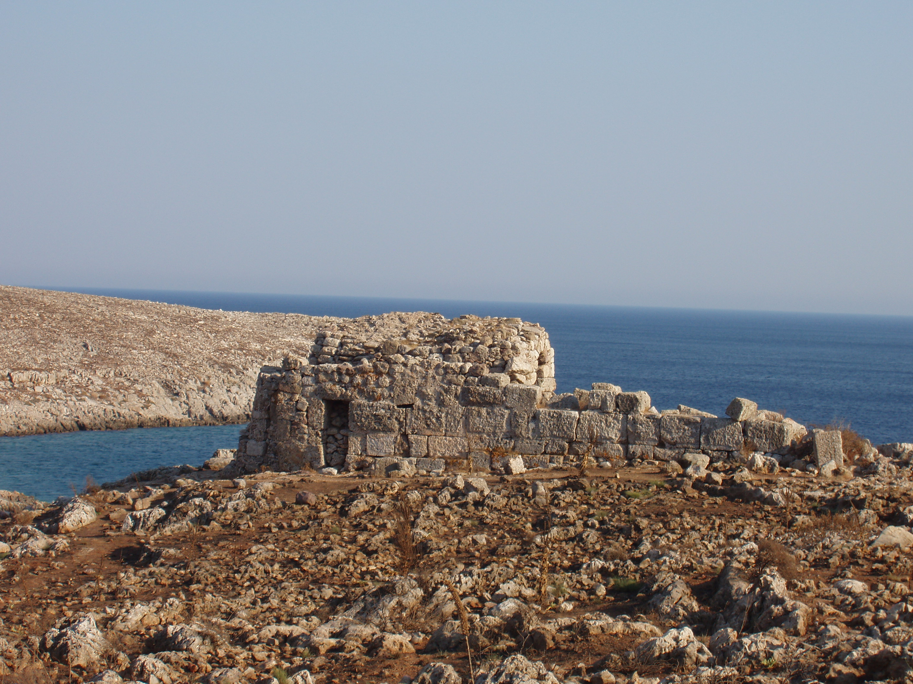
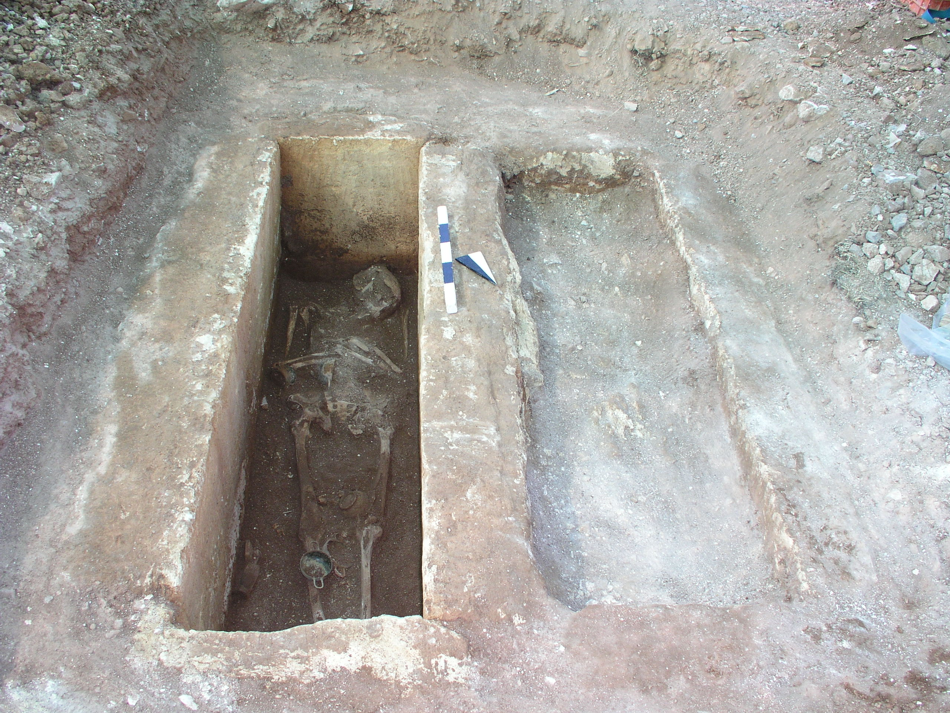
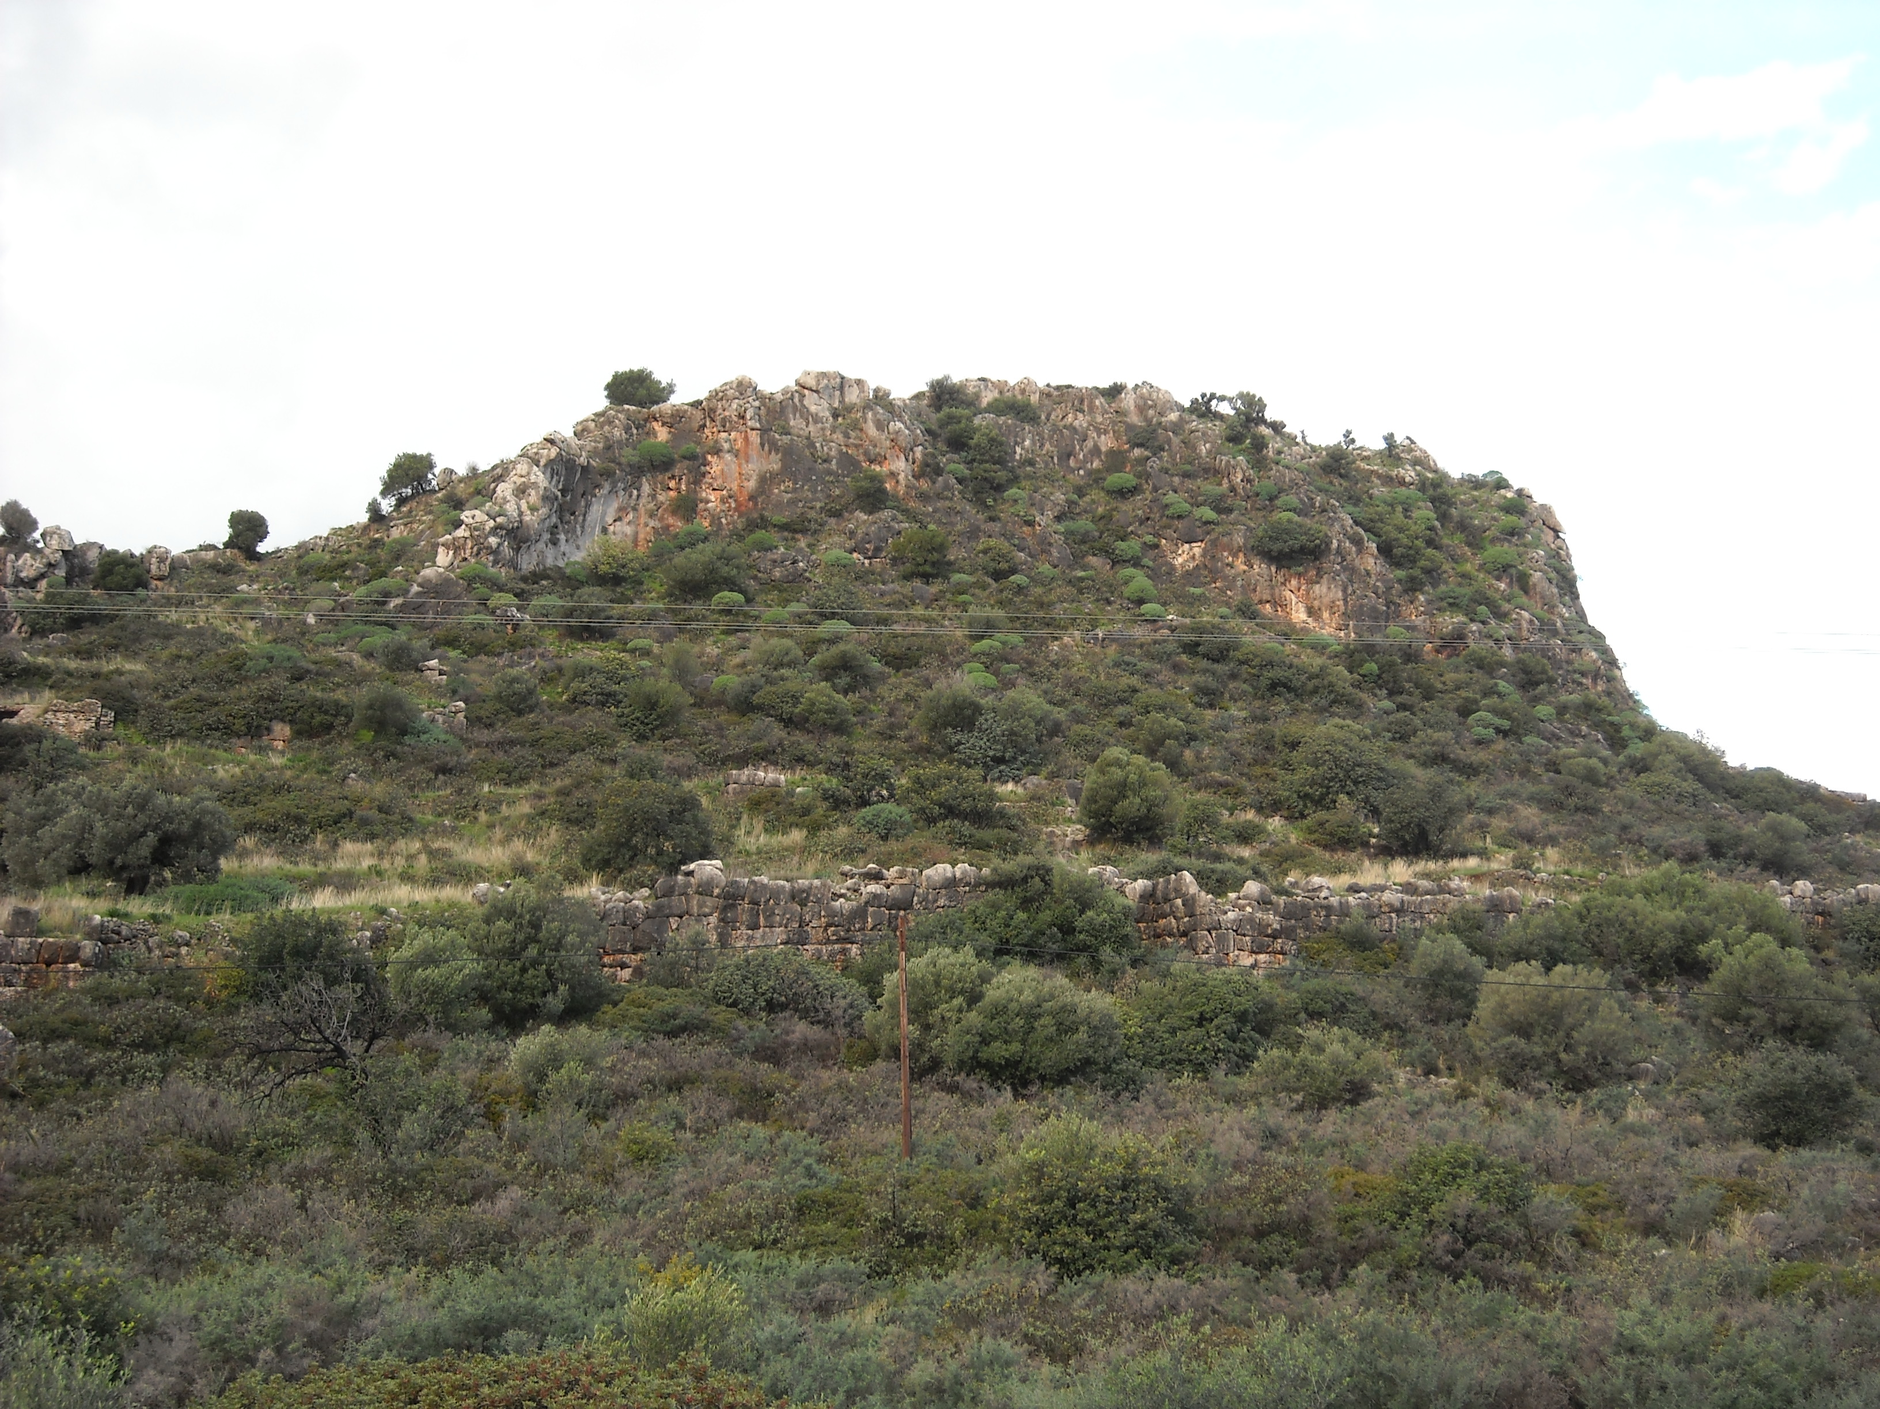

UNDERSTANDING THE PELOPONNESE:
WORK-IN-PROGRESS

11-12 March 2011, the University of Nottingham, University Park

Organisers:

- Nina Charami, PhD student, Department of Archaeology
- Philip Davies, PhD student, Department of Classics
- Nikolas Dimakis, PhD student, Department of Archaeology

PROGRAMME

Friday 11 March 2011
Sir Clive Granger Building (Lecture Theatre A41)

17.30-18.00 | Conference registration
18.00-18.15 | Opening of Conference
18.15-19.00 | CSPS Annual Lecture (Keynote Address) by  Dr. Chrysanthi Gallou (University of Nottingham)  Investigating the world’s oldest submerged town: Pavlopetri in Laconia
19.00 | Reception hosted by CSPS at University Museum, Department of Archaeology

Saturday 12 March 2011
Trent Building, Graduate School, Ground Floor (room A18)

8.30-9.00 | Registration
Session 1 - Burials and Landscape
(chaired by Dr. Chrysanthi Gallou)
9.00-9.20 | Samuel Farnham (University of Nottingham)  Burial rites in the north-east Peloponnese during the Geometric period
9.20-9.40 | Nikolaos Dimakis (University of Nottingham)  Social Identity and Status in the Classical and Hellenistic Northern Peloponnese: the evidence from burials
9.40-10.00 | Socrates Koursoumis and Dimosthenis Kosmopoulos (Hellenic Ministry of Culture and Tourism)  The boundary line between Messenia and Laconia on Mt Taygetos
10.00-10.20 | Nina Charami (University of Nottingham)  Fortified sites and settlements in Laconia during the Classical and Hellenistic times (5th – 2nd c. B.C.)
10.20-10.40 | Discussion
10.40-11.10 | Coffee/tea break
Session 2 - Social Identity
(chaired by Prof. W.G. Cavanagh)
11.10-11.30 | Jackie Whalen (University of St. Andrews)  Hellenic black sheep: Fighting the Spartan stereotype
11.30-11.50 | Nicolette Pavlides (University of Edinburgh)  The heroes of Sparta: Invention and Tradition
11.50-12.10 | Peter Davies (University of Nottingham)  Formation, Maintenance and Abandonment: Population Movement in the Survey Data of the Hellenistic Peloponnese
12.10-12.30 | Discussion
12.30-14.30 | Lunch break (reception held at the University Museum, Department of Archaeology)
Session 3 – Citizenship and Hierarchy
(chaired by Prof. Steven Hodkinson)
14.30-14.50 | David Smith (University of Liverpool)  ‘Hierarchy’ in the Early Helladic Peloponnese
14.50-15.10 | Philip Davies (University of Nottingham)  Status Attainment, Social Mobility and Spartan Political Office
15.10-15.30 | Jean-Sebastien Balzat (University of Oxford)  Messenian elites under the Roman Empire
15.30-15.50 | Discussion
15.50-16.20 | Coffee/tea break
Session 4 – Religion and Culture
(chaired by Dr. James Roy)
16.20-16.40 | Aikaterini-Iliana Rassia (King’s College of London)  The Ethical Messages of the Cult of Helen
16.40-17.00 | James Smith (University of Exeter)  Alkman PMGF 3: The Transformation from Choregos to Bride
17.00-17.20 | Eleni Poimenidou (King’s College of London)  The Messenian Sculptor Damophon
17.20-18.00 | Discussion, final remarks and closing of the CSPS Postgraduate Conference

ABSTRACTS

Sam Farnham (University of Nottingham)
Burial rites in the north-east Peloponnese during the Geometric period
This paper outlines part of a broader project aimed at redressing the bias of in-depth interpretative studies of Early Iron Age burials towards Athens and Attica. The historical importance of this period, which can be schematized as the transition from ‘palace to polis’ is not limited to this region of Greece. This study hopes to go some way towards realizing the potential of the rich data-sets that have long been available for study from other sites in the Peloponnese where poleis are attested. The application of a novel analytical framework drawing on material culture studies focusing on the potential significance of the widely diverging burial practices, evident both between and within sites, forms the methodological core of this analysis.

Nikolaos Dimakis (University of Nottingham)
Social Identity and Status in the Classical and Hellenistic Northern Peloponnese: the evidence from burials

Surprisingly, the Peloponnese as an entire region has only recently started being a focus of study. As a naturally bounded area the peninsula lends itself to fruitful analysis. My thesis focus on the Classical and Hellenistic (5th-2nd centuries BC) burial evidence from the northern Peloponnese namely the regions Achaia, Arcadia, the Argolid and Cynouria, Corinthia and Sicyonia, Eleia and Triphylia.
My approach is thematic and does not attempt to supply a narrative history. All questions addressed mediate the relation between burials to their socio-political context shedding light on social diversity and degrees of socio-political ranking. Based on the quantity and quality of the material assembled I have differentiated between four related and complementary levels of semiotic meaning in interpretive burials. These have taken the form of a number of criteria selected to enable me to examine status and identity. Namely the location of cemeteries, the internal arrangement of cemeteries, mortuary variability and the burial inventory.
By studying the transformations in the mortuary record of a wide territory such as the Northern Peloponnese, varying perceptions about identity and status come to the light. Such a cross-regional analysis shall demonstrate whether the same burial practices have been applied in dissimilar socio-political contexts bringing to the surface burial patterns that may not necessarily correspond to the contemporary political borders. Developments like these may occur within a single region or at interregional scale and may be to do with particular ways of expressing distinct identities, social relations and socio-political intentions creating a mosaic of attitudes to death.

Nina Charami (University of Nottingham)
Fortified sites and settlements in Laconia during the Classical and Hellenistic times (5th – 2nd c. B.C.)

During the Classical and Hellenistic periods (5th-2nd c. B.C.) the Lakedaimonian territory controlled by Sparta underwent major alterations and fluctuations due to a large number of military expeditions held in the Peloponnese. The establishment of a wide network of fortifications across Laconia provides tangible evidence of the political and social fluidity in the area during the aforementioned centuries. One of the primary aims of my research is the examination of emerging fortification patterns in the micro-scale of the perioikic communities along with their functionality and significance (military, urban, strategic) within that context. One step further will be the association of fortified sites and settlements with Sparta within the broader context of the Lakedaimonian state rendering legitimate the inclusion of marginal areas (such as Kynouria, Thyreatis, southern Arcadia, eastern Messenia and Kythera) that will elucidate changes in the territorial borders. Observations on the military, political and social history of Laconia and the relationship between Sparta and the perioikic communities will be assessed by analyzing and intersecting the results of the above posed questions.
In this paper the research and survey conducted so far will be displayed along with some preliminary observations and remarks on the fortification patterns. Moreover, the main targets and the prospective contribution of this thesis to the understanding of Classical and Hellenistic Laconia will be put forward in detail.

Jackie Whalen (University of St. Andrews)
Hellenic black sheep: Fighting the Spartan stereotype

The ‘Spartan mirage’ describes the fundamental challenge that has faced historians since antiquity: that Spartan history has been constructed primarily from the subjective narratives of non-Spartan sources. One element of the mirage is the image of the Spartans themselves and what it was to ‘be Spartan’. The traditional view of Spartans as an austere, disciplined, sober and anomalous people has been increasingly called into question over the last 20 to 30 years thanks to the corpus of revisionist research that has resulted from a resurgence of academic interest in Sparta. Even more recently, scholars of various historical ages have been exploring sociological, psychological and theoretical issues such as hindsight bias, creeping determinism, and racism, in order to analyse historical evidence in different ways and formulate more comprehensive hypotheses.
As part of on-going research on Spartan austerity, this paper uses socio-psychological approaches to deconstruct Spartan stereotypes (good and bad) found in the key primary sources, such as Herodotos, Thucydides, Xenophon and Plutarch. By doing so we can uncover a more realistic image of the Spartans and investigate whether they saw themselves as austere or as living in an austere society. For example psychological ideas on In-groups and Out-groups will help to evaluate the Herodotean view of Spartans as the Greek Other; the theory of sideshadowing can help avoid reading in hindsight the narratives of both ancient and modern sources; and identifying modern concepts such as ethnicity, identity and racism in Classical Greece is useful in evaluating the internal and external views that Greek poleis had of each another.

Nicolette Pavlides (University of Edinburgh)
The heroes of Sparta: Invention and Tradition

From the early seventh-century B.C. onwards Sparta witnessed the popularity of hero-cult as evidenced by the Menelaion, the worship of Agamemnon and Alexandra/Kassandra and from the sixth-century B.C. on, the cults of the Dioskouroi and Orestes. Because of Sparta's aggressive attitude towards to her neighbours during the Archaic period it has been suggested that Sparta's popularity of Achaian heroes was a calculated attempt to introduce Achaian heroes for political purposes; the so called “Achaian Policy”. For example, the Menelaion has been interpreted as politically motivated because of seventh-century competition with Argos that sought to legitimize Sparta’s presence in the area through the promotion of Achaian heroes. Likewise, the cult of Agamemnon and Alexandra/Kassandra has been regarded as an attempt to claim a foreign hero as Sparta’s own in order to show its dominance in the Peloponnese, and the transfer of the bones of Orestes in an effort to form alliances in the Peloponnese or as a reflection of internal political upheaval. In general, scholars have emphasized how the Spartan consciousness of its Dorian identity influenced its need for Achaian heroes to demonstrate hegemony in the Peloponnese. This paper examines the validity of ethnic identity as an inspiration behind the so-called “Achaian” hero cults in Archaic Sparta. It challenges the tendency of modern scholars to exaggerate the political use of religion and so its effect as a motivating factor behind the establishment of hero-cults.

Peter Davies (University of Nottingham)
Formation, Maintenance and Abandonment: Population Movement in the Survey Data of the Hellenistic Peloponnese

Greece has seen a great deal of surface survey over the last forty years. Unfortunately, the majority has yet to be published and what has been is often overlooked by Hellenists. This paper will highlight some of the difficulties we experience in using those studies which have been published. But I will also explore the ways in which we can usefully synthesise this data. I will sketch briefly the methodological inconsistencies of Greek survey and the greater problems which are thrown up by the inconsistent manner in which the survey data is published.
I will then explore the possibilities for, and difficulties with, comparative study of the various mainland Greek surveys. In particular I will suggest that while a great deal can be gained from direct synchronic and diachronic comparison of survey areas it is in the comparison of processes of change from which we can gain the most using these data sets. This Processual comparability highlights features of societies which are often hidden by the raw data of the surveys. Especially in suggesting those influences which lie behind the decisions to form, maintain or abandon settlements. I will argue that the abstraction of these processes from the grander political changes of the period means we must find causation not within political or military history, but within the shifting social milieu of the individual poleis.

David Smith (University of Liverpool)
‘Hierarchy’ in the Early Helladic Peloponnese

The Early Helladic period in the Peloponnese is traditionally viewed as a phase of incipient hierarchical social organisation, with the appearance of organised, highly-socialised burial practices and the spread of a monumental architectural tradition, epitomised by the so-called ‘corridor house’ structures and in the construction of monumental fortification walls at a number of Peloponnesian sites.
In the same period, we see a non-uniform shift in Peloponnesian settlement patterns. In some areas this shift sees an expansion onto land with apparently minimal agricultural potential; in others agriculturally viable land forms the focus of settlement. In all areas, settlement density appears to peak during EHII, at which point, it has been suggested, several sites enjoy a phase of expansive growth and occupy the upper tiers of local or regional settlement hierarchies.
While these phenomena, along with the advent of sealing systems and an increased visibility for metallurgical technology, are often viewed as components of a systemic process of socio-economic development, what we see instead, are a series of temporally- and spatially-peculiar changes resulting from the particular geological, geographical or socio-political position of the study area.
My research attempts a critical re-evaluation of both adult and infant burial practices, settlement patterns, and monumental construction, intended to challenge existing ideas of ‘hierarchy’ and its operation in the Early Bronze Age Peloponnese.

Philip Davies (University of Nottingham)
Status Attainment, Social Mobility and Spartan Political Office
Building upon recent research, which has challenged a simplistic impression of Sparta as a static and monolithic society, my research assesses the role which social mobility played within Spartan society. Such an analysis has to grapple with several obstacles, which I will lay out in this paper. In particular, my research is focussed not upon the margins of and movements between the relatively clearly defined major strata of Spartan society (homoioi, perioeci, helots etc.), but upon social differentiation among the ruling class of homoioi, or Spartiates. Consequently, I will discuss how social distinction was conceived, not only among ancient Greeks in general, but among the members of this nominally homogenous Spartan social stratum, and how we may go about analysing this.
Having thus set out the conceptual framework of my research, I will turn to Spartan political office as an avenue for social mobility. I will give an overview of the Spartan political offices, their primary roles, and the difficulty of forming a cohesive picture of these from the conflicting information presented to us by contemporary sources. On the basis of their conditions of membership, and the cases of individuals identifiable as having held one or more office, I will then consider the role which different offices, and the Spartan political structure as a whole, provided as an avenue for social mobility in Spartan society.

Jean-Sebastian Balzat (University of Oxford)
Messenian elites under the Roman Empire
This paper focuses on the history and evolution of the Peloponnesian elites under the Roman Empire. It will focus on the history of the Messenian elites in particular, taking the extension of Roman citizenship to the local elites of Messenia as its start point. It will show that, as elsewhere in the Roman East, different phases in the extension of citizenship can be identified. The results of recent research on the social and economic history of the Roman Peloponnese (A. Rizakis, Cl. Lepenioti 2010) will be considered in the light of what evidence we have for the acquisition of Roman rights by the Messenian elites leading to a broader appreciation of the way in which these elites evolved from the Late Republic to Flavian period.

Aikaterini-Iliana Rassia (King’s College of London)

Mapping out the ethical messages in the cult of Helen

For a long time, scholars have not attached much importance to ancient people’s mentality and more specifically to their religious-ethical behaviour. My starting point is the opposite: ancient Greek religion is a construction of ethics as a process of moulding peoples’ behaviour. One might, therefore, wonder: “How can we define ethics in terms of ancient Greek religion?” Indeed, this question has rarely been discussed in a scholarly fashion. However, the idea that ethics was in some way associated with the divine world cannot be disputed. Ethics as a subjective concept was interpreted in a number of different ways with diverse implications concerning gender or social differences.
In particular, the objective of this paper is to argue about the ethical messages that are embedded in the cult of Helen. It will be argued that Helen is a crucial heroine for the elaboration of an ethical consciousness. For instance, Helen symbolizes the seductive power of a bride, a woman’s capacity for peitho (i.e. persuasion) and eros (sexuality). Helen may be the ultimate paradigm of the feminine power of seduction, but is at the same time an example of how disastrous the manipulation of this power beyond the purposes of marriage can be. In the end, it will be evident how important was the cult of Helen within the sacred life of ancient Greece for shaping peoples’ and especially women’s ancient norms of behaviour (i.e. ethics).

James Smith (University of Exeter)
Alkman PMGF 3: The Transformation from Choregos to Bride.

Since Claude Calame published his pioneering study of female choruses in ancient Greece, it has been frequently argued that Alkman’s Louvre Partheneion (PMGF 1) may have formed part of a rite of passage for Spartan girls. Unfortunately, Alkman’s only other substantial fragment to survive, PMGF 3, has received comparatively little attention. Recently, Anastasia Peponi has sought to redress this trend by attempting to reconstruct the choreography of the poem from an examination of the lyrics. She concludes correctly, in my opinion, that the poem celebrates the point when Astymeloisa, the girl central to the poem, is just approaching her marriage. In this paper, I hope to demonstrate that girls in Archaic Sparta would have participated in a series of ritual performances to prepare them for marriage and adulthood. By comparing Fragment 3 and the Louvre Partheneion, I will show that they represent two separate points in a girl’s transition to adult. Through an examination of the poems performance context, religious allusions, and the relationship which develops between Astymeloisa and her chorus, I hope to demonstrate that Astymeloisa fits the mould of a choregos who is on the point of reaching maturity. Fragment 3 represents the moment in the Spartan transitional process, when Astymeloisa is symbolically transformed into a bride in front of the watching Spartan population.

Eleni Poimenidou (King’s College London)
The Messenian Sculptor Damophon

Damophon was a prolific artist of the second century B.C., whose work as a whole hasn’t yet been thoroughly studied, while little importance has been given to his “piecing” technique, that is the assembling of small pieces of marble to create statues, most of which were colossal. Additionally, studies up till now regarding Hellenistic sculpture have mostly focused on preserved works from Delos or Pergamon, although there was intense sculptural activity in the Greek mainland as well, and particularly in the Peloponnese. This paper seeks to show that Damophon’s work, which mirrors the stylistic tendencies and technical improvements of his era, can help our better understanding of contemporary sculpture. Damophon is among the rare cases of artists that we known of through his preserved original works, as well as inscriptions related to him. Through scrutiny of all surviving fragments either attributed to or associated with Damophon, an attempt is made to better comprehend his style and technique, as well as to reconstruct, to the extent possible, the original image of the statues. Special attention is also drawn to new evidence brought to light in Messene, which reveal Damophon’s activity beyond the Peloponnese and help us define more closely the date of his activity. Finally, all available epigraphic evidence, as well as information deriving from Pausanias’ reference to the honours bestowed on Damophon from the cities he worked for, both for his high calibre art and benefactions, are assessed in order to define his socioeconomic status

Peponi, 2007, 355-357.

