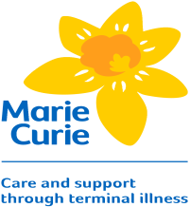
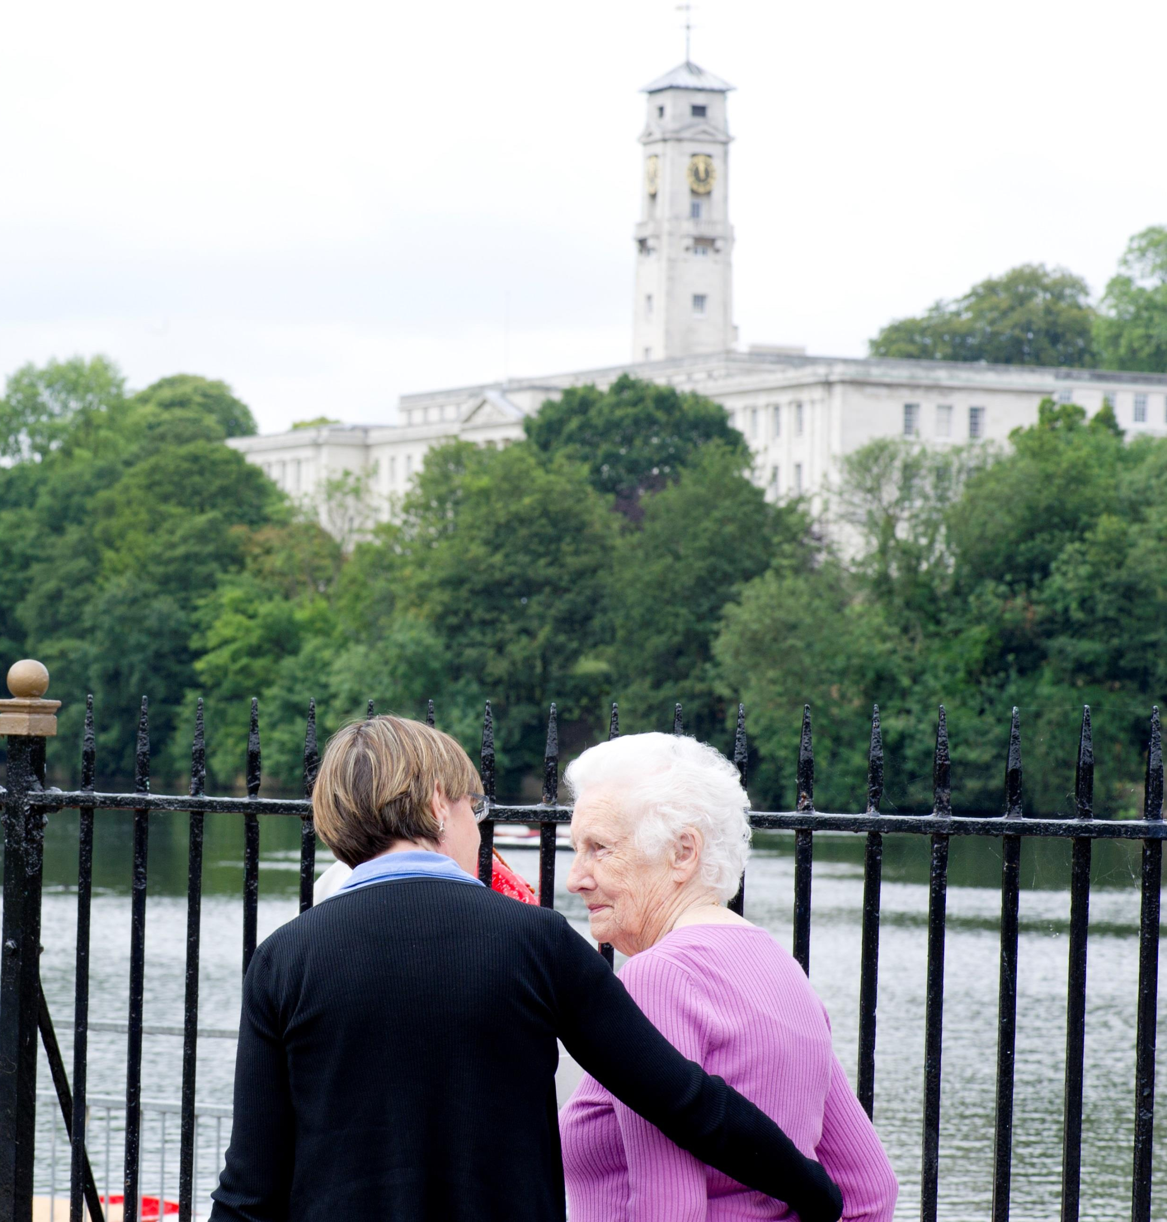
This is an introductory training programme for people who support carers in end of life contexts.
It assumes no previous knowledge, and is suitable for people employed by an organisation and also for volunteers and will run over one day.
For further information please contact:
(Insert contact details here)

Supporting carers in end of life care:
An introductory Programme

(Date)
(Time)
(Location)

Supporting carers in end of life care:
An introductory Programme

This is an introductory training programme for people who support carers in end of life contexts.
It assumes no previous knowledge, and is suitable for people employed by an organisation and also for volunteers and will run over one day.
For further information please contact:
(Insert contact details here)

Every year in the UK about half a million people die: some of these deaths are unexpected, but often people are known to have reached the end of their lives. When health and social care professionals describe someone who is at the end of life they might use a range of different words such as ‘palliative’ ‘terminal’ and ‘dying’. During the training we will explore what these different words mean, and discuss how you might know when someone is a carer in an end of life situation.
When someone is known to be at the end of life, everyone within his or her family and social group is affected. Carers in this situation are often the wife, husband or partner of the person who is ill, but may also include other family members and friends. It can be hard to identify who carers are in end of life situations, as many people do not think of themselves in this way. A challenge for supporters is to help people understand that they may need help due to their caring role.
Many people with a known terminal illness would prefer to die in their own home if possible. For this to happen, a range of professional and lay-carers are needed to support the person who is ill. Carers in end of life situations are in a unique position. They provide care to the person who is dying. This care might include emotional support, in addition to physical care as the person becomes more unwell. Carers also have their own support needs. These needs might include information about how to care for the person who is ill and dying, and also how to look after their own health and well-being.

Q & A

Who is the course for?
The course if for anyone who is
interested in supporting people
who are caring for someone at the end of life. This might include volunteers and carer support workers, but people working in other roles are also welcome.

How long is the course?
This is a one day introductory course.
You will be directed towards resources about end of life issues so you can continue your reading on the topic.

The training day is split into seven short sessions.
Session one: introduction and welcome
Session two: caring and being cared for
Session three: supporting in practice
Session four: being a safe supporter
Session five: the principles of supporting carers
Session six: boundaries and exit strategies
Session seven: ongoing learning and development
By the end of the course you will have an insight into issues that carers may need support with, in end of life situations. You will have some practical strategies as to how to do this, and an awareness of your own personal support needs.
Development of the course was funded by a grant from Marie Curie Cancer Care and Dimbleby Cancer Care. The course was developed in collaboration between researchers from the Universities of Nottingham, Cambridge and Manchester, the Carers Federation Ltd, and experienced carer research partners.
Do I need any specific qualifications or experience before the course?
You do not need to have any experience of supporting in end of life contexts. However, some experience of supporting carers in other contexts will enable you to build on your existing skills and knowledge.

