Notes on Completing Self-Assessment Form

Created: June 2021
Updated: January 2022

Introduction
To submit a self-assessment form, the self-assessment online form should be used which will be processed for the purpose of the Self-Assessment Process only and will comply with the Data Protection Policy in relation to appropriately processing and storing this information.

Records will be held securely within Human Resources and shared appropriately as outlined below.

The self-assessment documentation and CV will be shared with the relevant Head of School (or nominee) who will provide further comments relating to the evidence of contribution made on the self-assessment form and against the relevant criteria within the Level 7 Academic Framework. This information will also be shared with the relevant Faculty and University Committees.

Completing the Self-Assessment Form
- Please access the Pro-forma for Professorial Banding Self-Assessment form and submit your relevant details and evidence of contribution against the relevant banding information contained within the Level 7 Academic Framework (please note that you will need to be logged in to the University network in order to complete your pro-forma).

- Attach an up-to-date CV (using the template form and with reference to the CV completion notes) to the form.
- Once the form has been completed, press submit (please note that this should be the final document which will be sent to your Head of School to complete their part of the form). You will not be able to edit the form once this has been submitted and should save a copy for your own records.

Notification of submission
An email from Human Resources will be provided once the form and CV have been checked.

Head of School Form
Once submitted and checked by HR, your Head of School/Department will be notified that they will need to submit their form.

The information you have provided on the pro-forma and CV will be made available to the Head of the School (or appropriate nominee) to enable them to complete their form.

A copy of the form will be shared with you by your Head of School.

Self-Assessment Pro-Forma Template
The template is in two sections.

Section one asks for the following information:
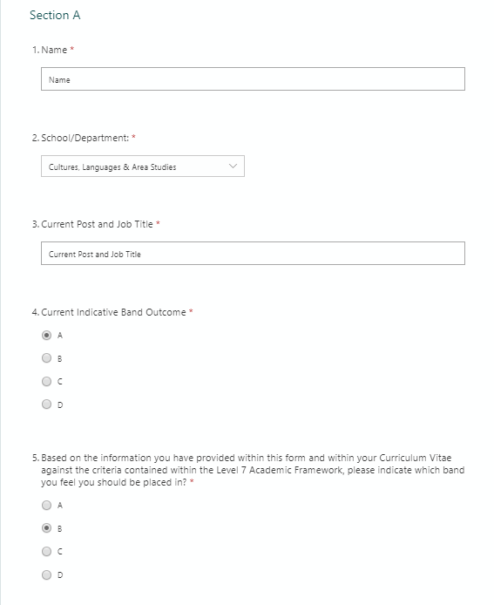
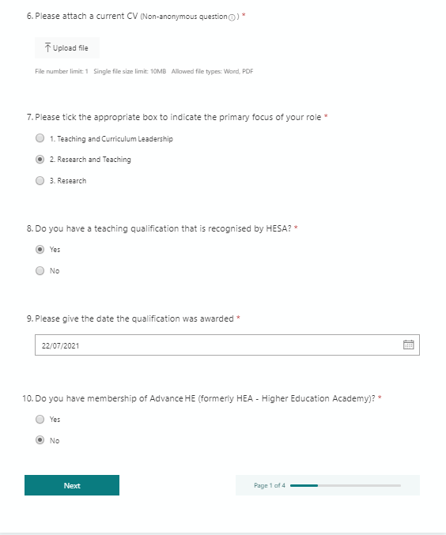

Section two asks for the following information:

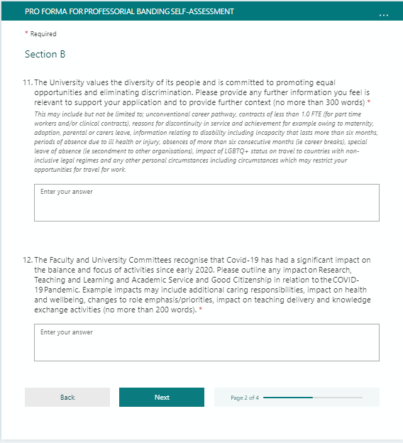

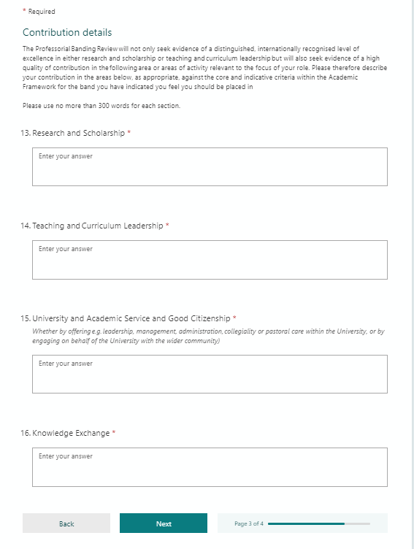

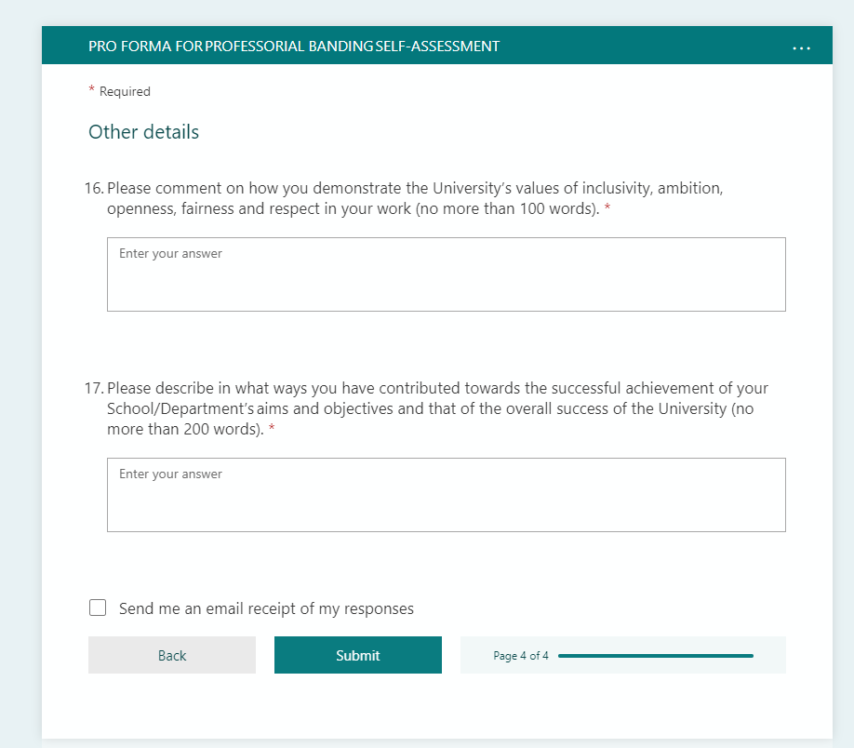

Word Version of the Self-Assessment Pro-forma
This may be used as a template, which can then be copied and pasted into the on-line Self-Assessment Pro-forma.

STRICTLY CONFIDENTIAL
PRO-FORMA FOR PROFESSORIAL BANDING SELF-ASSESSMENT
This information will be shared with the Head of School/Department, Faculty Committee and University Committee to support the Professorial Banding Review. This information will also be retained and stored confidentially and securely by the Faculty and HR for the purposes of recording information relating to the Professorial Banding Review.

Please, therefore, ensure that all the information you wish to submit is included within this form and this is your final version before you submit the form.

The University values the diversity of its people and is committed to promoting equal opportunities and eliminating discrimination. The self-assessment process will operate fairly and with due regard to the Equality Act 2010 and to the protected characteristics detailed within the Act.
Please ensure that all sections of the form are filled out with all the relevant details you wish to share in support of the self-assessment.

All information relating to personal circumstances disclosed in this pro-forma is encouraged and will remain confidential. It will be used to ensure that the recognition of impact of personal characteristics and circumstances is considered, to enable fair and equitable consideration of all individuals to support the process.

SECTION A
Name: |  | School/Department:
Current Post and Job Title:
Current Indicative Band Outcome (please circle):
A | B | C | D
Based on the information you have provided within this form and within your Curriculum Vitae against the criteria contained within the Level 7 Academic Framework, please indicate which band you feel you should be placed in (please circle):
A | B | C | D
CV attached ( )
Primary focus of your role (please tick):
Teaching & Curriculum Leadership ( )
Research & Teaching ( )
Research ( )
Do you have a teaching qualification that is recognised by HESA?
Yes ( )
No ( )
Do you have membership of Advance HE (formerly HEA – Higher Education Academy?)
Yes ( )
No ( )
Please state details and level of membership (free text)

SECTION B
- The University values the diversity of its people and is committed to promoting equal opportunities and eliminating discrimination. Please provide any further information you feel is relevant to support your application and to provide further context, this may include, but not be limited to; unconventional career pathway¹, contracts of less than 1.0 FTE (for part-time workers and/or clinical contracts), reasons for discontinuity in service and achievement for example owing to maternity, adoption, parental or carers leave, information relating to disability including incapacity that lasts more than six months, periods of absence due to ill health or injury, absences of more than six consecutive months (ie career breaks), special leave of absence (ie secondment to other organisations), impact of LGBTQ+ status on travel to countries with non-inclusive legal regimes and any other personal circumstances including circumstances which may restrict your opportunities for travel for work.

- The Faculty and University Committees recognise that Covid-19 has had a significant impact on the balance and focus of activities since early 2020. Please outline any impact on research, teaching and learning and academic service and good citizenship in relation to the Covid-19 pandemic. Example impacts may include additional caring responsibilities, impact on health and wellbeing, changes to role emphasis/priorities, impact on teaching delivery and knowledge exchange activities (no more than 200 words).

- The Professorial Banding Review will not only seek evidence of a distinguished, internationally recognised level of excellence in either research and scholarship or teaching and curriculum leadership, but will also seek evidence of a high quality of contribution in the remaining areas of activity relevant to the focus of your role. Please, therefore, describe your contribution in the areas below, as appropriate, against the core and indicative criteria within the Academic Framework for the band you have indicated you feel you should be placed in (no more than 300 words for each section).

Research and Scholarship

Teaching and Curriculum Leadership

University and Academic Service and Good Citizenship (whether by offering eg leadership, management, administration, collegiality, knowledge exchange or pastoral care within the University, or by engaging on behalf of the University with the wider community)
Knowledge Exchange

4. Please briefly describe below (no more than 200 words) in what way(s) your role has developed and changed since either being recruited to your post/since your last promotion/or over time, articulating in what ways you consider your role best fits the appropriate Band (please use the criteria within the Level 7 Academic Framework).

5. Please describe in what ways you have contributed towards the successful achievement of your School/Department’s aims and objectives and that of the overall success of the University (no more than 200 words).

