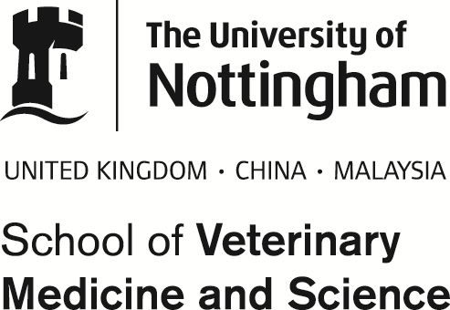
Biobank
Phone: 0115 95 16563
Email: SV-Biobank@exmail.nottingham.ac.uk

BIOBANK TISSUE DONATION FORM

Name ……………………………………. Clinic……………………….…………..

Phone………………………………… …. E-mail………………………………….

Material or tissue:

Date of sample collection:

Species and signalment:

Size and number of samples:

How have samples been stored:

I am donating the sample(s) to the Biobank at Nottingham Veterinary School, and do not expect their return.

Please sign ___________________________________________________ Date ____________________________________
And attach one printed copy to the sample(s) and e-mail this to
SV-Biobank@exmail.nottingham.ac.uk

SAMPLES WILL NOT BE COLLECTED AND PROCESSED WITHOUT THE SIGNATURE AND CONFIRMATION OF ALL OF THE ABOVE DETAILS.
THE UNIVERSITY ACCEPTS NO RESPONSIBILITY FOR THE COLLECTION, LOSS OR DAMAGE OF STORED SAMPLES

