Protocol: Membrane preparation

Purpose of Procedure: To isolate membranes from tissue culture cells

Reagents Required:
Membrane Isolation Buffer 1 (MIB1): 10 mM Tris pH 7.4, 250 mM sucrose (8.6%), 0.2 mM CaCl₂
MIB2: 10 mM Tris pH 7.4, 25 mM sucrose (0.86%), 1 mM EDTA
MIB3: 10 mM Tris pH 7.4, 35-42% w/v sucrose (effectively 1- 1.15 M), 1 mM EDTA
MIB4: 10 mM Tris pH 7.4, 250 mM sucrose
EDTA-free Protease inhibitors 100x

- in MIB3 35% sucrose should be used for mammalian cells
- in MIB3 42% sucrose should be used for insect cells
- No EDTA should be used in buffers for insect cell membrane preparation.
- All four buffers should be stored at 4C and used ice-cold.
- A sucrose cushion is used to prepare plasma membranes which are formed at the interface of the high and low % sucrose solutions.
- The CaCl₂ is employed to precipitate DNA during cell fracture

Hazardous Chemicals Employed:
protease inhibitors

Forenote: This is designed to be a quantitative procedure, so that you can compare membrane preparations across time and projects. Wherever indicated you should either weigh tubes to determined pelleted masses, or carry out protein assays to quantify protein recovery. The following schematic will act as a guide to this

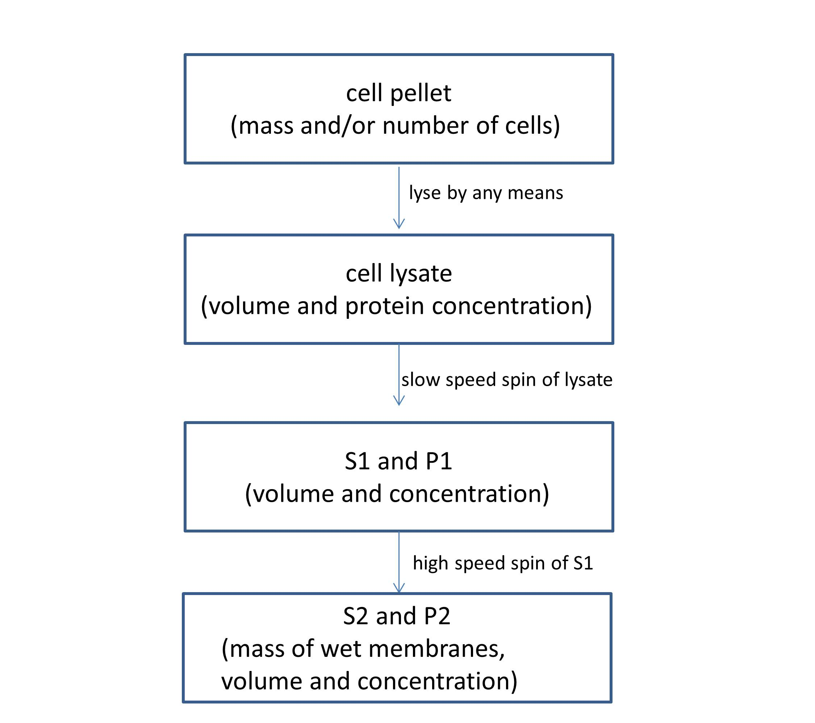

Procedure

Spinning down your cell pellet
- Weigh the tubes you are using for the centrifugation.
- Spin your cells down, preferably at 4C at 2000g for 15 minutes.
- Resuspend the pellet in an excess of ice-cold PBS and re-centrifuge to remove any growth media. Remove the PBS, weigh the tube so that you know the mass of cells.
- If not using the pellet straight away then freeze at -80C.

The pelleted mass is “one volume”. So in the next step when you resuspend the pellet you will be resuspending in 5-10x this volume.

Cell disruption
This is how you will lyse your cells using the bomb (A), the pressure disruptor (Constant Systems, B), the French Press (C) or a sonicator (D).

A. The bomb
- Pre-cool N₂ bomb on ice. Resuspend cell pellet in 5-10x volumes of MIB1 containing protease inhibitors

- Load bomb and seal it. Close ALL valves. Open the nitrogen cylinder and allow the pressure to build in the head unit. Open the valve closest to the bomb, and then open the valve from the head to the gas-line. Pressurize to 1000 psi. Close the bomb-valve, and then screw shut the other valves. Vent any gas in the line via the head-release valve. Consult the manual or IDK if unsure. Leave for 10-15 minutes on ice.

- Bleed into a 50ml cylinder (with a pierced Parafilm seal, and a small hole punctured into it to enable gaseous release), reload the bomb and repeat at least one more time. If necessary add a ml or two more MIB1 to the 50 ml cylinder to wash out all broken cells.

- Verify lysis by microscopy. Retain a sample for protein concentration determination

B. The Constant Systems Pressure Disruptor (only to be used after training from IDK).
- Pre-cool disruptor with tap water through the cooling jacket. Resuspend cell pellet in 5-10x volumes of MIB1 containing protease inhibitors

- Disrupt cells by 2 passages at 2,500 to 5,000 psi for mammalian and insect cells; you will need 10,000 - 20,000 psi for bacteria

- Verify lysis by microscopy (eukaryotic cells). Retain a sample for protein concentration determination

C. The French Press (currently broken)
This is a third method of cell disruption by pressurization.

- Assemble the French press as directed in separate protocol

- Resuspend cell pellet in 5-10x volumes of MIB1 containing protease inhibitors

- Operate the French press as described in separate protocol.

- Check lysis by microscopy and repeat the cell breakage if less than 90% lysis has occurred. Retain a sample for protein concentration determination

D. Sonication
This is probably saved for when the size of the cell pellet is small (say less than 50 million cells).

- Resuspend cell pellet in 1ml of ice-cold MIB1 containing protease inhibitors and transfer to a chilled 1.5 ml tube.

- Set the sonicator to 40% power and give 3 bursts of ten seconds (keeping the tube on ice), with interburst durations of at least 30 seconds.

- Verify lysis by microscopy, and retain a sample for protein concentration determination

Centrifugation of crude membranes.
You will now have a cell lysate – the next few steps assume the volume is between 10 and 20 mls. If it is smaller then use the benchtop ultracentrifuge and adjust volumes accordingly.

- Centrifuge in JA-20 rotor at 2000-3000g for 15 minutes at 4C to pellet out any unbroken cells and large debris. Retain a sample of the first supernatant (S1) for a protein assay. Resuspend this first pellet (P1) in the same volume it was originally and retain a small sample for a protein assay.

- Load supernatant into pre-weighed 12ml thin-walled polyallomer tubes, at least 75% full, using additional MIB4 if necessary. For small volumes load into 1.5ml ultracentrifuge tubes (TLA100), or medium volumes into 6ml ultracentrifuge tubes (MLV80). Again all tubes should be >60-70% full.

- Centrifuge at 100,000g for 1 hour 4C.

  - SW-41 rotor, making sure the rotor tubes are in the correct holders and are all balanced to within 0.1g, for 45 minutes at 26,000 rpm (100,000 g)
  - TLA100 rotor that is 55,000 rpm (100,000g)
  - MLA80 - 42,000 rpm (100,000g)

- Retain the supernatant (S2) for a protein assay.

- Resuspend the pellets (P2) by shearing initially through a broad needle (e.g. 19G) for 3-4 times, then through a narrow gauge needle (e.g. 25G) at least 20 times in a suitable volume of MIB4 and protease inhibitors.

- At this stage you should carry out a protein assay on all the fractions collected, i.e. the lysate, the S1, the P1, P2, S2 and P2 (membrane pellet)

- Freeze aliquots of the membranes at -80C. Freeze aliquots in small volumes, i.e. if you make a 1ml membranes then freeze in 50 ul aliquots. They may not defrost and refreeze well so don’t be tempted to freeze the whole thing in one aliquot. Retain the other fractions until you have analysed them on a gel, and until you have quantified each membrane preparation.

Making Plasma membranes by sucrose cushion. Note that the % sucrose used here may be optimal for a particular cell line and may not be a catch-all method for making plasma membranes.

- As for steps 1-3 above.

- Dilute cells 2.5 fold with MIB2 to reduce the sucrose concentration (will enable easy overlaying in step 4

- Centrifuge at 1500 rpm in JA-20 for 10 minutes at 4C

- Layer supernatant over 8 ml (this is a volume that can easily be seen in the bottom of an SW-28 tube). of MIB3 in SW-41 tubes. Ensure balance.

- Spin at 9,000 rpm (30,000g) for 30 minutes at 4C. Remove the supernatant from the top and carefully collect the interface with a pipette.

- Dilute the interface with solution MIB4 to fill SW-41 tubes and follow steps 3-5 in the crude membrane preparation protocol (above).

