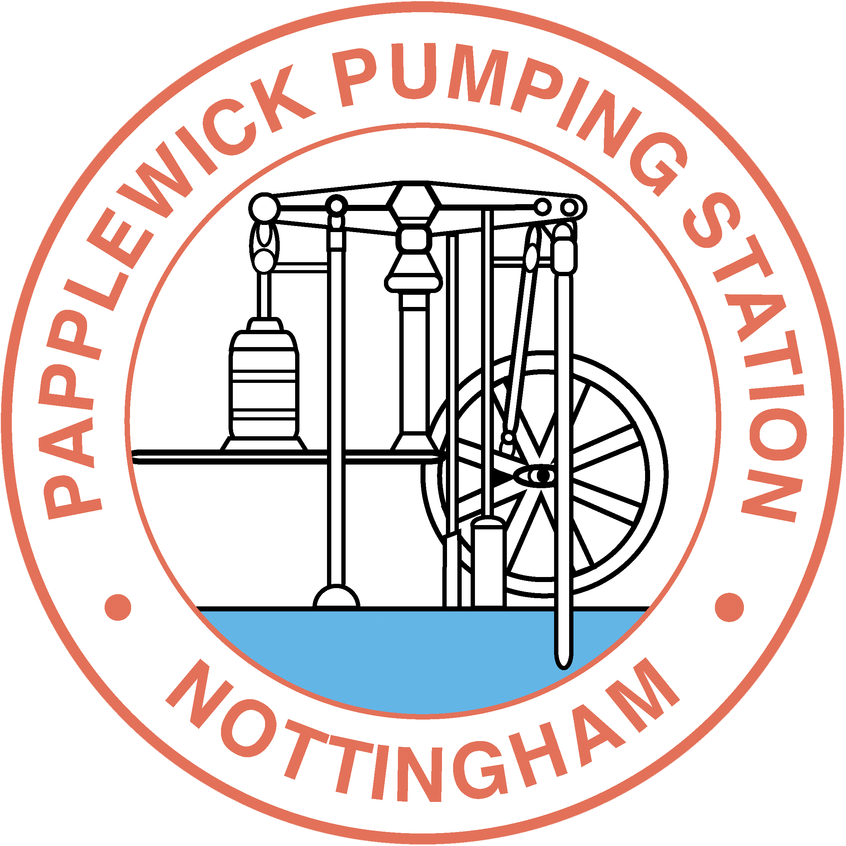

Papplewick Pumping Station Water Education Trust (WET) Scholarship.

Please ensure this application form is fully completed and signed by all parties. We recommend that you first download and discuss the application form with your supervisor before you apply for this prize. Please return to BR-RA-DTP-Funding@exmail.nottingham.ac.uk by 31 March 2023.

Your Application includes:
- Application form

- Referee report (signed by your supervisor)

- Copies of quotations for ALL expenses (except subsistence)

You MUST scan the signed documents and quotations and upload them as a single attachment with your application.
You do not currently hold a Graduate School Travel Prize.
You have provided details of Communication & Presentation skills courses/equivalent you have attended.
You have identified funding to make up the balance of the trip (above £500).
You have read, understood and accepted the terms and conditions of the award.

Papplewick Pumping Station Water Education Trust (WET) Scholarship

Please read the accompanying notes before completing this form

1 PERSONAL DETAILS
Surname |  |  | Mr Miss  Ms Dr
Forenames
School
Year of study at the time of travel |  | Full-time  Part-time
What is the source of funding for your degree (fees and/or stipend)?
Research Council
School
Industry
Self-funded
Other please specify

Please give details of attendance at one or more Graduate School communication and presentation skills training courses, or indicate any equivalent skills training received elsewhere.

For spoken presentations
Graduate School presentation skills course
Course Title
Course Title
Course Title
(e.g. Presentation skills for researchers, Advanced presentation skills, Further presentation skills)

Or equivalent course: Title

For poster presentations
Graduate School poster preparation and presentation course
Course Title
(e.g. Using posters to communicate research)

Or equivalent course: Title

Identify how you have engaged with the training opportunities provided by the Graduate School and elsewhere in the University that will support your application. This may also include supporting public engagement, student learning, etc.

Identify any academic awards, prizes you have been awarded or publications you have contributed to, or expect to contribute to.

2 VISIT DETAILS
Conference title/purpose of visit
Location (city and country)
Travel dates  *you must apply to the funding round that covers your period of travel. |  | - Outbound travel date:  - Return travel date:
Are you presenting a paper or poster?

Paper Poster Title
Accepted

Waiting Decision

List the authors of the paper/poster being presented (in the order they are shown)
Briefly outline the findings and contribution of the paper
Identify the value of the conference/visit for you and explain how attending this conference/visit is relevant to your research and future career aspirations.

3 RESOURCES REQUIRED FOR THE VISIT
Please provide details of the total cost of your proposed visit, indicating the source of the information and a full itemised list as necessary. Scanned copies of all quotes/documentation must be included in your application (URLs are NOT sufficient).
Travel should be booked following the University of Nottingham Travel and Expenses Policy. Please contact the person in your School responsible for booking student travel for further advice. | COST (£)
Travel costs

Registration Fee

Accommodation

Subsistence

Any other expenses (please specify)

Total cost of the visit | £
Balance to be funded elsewhere | £

Please provide a brief justification of your budget (eg efforts to minimise costs), explain how the balance will be funded and what steps you have taken to secure funding from other sources. (max 300 words)

4 DECLARATIONS

Applicant's Declaration

I understand that if awarded a grant, I will be required to write a brief report on the visit and provide an account of expenditure together with scanned copies of all relevant receipts.

I have read and understood the terms and conditions for the Papplewick Pumping Station Water Education Trust (WET) Scholarship and agree to abide by these and any other conditions attached to any grant offered and accepted as a result of this application.
Name (BLOCK CAPITALS)

Signed ……..…………………………..…………….... Date

Papplewick Pumping Station Water Education Trust (WET) Scholarship Supervisor Statement of Support

This is a competitive award to support high quality postgraduate research students in presenting
their work at conferences of high standing in their field. In it may also be used to support research visits to leading research centres where this would be particularly beneficial.

Statements from the student and/or supervisor should also provide evidence of excellence eg papers published, awards received, and evidence of contributions to university life eg participation in events, service to others.
Name of applicant:
Name of supervisor:

Please comment on the following:

- The quality of the student and the value to the student of participating in this conference/visit.

- The standing of the conference/visit, and how this activity will support the student’s research and career.

- The ability of the applicant to act as an ambassador for the University.

- The School’s ability to financially support this application or any other funding implications that the panel should be aware of.

I fully support this student’s application

Signed …………………………………………......................... Date

Papplewick Pumping Station Water Education Trust (WET) Scholarship
(For information only)

 | Points allocated
Personal Details  Evidence of training and involvement with the Graduate School, and University | Maximum 5 points
Comments:

Student’s statement | Maximum 10 points
Comments:

Supervisor’s statement | Maximum 10 points
Comments:

Resources Required for the Visit  Justification of budget and evidence of other support | Maximum 5 points
Comments:

Total | Maximum 30 points

