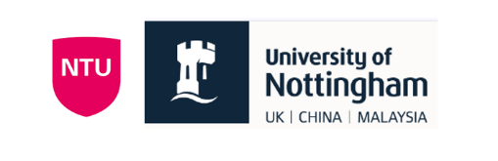
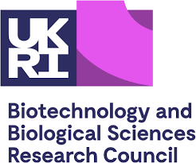
Nottingham Magnify Project 2025

Name of Supervisor:
Peter Harvey
Research Theme:
Biotechnology
Location of Project:
School of Chemistry (Harvey and Ciano labs) – main location. School of Medicine (Preclinical MRI scanner)

Project Title:
Harnessing nature for next-generation diagnostic biomedical imaging
Project Description:
Contrast agents are applied in over 30 million clinical magnetic resonance imaging (MRI) scans every year, but the technology of these contrast agents have barely altered in the last 30 years. All are based on synthetic gadolinium complexes, which are challenging to adapt for new applications and pressing diagnostic needs. A particular challenge is in the development of contrast agents that can detect key biomarkers of biochemical processes and disease.
The inherent flexibility of protein engineering provides an untapped platform for modification and technology development in this space, but the knowledge of gadolinium-binding proteins is extremely limited. A unique collaboration between the School of Chemistry, School of Medicine, and Faculty of Engineering at the University of Nottingham has identified a lanthanide-binding enzyme with unexplored potential for use in MR imaging. This enzyme, currently being investigated for applications in biocatalysis, is an ideal target for modification for use as a diagnostic sensor in MRI.
The project will involve expression of the lanthanide-binding enzyme within the Ciano and Pordea groups, with training in classic molecular biology techniques. The protein will be expressed in E. coli and purified via affinity and size exclusion columns, using standard methodologies. The student will have the opportunity to learn and/or develop the skills required to work with bacterial expression strains and check protein purity (e.g. gel electrophoresis).
Once isolated and purified, the protein will then be studied in the Harvey lab. Here, complexation with gadolinium and other lanthanide ions will be carried out, in order to characterise the binding of the protein with different metals. Lanthanides are unique in the periodic table with relatively similar chemical properties amongst the ions, but with highly varied physical properties. This will allow not only MRI applications, but additional studies in luminescence towards microscopy studies. Once complexed, the protein will then be taken to the preclinical MRI scanner on campus for imaging and characterisation. Doping with the enzyme substrate is expected to result in changes to the MRI properties of the protein. The student will be able to setup and monitor the MR image acquisition under the supervision of a trained operator, before being trained in image analysis and processing.
Expression, characterisation, and imaging of the protein is achievable in the 10 week project and completion of these aims would result in a successful and, likely, publishable project output. The student will gain experience in protein expression and purification, biochemical characterisation, protein design, and biomedical imaging. They will be aligned closely with senior members of the Harvey and Ciano labs for day-to-day supervision and support, with opportunities to attend both meetings and work with interdisciplinary research teams spanning synthetic chemistry, bioengineering, cell biology, and biomedical imaging.

Potential skills that can be developed:
confocal microscopy, electron; high resolution microscopy; mass spectrometry; biological chemistry; therapeutics; biochemistry; imaging;
Training opportunities:
Protein expression in E.coli, protein purification (Ni-column and size exclusion), and gel electrophoresis. Knowledge in biomedical imaging will be developed with hands-on experience with the preclinical MRI scanner, followed by training in image processing tools. The student will also gain presentation skills through updates at group meetings, with regular support with 1-to-1 meetings throughout the project.

