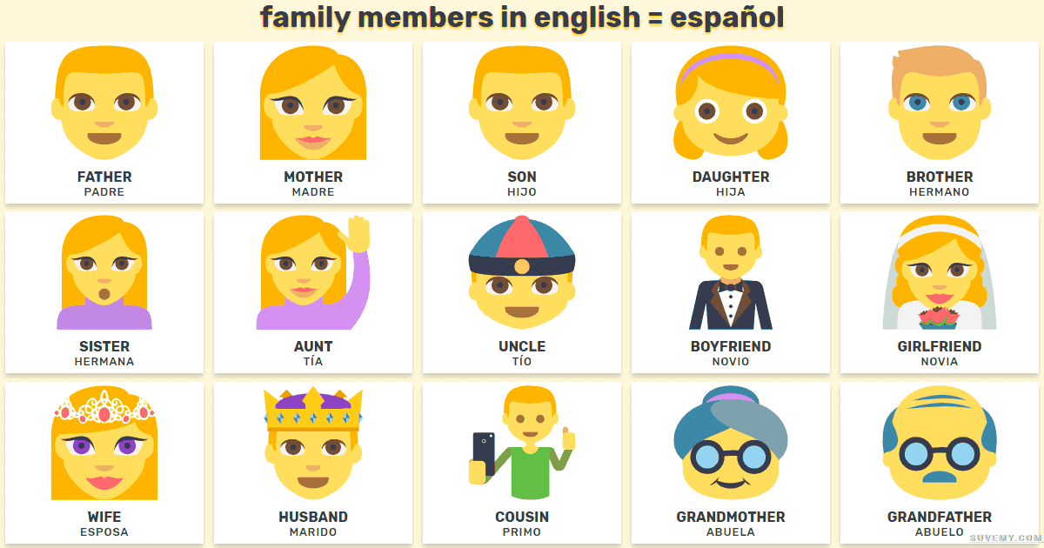

Extra tip:

To say an adopted family member, simply place “adoptado” for a male or “adoptada” for a girl after the noun.

Example: Mi hermano adoptado = my adopted brother

More Members:

Padastro = step dad

Madastra = step mum

Hermanastro = step brother

Hermanastra = step sister