The Three Step Meeting Model

Contents

Meeting one: Initial Conversation 2

Purpose: 2

Tips for line managers: 2

Tips for employees: 2

Outcome: 2

Meeting two: Explorative conversation 3

Purpose: 3

Tips for line managers: 3

Tips for employees: 3

Outcome: 3

Meeting three: Outcome meeting 4

Purpose**:** 4

Tips for line managers: 4

Tips for employees: 4

Outcome: 4

Support with determining reasonability 5

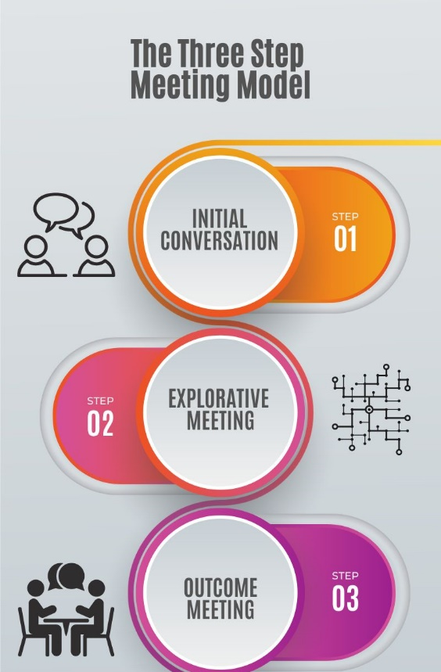

## Meeting one: Initial Conversation

### Purpose:

When a potential need has been identified, the line manager takes the lead to initiate the first conversation. The purpose of this first interaction is to allow the manager to check in with the employee regarding their wellbeing and to seek to understand whether they feel they would benefit from any support or adjustments in the workplace. It's also the line managers responsibility to signpost the employee to the resources available across the adjustments SharePoint to aid them in understanding the process.

### Tips for line managers:

* Find the right space that offers the colleague privacy to talk openly
* Protect that time - puts phones aside and give your full attention
* Listenempathetically
* Steer clear of assumptions - every colleague and situation is unique
* Be patient - it can be daunting to open up
* Let them know you appreciate them sharing this with you
* Reassure them that you're here to support them and that you can work to find potential solutions together; they're not expected to know everything
* Be mindful of not making promises on the spot that might need further exploration before being agreed

### Tips for employees:

* Be honest and open about your situation - we know it can be tricky!
* Trust in those around you; they are here to support you
* Don't be afraid to speak up if you know what will/won't work for you - this can speed the process up
* It's okay not to have all the answers straight away

Outcome:By the end of this initial conversation, both parties should be aware of the next steps being taken. It's likely that you'll find yourselves in one of the below scenarios:

1. After the conversation, no adjustments are needed at present, but you've nurtured your working relationship and created an environment where if things change, the employee might feel more comfortable reaching out for support
2. Adjustments will be explored, and the employee has an idea about what might help
3. Adjustments will be explored, but the employee is unsure of what might help

For 2 or 3, an explorative meeting should be agreed. Ahead of this meeting, we would strongly encourage the employee to complete sections 1-3 of their adjustment passport (optional) to help them reflect on their situation. The line manager should've explained the process, purpose of the next meeting and signposted any relevant resources.

## Meeting two: Explorative conversation

### Purpose:

This meeting provides the space for the employee to share their reflections on their impairment/condition/circumstance and how it impacts them in the workplace (sections 1-3 of the optional passport). It's an opportunity for the line manager to gain a greater awareness of the lived experience of their employee and to explore what adjustments might be possible to remove barriers for the employee in the workplace.

### Tips for line managers:

* Make sure you carve out the dedicated space for this meeting
* Listen openly to the employee's lived experience and potential solutions they've considered
* Use probing questions such as ‘what would support look like for you?', ‘what is the impact of that on you?’ or ‘how might we improve your experience’ or ’if we were able to do that, what impact would that have on you?'
* If you have some ideas too; share them!

### Tips for employees:

* Prepare! We would strongly encourage staff to complete sections 1-3 of the optional passport ahead of the meeting or prepare your own reflections in a format that works for you
* As per the process map, make sure you've gathered any other guidance/advice ahead of this meeting - this could be from your doctor, personal research, Occupational Health etc
* Work collaboratively with your manager; help them to understand what would help you
* Speak freely; this is your chance to speak up about what would improve your experience at work and your line manager is there to support you

Outcome:By the end of this explorative meeting, both parties should be aware of the next steps being taken. It's likely that you'll find yourselves in one of the below scenarios:

1. After the conversation, some quick win adjustments are needed and within the line managers discretion to agree there and then
2. After the conversation, some potential adjustments have been identified and now the line manager needs to explore the reasonability of these further with either their Human Resources Business Partner or operational teams as per the process map

For any quick win adjustments, the line manager and employee might be able to fill out section 4 of the passport (optional) there and then. For any adjustments that need further exploration, an outcome meeting would be necessary. It might not be appropriate to agree the exact date, but the line manager should inform the employee of the next steps that they're taking and how they will keep the employee updated.

## Meeting three: Outcome meeting

### Purpose**:**

In this meeting, the line manager will share whether or not the adjustment will be accommodated. Our approach is to say yes to requests, unless we are satisfied that the request is beyond reasonable. Support with determining reasonability can be found here. If the original request can't be accommodated, specific and clear reasoning must be provided and alterative adjustments should be suggested and agreed if appropriate. For any adjustments that're now agreed, we'd encourage the line manager and employee to complete section 4 of the passport.

### Tips for line managers:

* Make sure you carve out the dedicated space for this meeting
* Approach the conversation sensitively; any requests have been made because there is a need and we should be mindful of that when communicating the outcome where the adjustment may not have been approved
* Ensure clear reasoning is provided if the adjustment was not able to be accommodated
* Remember that adjustments should be trialled and won't necessarily have the desired impact immediately; encourage this perspective for the employee too
* Keep lines of communication open, make sure your employee knows that you will be checking in to see whether adjustments are working etc
* If you would like support with this conversation, get in touch with your Human Resources Business Partner

### Tips for employees:

* Attend the meeting with an open mind; your request might be met or an alternative suggested
* Don't feel disheartened if the request was deemed unreasonable; you are able to raise this further with the Review Group and explore this further if the alternative amendments don't feel appropriate
* Remember your line manager is there to support you and will be able to guide you in terms of next steps

Outcome:By the end of this outcome meeting, both parties should be aware of the next steps being taken. It's likely that you'll find yourselves in one of the below scenarios:

1. Adjustments were deemed reasonable and the line manager is now responsible for getting them implemented as per the process map
2. Alternative adjustments were agreed and the line manager is now responsible for getting them implemented as per the process map
3. Adjustments were deemed unreasonable for the University to accommodate, but might still be worth exploring via Access to Work

The line manager must ensure the employee understands the outcome, and the steps moving forwards including how/when the line manager will update the employee. Once the adjustments are implemented, they should then be reviewed as per the passport guidance.

## Support with determining reasonability

Various factors influence whether a particular adjustment is considered reasonable.  The test of what is reasonable is ultimately an objective test and not simply a matter of what you may personally think is reasonable.

When deciding whether an adjustment is reasonable you can consider:

* how effective the change will be in avoiding the disadvantage the disabled worker would otherwise experience
* its practicality
* the cost
* your organisation’s resources and size
* the availability of financial support

Your overall aim should be, as far as possible, to remove or reduce any disadvantage faced by a disabled worker.

**Things to consider:**

* The adjustment must be effective in helping to remove or reduce any disadvantage the disabled worker is facing.
* In reality it may take several different adjustments to deal with that disadvantage but each change must contribute towards this.
* We need to consider whether an adjustment is practical. The easier an adjustment is, the more likely it is to be reasonable. However, just because something is difficult doesn’t mean it can’t also be reasonable. We need to balance this against other factors.
* If an adjustment costs little or nothing and is not disruptive, it would be reasonable unless some other factor (such as impracticality or lack of effectiveness) made it unreasonable.
* Our size and resources are another factor. If an adjustment costs a significant amount, it is more likely to be reasonable for us to implement it, in comparison to smaller organisations, as we have substantial financial resources (resources must be looked at across the whole organisation).
* In changing policies, criteria or practices, we shouldn't be changing the basic nature of the job, where this would go beyond what is reasonable.
* What is reasonable in one situation may be different from what is reasonable in another situation, such as where someone is already working for you and faces losing their job without an adjustment, or where someone is a job applicant. Where someone is already working for you, or about to start a long-term job with you, you would probably be expected to make more permanent changes (and, if necessary, spend more money) than you would to make adjustments for someone who is attending a job interview for an hour.
* As a larger employer, it's more likely to be reasonable for us to make certain adjustments such as redeployment or flexible working patterns in comparison to smaller employers
* If advice or support is available, for example, from Access to Work or from another organisation (sometimes charities will help with costs of adjustments), then this is likely to make the adjustment reasonable.
* If making a particular adjustment would increase the risks to the health and safety of anybody, including the disabled worker concerned, then you can consider this when making a decision about whether that particular adjustment or solution is reasonable. But the decision must be based on a proper assessment of the potential health and safety risks.  You should not make assumptions about risks which may face certain disabled workers.

If, taking all of the relevant issues into account, an adjustment is reasonable then we must make it happen.