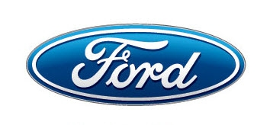
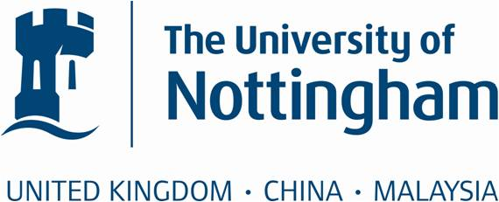

Ford Blue Oval Scholarship Programme
For two students who entered any of the following engineering programmes in 2014:

BEng/MEng Electrical and Electronic Engineering
BEng/MEng Manufacturing Engineering
BEng/MEng Mechanical Engineering
BEng/MEng Product Design and Manufacture
The Ford Blue Oval Scholarship Programme is helping to develop the UK’s next generation of student engineers, scientists and innovators.

Ford is providing sponsorship of £20,000 for two students over the duration of the degree for undergraduates on a selection of engineering, science, manufacturing and technology courses. The University of Nottingham is one of five leading universities that will each receive funding for two scholarships.
Originally announced by William Clay Ford, great-grandson of Henry Ford and executive chairman of Ford Motor Company, the scholarship programme recognises the skills that are fundamental to Ford’s future industrial base, the rebalancing of the UK economy and long-term economic success.

Ford of Britain, which has celebrated over 100 years as a leading marketing and sales operation in the UK, is reinforcing its relationship with a country which has made it the market leader in car sales for 35 consecutive years, and the commercial vehicle sales leader for 46 years.

About Ford of Britain
• In the UK, Ford directly employs over 15,000 people; many in highly-skilled roles developing and building high-technology, fuel-efficient, low CO₂ engines, but in total 100,000 jobs are supported through the Ford supplier chain and dealer network.

• Ford's recently announced £1.5 billion investment, in low-carbon engineering and manufacturing, is helping to underpin the UK's manufacturing and export-based economic recovery.

• Ford plants at Bridgend in South Wales and Dagenham in East London have the combined capacity to assemble two million engines annually so that one in three Ford vehicles globally can be powered by a UK-built engine.

• Ford's Dunton Technical Centre in Essex is the global centre of excellence for diesel powertrain R&D and for European commercial vehicles.
Ford Blue Oval Scholarship Programme

Two scholarships worth £10,000 each will be awarded to 2 first year students (one male, one female) at The University of Nottingham on the following courses:
Course | UCAS code
BEng/MEng Electrical and Electronic Engineering (with or without year abroad/industrial year) | H603/H600/H60A/H60B/H606/H605
BEng/MEng Electronic and Computer Engineering | H613/H611
BEng/MEng Electrical and Electronic Engineering with Management | H6NB/H6NG
BEng/MEng Electrical and Electronic Engineering with Mathematics | H6G1/H6GC
BEng/MEng Manufacturing Engineering | H708/H707
BEng/MEng Mechanical Engineering | H302/H300
BEng/MEng Product Design & Manufacture | H700/H715

Eligibility criteria
To be eligible for the scholarship, students must:
- Have started on one of the undergraduate courses listed above at the University of Nottingham, in September 2014.
- Have achieved at least a 60% average in the January 2015 exams
- Be a UK student and not be classed as a European Union or international student for tuition fees purposes.
- Not be part of any other scholarship programme run by another commercial organisation for the purposes of higher education.
- Display an interest or aptitude in the fields of relevant subjects, such as engineering, technology, science and information technology, in addition to their academic qualifications.
- The Ford Scholar will commit to providing an annual update report to the University every September, for the University to send onto Ford Motor Company. The report will detail the student’s progressing in their learning and career development, and other interests relating to how they are using the scholarship and their University experience.

Applications will be assessed on the assumption that applicants meet the eligibility criteria outlined above. Any offer of an award will be conditional on eligibility being verified by the University.

The award will be made to students who have an interest in, and a commitment to, engineering and the automotive industry expressed in a written statement, a short presentation and interview.

How to apply
1. Complete and return the application form to the address shown on the last page of this document by Friday 27 February 2015. (Emailed applications are acceptable).
2. The University will take into account entry grades, performance in January exams and your written statement when drawing up a shortlist.
3. Shortlisted candidates will be asked to attend an interview and to give a ten minute presentation on their reasons for applying and their interest in and commitment to engineering and the automotive industry.
4. Successful applicants will be notified before the end of spring term (27 March 2015).
5. Scholarships will be awarded at the start of the summer term this year (£3,333 per year for three year degrees and £2,500 per year for four year degrees) and in January thereafter subject to academic progression.

Ford Blue Oval Scholarship Programme: Application form

Student ID

Surname

First name/s

Date of birth

Please indicate which course you are on
Course | MEng/BEng

Telephone
number
Home / mobile

Email
address

Entry
qualifications

Please state subjects and grades

January
exam results

Please state modules and marks

Are you in receipt of any other scholarship Yes No

If yes, please give the name of the award and the amount of the award.

Please write a statement describing your interest in and commitment to engineering and the automotive industry. (Please use additional sheet if required.
Max 250 words)

Declaration
Please sign and date the following
I confirm that the information supplied is correct and agree that the University may seek any further evidence necessary to substantiate my statements. I understand that giving false information, and/or withholding information, may constitute a fraudulent application and could result in an awarded scholarship being withdrawn.

I give consent to the University of Nottingham and Ford to use my name and image for the sole purpose of publicising and communicating the scholarship programme. I understand that I may be invited to attend events organised by Ford or the University of Nottingham to promote the scholarship programme and that I am required to inform Lucy Rose (address shown below) if I have any objections to this.

Signature Date

The completed form should be submitted to:

Lucy Rose

University of Nottingham

A21 Coates Building

Faculty of Engineering

University Park

Nottingham

NG7 2RD

Tel: +44 (0)115 8468068

lucy.rose@nottingham.ac.uk

Deadline for applications: Friday 27 February 2015

Data Protection: All information and supporting documentation supplied by you with this application will be used for the sole purpose of assessing your application for financial help. Some information, including the outcome of the application, will be held on a computer-based system maintained in accordance with the provisions of the Data Protection Act 1998. The data will not be passed to any other third party without your consent, except when the University is required to do so by law. Any formal enquiries concerning the use of data noted here should be addressed to the Head of Financial Support.
www.nottingham.ac.uk/student-support

