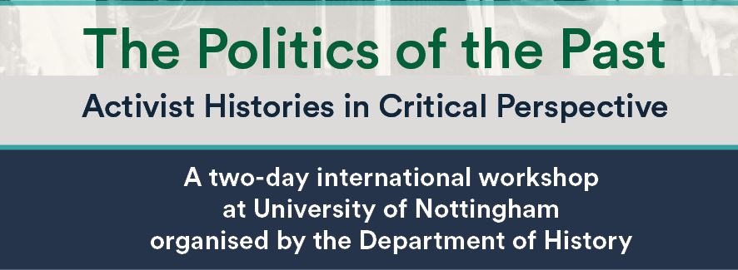
The Politics of the Past:
Activist Histories in Critical Perspective

International Workshop at the University of Nottingham, 18 -19 May 2023
Jubilee Campus, Business School South Building A06 (workshop) & A24 (roundtable)

DAY ONE, 18 May 2023
14:00-14:15 | Welcome & introduction
14:15-16:45 | PANEL ONE: Navigating the Age of Catastrophe
Julie Gottlieb (Sheffield), “F.L Lucas: classical scholar as chronicler of the crisis of the 1930s"

Per Rolandsson (UoN), “Siegfried Kracauer and the Science of Crisis”

16:45-17:00 | Coffee Break (with Cake)
17:00-18:00 | Doing Radical History Today – A Round Table  Sam Knapton (UoN) – Laura Schwartz (Warwick) – Nathan Richards (UoN) – Martina Salvante (UoN)
18:30 | Hot Buffet Dinner

DAY TWO, 19 May 2023
09:15-10:45 | PANEL TWO: The New Left
Madeleine Davis (Queen Mary), “Activism and commitment in New Left history-making”

Sophie Scott-Brown (Oxford)), “Hero or Organiser? Raph Samuel, EP Thompson, and the 'People's Historian'”

10:45-11:00 | Coffee Break
11:00-12:30 | PANEL THREE: The Postcolonial Challenge
Spencer Mawby (UoN), “Eric Williams and Time's Monster: History, Anticolonialism and Prime Ministerial politics in Trinidad”

Dean Blackburn (UoN), “Stuart Hall: History and the ‘Contingency of the Present”’

12:30-13:30 | Lunch
13:30-15:00 | PANEL FOUR: The Feminist Challenge
Natalie Thomlinson (Reading), “Raising Clio's consciousness: The Women's Liberation Movement in Britain and the rise of feminist history”

Vera Marstaller (Freiburg), "How to write decolonial-feminist history? The singer Chavela Vargas (1919-2012) as a historian of the 20th century“

15:00-15:30 | Coffee Break
15:30-16:45 | PANEL FIVE: Confronting Fascism
Rúben Leitão Serém (UoN), "Herbert Southworth: between activism and empiricism"

Emile Chabal (Edinburgh), "Eric Hobsbawm: the non-activist historian".

16:45-17:00 | Concluding Remarks

