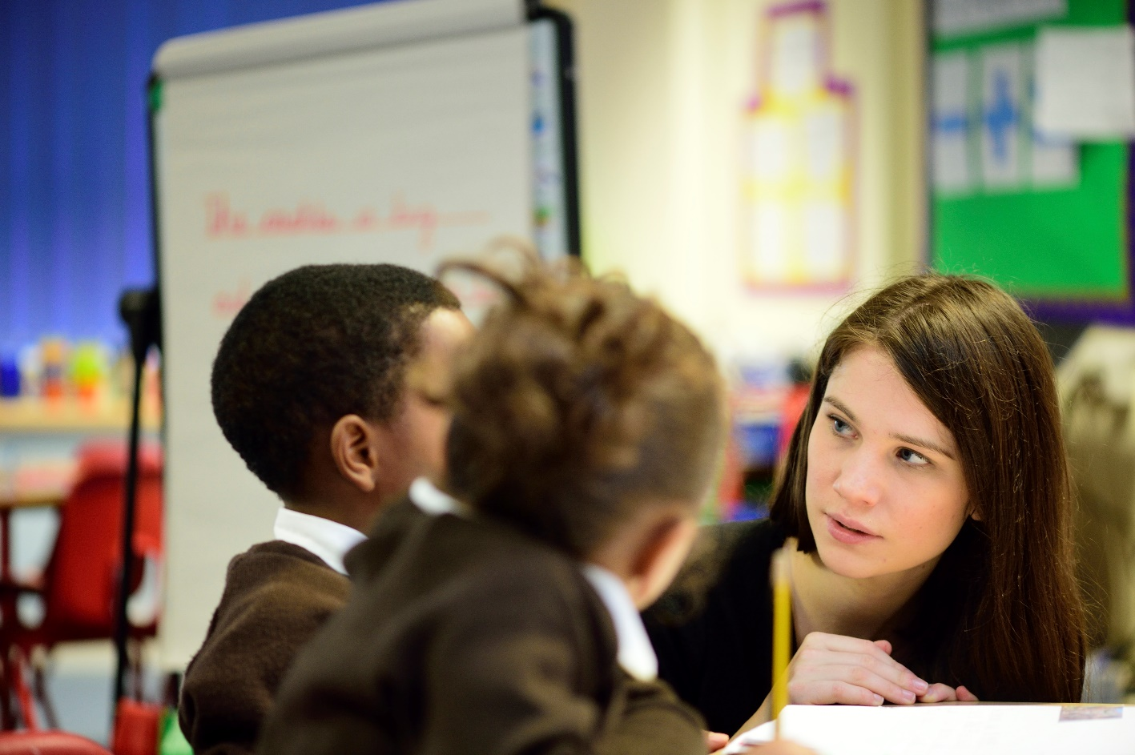

School of Education PGCE

Pre-Course Primary Experience Booklet

Introduction

We recommend that all beginning teachers who will be starting a PGCE course undertake between two and five days experience in a state primary school in England prior to starting the course.

This can take place at any time that is convenient to you before the start of the PGCE course. The aims of this experience are to help you understand the context and experiences of being in primary school, to learn from the experienced teachers there and to make sense of the transition that pupils experience as they move to a secondary setting.

This is an expectation for secondary PGCE courses at most institutions and many schools are used to receiving such requests from prospective teachers. You may have to approach more than one school, but if you do so in the right way and in good time you should not find it difficult to arrange a placement.

In general, the experience should allow you to:

- gain an increasingly sophisticated understanding of the complexities of what it is to teach effectively, including understanding: pupils, teaching, schools, and the curriculum
- think about your own experience of schooling and how this relates to yourself as a beginning teacher

Specifically, the tasks you undertake will lead you to:

- consider your own thoughts and preconceptions about primary schools
- understand expectations of how beginning teachers should observe, gather data and reflect on what they have seen
- develop an understanding of a school in its community
- increase your understanding of individual differences (attainment, concentration, social interaction, etc.)
- develop an understanding of the complexities of the teacher’s role
- negotiate a small amount of teaching, whether of a small group, a larger group or the whole class
- begin to collect evidence about how your particular subject – English, geography, history, mathematics, modern languages and science – is addressed at Key Stages 1 and 2
- consider the transition from primary school to secondary school, and continuity from Key Stage 2 to Key Stage 3
- observe at first hand the implementation of the behaviour policy
- explore how child protection and safeguarding is addressed in primary schools.

Arranging Your Pre-Course Primary Experience Placement

You will need to contact the headteacher of a primary school as soon as possible, explaining that you would like to spend some time in their school, observing and supporting teachers. Use the letter to a primary school headteacher on the website to introduce yourself to the school as someone who has been accepted onto the PGCE course at the University of Nottingham. You should ask if you can spend most of your time in school focusing on Key Stage 2 (Years 3 to 6) and you will probably find that you are invited to work with a particular class teacher. You should see your relationship with the staff of the primary school as a reciprocal one. They will be providing you with a valuable opportunity to find out about primary education and make a good start on your PGCE studies; you will be able to offer them an ‘extra pair of hands’ in the classroom and to make other contributions within the school. We would also like you to have a go at some teaching, perhaps of a small group of pupils, under the guidance of the teacher with whom you are working.

You will need to ask the headteacher to complete the school report form on the website which indicates the period of time spent in school and asks for comments about your work with the school.

What does primary experience involve?

During the course of your experience you will collect and record information and impressions for ten short tasks that will be relevant to the first phase of the course:

- your experiences and preconceptions
- the primary school in its context
- pupil observation
- teacher observation
- finding out about your subject at Key Stages 1 and 2
- finding out about Literacy and Numeracy
- introduction to teaching
- transition from primary school to secondary school
- beginning to reflect on your learning and looking to the future
- considering the implications of policies around child protection and safeguarding to
your work as a teacher.

Read through this booklet before you start your period of experience so that you can plan your observations and discussions during your time in a primary school. You are required to make and keep notes in relation to the tasks; the exact format of the task is indicated on the task sheets. You are not expected to write in essay format or at great length for any of the tasks. Most of the notes that you make will be in bullet point fashion, but there are some tasks that require a slightly longer response. You will need to bring these notes and the various documents to sessions and tutorial discussions during the first weeks of the PGCE course. You will also need to bring the completed school report form with you when you start the course.

When we have talked to beginning teachers before they start primary experience, they often have questions about how they will be expected to conduct themselves in the primary school, including what clothes they should wear! If you make a preliminary visit to the primary school to arrange your placement you will be able to work out for yourself answers to most questions you might have, but if in doubt don’t be afraid to ask the staff you meet. For example, you might ask the headteacher whether it is appropriate for you to use the staff room during your time in the school. The key to your approach should be to conduct yourself in a professional manner, being aware of your role in relation to pupils and teachers. It is of course particularly important that you carry out your observations with sensitivity and respect, treating the results as confidential. After you have completed the primary experience, a personal letter of thanks to the headteacher would be much appreciated.

The Cambridge Primary Review, published in 2009 was the result of a comprehensive survey of primary education at a time when a new curriculum was being planned. Although some of its recommendations were not implemented, it remains a valuable overview of issues within the primary phase.

You may also find this keynote lecture by Robin Alexander of interest.

How will primary experience be followed up on the PGCE course?

Your notes and reflections on primary experience will be followed up and developed through lectures, tutorial discussions and possibly a group presentation. The tasks in this booklet also serve as an introduction to the more extensive observations you will be required to complete for your Personal Learning Record during the Autumn Term.

PGCE Students’ reflections on their Primary School Experience

My observations quickly rewarded me with insights into the manifold ways in which children learn and the complexities of the teacher’s role in promoting and encouraging this development. The term ‘learning’ also began to develop a much broader meaning for me. As I observed it appeared that academic learning is only a part of a much wider picture which includes the promotion of self-esteem and socialisation. I came to see that learning can be divided into the different ways in which pupils respond to various teaching strategies and how sensitive the teacher is to these nuances and rhythms of learning.

I chose to observe ‘Ben’ during a Maths lesson in which he was a member of the highest ability group. The lesson was structured by Mr. Lee asking the class mental arithmetic questions for the first ten minutes, then with the children working through their Heinemann Maths books individually.

It was apparent that Ben was anxious to participate in the mental arithmetic as he put his hand up for most of the questions. In some instances he was over-enthusiastic and offered answers when he clearly did not know the correct response. This observation was open-ended and covert, where I glanced every minute or so and noted his 'actions'. However, I chose to observe the second part of the lesson in a structured way, to find out whether Ben was on or off ‘task’ during a twenty-minute period.

The skills that equipped this teacher to [define the pupil-teacher relationship] were infinite patience, honesty in his dealings with his pupils and good listening skills. The first and last of these are commonly cited as essential virtues but the second is one I only really came to appreciate during my time in the school. The children need to know where they stand and what is expected of them. It is essential to communicate this honestly and consistently.

To see where learning begins’: this was my stock reply to anyone who enquired why I was undertaking observation at primary school when I was training to be a secondary school teacher. Whilst I considered this statement only in terms of the pupils' learning, and only in the school context, it became apparent from the outset that it was where my learning would also begin.

On first sight this classroom seems to operate with very little input from the teacher. It was only after spending a few days with the class that I appreciated that there were well established routines that ensured the classroom was a productive area. I came to appreciate the worth of these routines as I became more familiar with them myself. Far from being constrictive they freed the teacher to be available to help far more pupils and also gave the children a strong sense of direction.

Adam’s ‘on task’ time varies considerably depending on the activity undertaken. He is likely to spend more time working on tasks where there is a creative element. For example, in the Graffiti lesson which I took he conscientiously worked through a selection of art activities, later showing an interest in writing sentences to explain them. Other activities which had higher proportions of on-task time were sport, art and science. There was noticeably more off-task time in large group activities such as television sessions, choir and assemblies, where he is less closely supervised.

I found my short stay at primary school very fruitful, and it only strengthened my resolve to teach. Moreover, I learnt that each child is an individual and should be treated as such in a positive manner, where encouragement and praise are bountiful.

Thanks to: -
Johanna Smith, John Sanders, Georgina Lee, Hilary King, Simon Bailey and Andrew Crofts.

Primary School Experience Tasks

Name:
Subject:

In completing these tasks please note the following:

  - recording your information in bullet point fashion is totally acceptable;
  - there is no need to copy out or word-process your notes;
  - record your notes on these sheets, but please feel free to add extra sheets. For certain tasks you are specifically asked to attach further information.

Task 1: Experiences and preconceptions

Before you begin your Primary School experience try to record some of your own memories of your own time in primary school. For example, do you remember any of the teachers - if so why? Can you remember some of the things you did and how you were taught?

What preconceptions do you have about primary schools today?

Task 2: The Primary School in its context

Find out about the school and its context by doing as many of the following as you can:
  - collect a school brochure and look at the school’s website
  - obtain a copy of the school’s latest OFSTED report
  - go to Compare the performances of schools and colleges in England and find the school’s performance data
  - collect or sketch a map of the school and have a look at the different areas
  - find out about the school’s catchment area and have walk or drive around it
  - find out about the proportion of children eligible for Pupil Premium funding and how the school uses the funding
  - talk to teachers and pupils about the school in relation to its community.

Task 3: Educating the whole child

Every Child Matters was a major policy of the Labour government that changed the ways schools work and teachers function within them. Following the tragic death of Victoria Climbie, a damning report on the failings of the various services involved was
published. The Every Child Matters green paper in response to the report resulted in the Children Act of 2004. Following on from this, the Coalition government commissioned reports by Professor Eileen Munro in 2011 and 2012 reviewing child protection, resulting in further reforms and changes to statutory guidance.

Schools play a key role in the life of a child and so have a safeguarding responsibility to the children in their care. In 2023 the Government produced further statutory guidance for schools which can be found in the Keeping children safe in education document.

Talk with teachers and teaching assistants (if possible, the designated person for safeguarding) in your school about child protection and safeguarding and how it impacts on their work and the work of the school.

Task 4: Pupil Observation

Consult your class teacher and identify two pupils of different achievement levels to observe. The teacher might be interested in finding out how particular pupils are working or might suggest those who would benefit from the extra attention. Make sure that neither pupil will be disrupted by the observation.

When you are observing the pupils, make notes on the following:

  - the balance of time spent ‘on task’ and ‘off task’
  - the balance of listening, talking, reading and writing that each child does
  - interactions between each child and the teacher
  - interactions between each child and other children.

When you have finished your observations, make notes on the following:

  - what were some of the issues in choosing which pupils to observe?
  - what kinds of information were you able to collect?
  - how did you feel about your role as observer?
  - which tasks did the pupils find interesting and enjoyable, which didn’t motivate them and which they did find difficult? Why do you think this was the case?
  - how did the teacher try to take account of the different achievement levels of the pupils?

Task 5: Teacher observation

Find out about your class teacher’s working day. What sort of preparation is required? Make notes on ‘behind the scenes’ work done at school before and after the school day and also what the teacher does at home.

Have a look at planning, and ways in which pupils’ learning is assessed and their progress monitored. Talk to the teacher about how planning and assessment work in practice.

Through observation of teaching and talking to the teacher, how does the teacher plan for and deal with classroom management issues?

Task 6: Finding out about your subject at Key Stage 2

How is your subject being taught and delivered in the primary school curriculum?

Outlined below are some subject specific questions and issues that we would like you to find out about. Just concentrate on your subject area.

Record your notes on a separate sheet and include with this document.

English

Look at the English National Curriculum for Key stage 2 and the summary and main findings of Ofsted’s Review of English teaching
  - How is English taught? Is it as a discrete subject or integrated across the curriculum?
  - Talk to the pupils about their perceptions of English as a subject.
  - Try to observe work in each of these areas of the curriculum: speaking and listening; reading; and writing.
  - What texts are used and what are the principles for choosing these?

Geography

Gather information on the place of geography in the primary school. In order to do this you will need to look at the National Curriculum Key Stages 1 and 2 and talk to the geography coordinator in the school. You may also be able to observe some geography being taught.

Consider the following:
- How significant is the teaching and learning of geography in the primary school?
- Is it identified and taught as a discrete subject or are aspects of it taught through topic work?
- What factors have impacted geography in primary schools? Have these had a
  - positive or negative effect?
- What type and range of resources are available to teach geography?
- What is the contribution of fieldwork to pupils’ geographical learning?

History

Look at the history National Curriculum for Key Stage 2. You will also need to talk to the history coordinator. If possible, try to observe some history being taught.

    - What sort of history is being studied? What skills and concepts are being developed? Find out how history is being taught. Is it a discrete subject or is it taught through literacy work or through topic lessons?
    - Look at the range of historical enquiries pupils are involved with.
    - Draw up a list of the variety of sources that pupils use.
    - Try to find out what the pupils most enjoy about history.
    - How much time is being allocated to the teaching of history?
    - What resources are available to teach history?

Mathematics

Look at the mathematics National Curriculum for Key Stages 1 and 2. Through reading, observation and conversation with teachers, try to find out:

- Where pupils do mathematics in other areas of the curriculum.
- How are the children grouped for their daily mathematics lesson? Why are they grouped like this? How does this affect their learning?
- What different approaches and styles of teaching are used for mathematics lessons? How do different styles benefit the learners?
- What range of resources does the school use for teaching mathematics?
- Discuss with teachers how they implement curriculum changes and where difficulties arise.

Modern Languages

The government made modern languages a statutory subject at Key Stage 2 from September 2014. Look at the languages curriculum for Key Stages 1 and 2 and find out how well-equipped teachers are for this development.

- Does the school allow for progression of skills and content across KS2?
- Which languages are taught, why and how?
- How many languages are spoken by the pupils in the school?
- How is Global Citizenship represented and explored in the curriculum?
- How is transition planned for in terms of modern languages progression at school?

Science

Using both your observations and discussions with appropriate members of staff, try to find out about the following areas:

- What information about achievement in science is given to the middle/secondary schools that take pupils?
- How does the school organise and co-ordinate the teaching of science? What roles do various teachers have?
- How is the National Curriculum programme of study used? For example,
  - has the school developed their own Schemes of Work or do they use a published scheme?
- Which teaching strategies are used for teaching science?
- What kinds of practical work, including investigations, are pupils engaged in and what resources and equipment are available to support this?
- Is there any contact with the local middle/secondary schools concerning the nature and the continuity of teaching of the science curriculum?

Task 7: Early Reading

Find out how reading is taught across the school. Please also read the summary of the Rose Review on the teaching of early reading and The Reading Framework (2023)

Task 8: Introduction to teaching

- Negotiate with the teacher to undertake some teaching, probably with a small group, but perhaps a brief session with a whole class. For example, you might work with a small group of pupils within a teacher’s lesson or you might read to the whole class and try out questioning techniques.

- Plan your teaching carefully, in consultation with the teacher. You should decide what your aims are for the teaching, what activities you would like the pupils to do and the learning outcomes that the pupils should achieve as a result of carrying out these activities. You will find it helpful to write out a step-by step plan for what you will be doing with the pupils, with approximate timings.

You should include your plan on a separate sheet.

After you have done your teaching evaluate it. What went well, what not so well, and why? What have you learnt from this in terms of your future teaching?

The class teacher and the pupils may be able to give you some constructive feedback.

Task 9: Transition from primary school to secondary school

Find out about primary teachers’ and Year 6 pupils’ perceptions of:

  - the transition from primary to secondary school
  - teachers and lessons in secondary schools

Task 10: Reflecting on your learning during primary school experience and looking to your future career as a secondary school teacher

As you approach the end of your primary school experience look back on your responses to Task 1 and reflect on how your understanding of primary education has developed over the course of the week.

Taking account of your experiences during your week in primary schools, what do you think will need to consider as you begin your career as a secondary school teacher?

