These notes describe a utility programme and its associated GUI which enables the export of local field potential (LFP) and event data files from NeuroExplorer (NEX; www.neuroexplorer.com) into MATLAB (The Mathworks, MA) for Independent Component Analysis (ICA) processing within EEGLAB (Delorme & Makeig, 2004; Makeig et al., 2004).

References:

Delorme A & Makeig S (2004) EEGLAB: an open source toolbox for analysis of single-trial EEG dynamics. Journal of Neuroscience Methods 134:9-21.

- includes details of EEGLAB ICA and time/frequency methods.

Makeig S, Debener S, Onton J & Delorme A (2004) Mining event-related brain dynamics. Trends in Cognitive Science 8:204-210.

- benefits and pitfalls of combining ICA, time/frequency analysis, and ERP-image visualization.

Web resources:

MATLAB site - http://www.mathworks.com/
EEGLAB site - http://www.sccn.ucsd.edu/eeglab/

Utility installation Instructions:

- Download both the EEGLAB and DALF files to a folder on your hard drive. (open ZIP file).
- Run MATLAB
- Select File > Set Path >
- The following window should open:

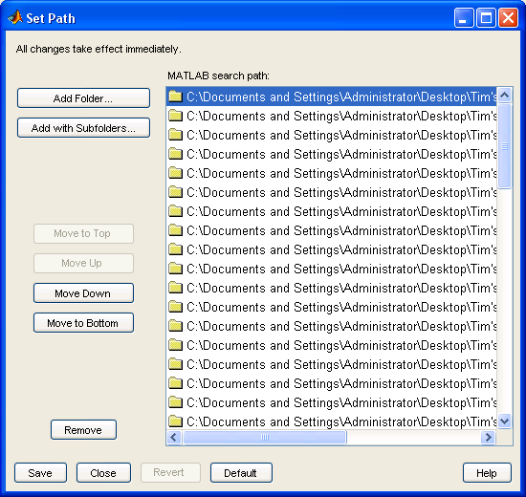

- Select Add with Subfolders and select the folder containing both the EEGLAB and DALF files and then select save.
- To check that the above is installed type ‘dalf’ to load the DALF GUI.
Getting started:

Before starting check that the path in MATLAB (File > Set Path) shows EEGLAB and DALF file paths.
If not, reinstall the files (shown above).

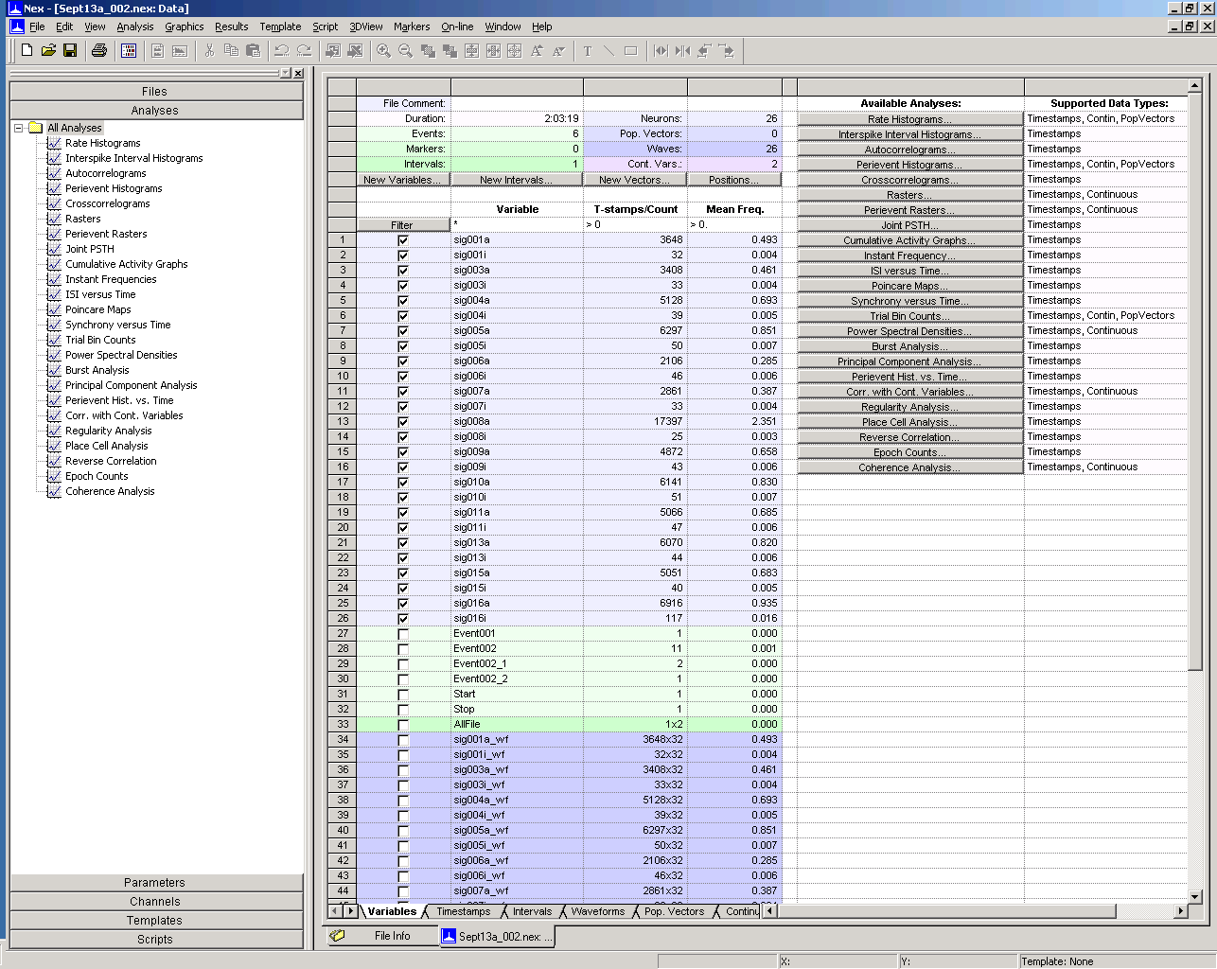
- Open the *.NEX file in NeuroExplorer:

- Deselect all variables except the LFP (e.g. AD01) and Event (e.g. Event002) variables required (you can import up to eight LFP and two event variables):
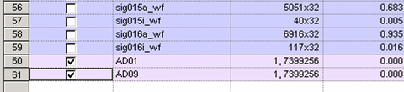
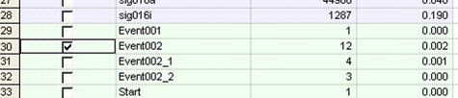
- Then select:

File > Send Data to Matlab > Send Selected Variables to Matlab
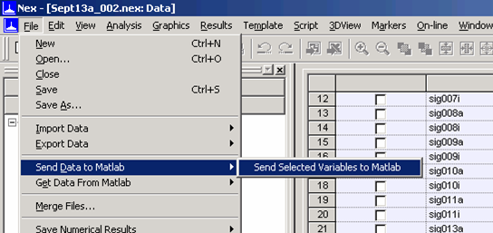
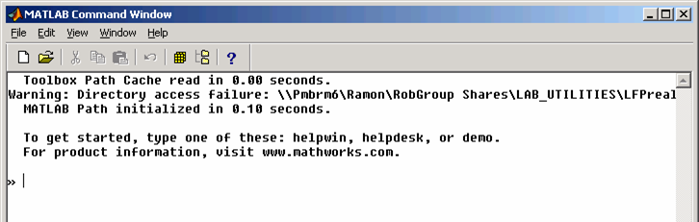
- The MATLAB Command window will now open:

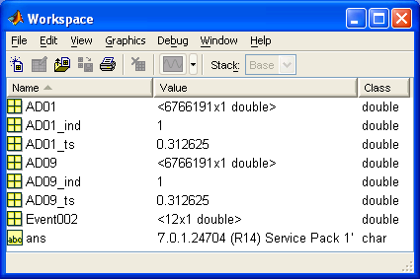
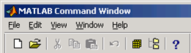
- Open the Workspace Browser – there should be 3 variables for each LFP channel imported and 1 for each event data:

- Return to the command window and execute the following command:

dalf (Data Analysis Local Field potentials)

DALF

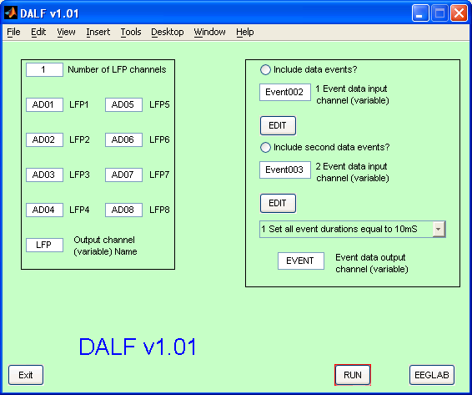

  - Top left: enter the number of LFP variables imported from NEX (not including the Event data). Enter each label (e.g. AD01) into the corresponding box. The output label can also be edited (default: ‘LFP’).

  - Top right: If you have imported event data click ‘Include data events?’ and enter the variable name in the box below exactly as it appears in NEX (default: ‘Event002’). If you have imported a second channel of event data, again click ‘Include second data events?’ and enter the variable name as it appears in NEX. The output label can be edited (default: EVENT).

  - Next select if you wish to:

1 Set all event durations equal to 10 ms – default
2 Input / edit individual event latency – allows you to add or remove individual events using the default duration (10 ms)
3 Edit event latency duration and type – allows you to edit the event data including event duration and type

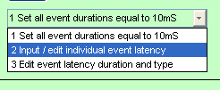
- If selecting option 2 or 3, you can use the Edit button to open the array editor:
A message will appear helping you edit the data. Below I used option 2:

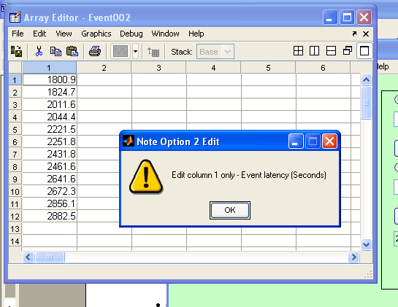

  - When you’ve finished editing the event variables close the array editor and click ‘RUN’.

  - To open EEGLAB click the bottom right icon

EEGLAB

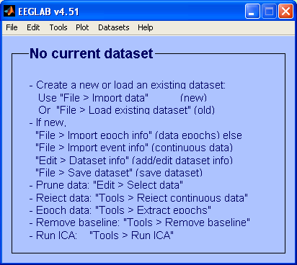

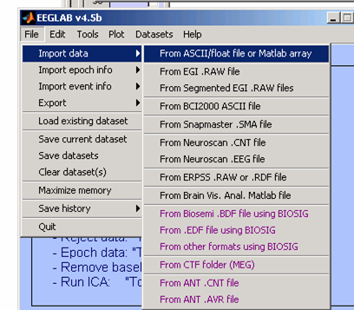
- To load the data click File > Import data > From ASCCII/float file or Matlab array

- This will load the following:

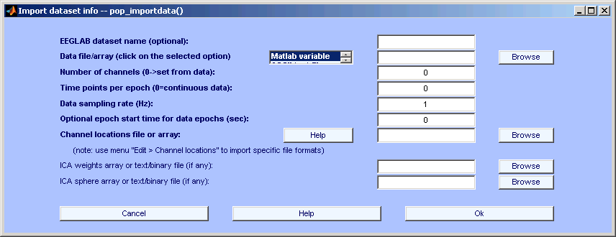
Make sure Matlab Variable is selected
Enter your Matlab array name here (in this case LFP)
- Select ‘Matlab Variable’ from the scroll list and enter the MATLAB array name (e.g. LFP).
Below this enter the number of LFP variables (e.g. 2) imported from NEX and the sample rate used (e.g. 1000).

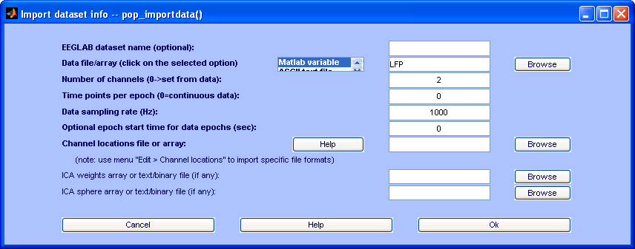

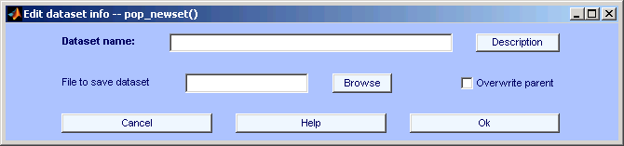
- Click ‘Ok’ and the window will be replaced with:

- Enter a dataset name and file name and where you wish to save it to, then click ‘Ok’

- The main EEGLAB window will then appear:

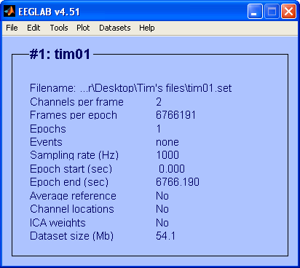

- To import event data select File > Import event info > From Matlab array or ASCII file.
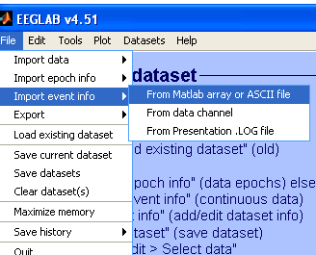

- This will open a new window:
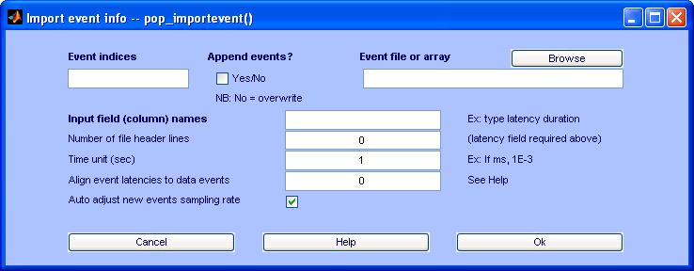

- In the Event file or array enter the variable name (e.g. EVENT).
- Enter Input field (column) names in the following order: latency duration type (case and order sensitive).
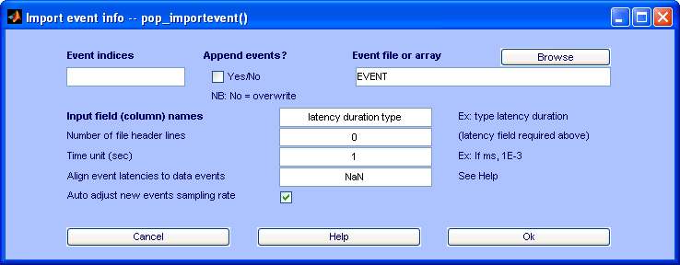

- Click ‘Ok’ and the main EEGLAB screen will show the number of events (e.g. 12):
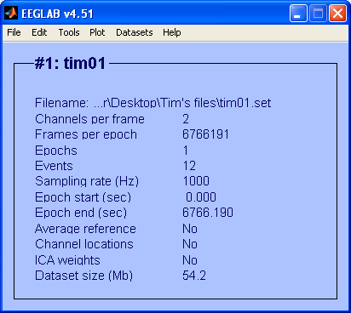

- To view the LFP and event data in EEGLAB, go to Plot > Channel data (scroll).
