USVisualiser User Manual

Welcome
Welcome to USVisualiser, a tool designed specifically to detect, filter, classify and perform principle component analysis (PCA) on ultrasonic vocalisations from animals. This user manual will guide you through the necessary steps in order to use the software.

The software was designed and built to be used on a computer equipped with Matlab 7.04 with the Matlab Image and Signal Processing Toolboxes installed. Without these the software will not function correctly.

Initial launching
In order to launch the program the directory in which the program files are in must be selected as Matlab’s current directory. The program can then be launched either by double clicking on the Main.m file and clicking the run button, or by typing main at the command prompt. This will bring up the main screen of the program as seen in Figure 1.
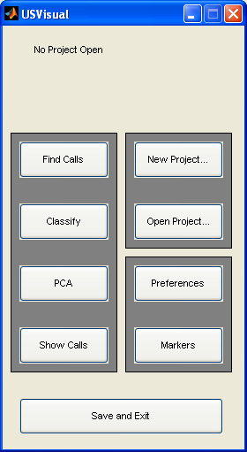
Figure 1. The main screen of the program from which all the other options can be selected
Before anything can be done with the program a new project file must be started or an existing one opened in order to do this the too buttons New project… and Load project can be used respectively.

Clicking on the New project… button will bring up a dialog box in order for the new project to be named. This will create a project file with the same name as the project, the file type of this file will be .mat (e.g. projectname.mat) and will be saved in the main program directory. Also created will be a folder to hold the other project files created during the running of the program. This will be named the same as the project and will also be located in the main program directory.

Clicking on the Open project… button will also bring up a dialog box in order for a previously created project to be reopened with all its settings intact. The file to open is the project .mat file which was created on starting the project. Everything that has been done to the project will be saved and displayed at the top of the main screen as shown in Figure 2.

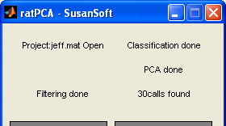
Figure 2. An opened project named ‘jeff’ the project has had filtering, classification and PCA applied. There were also 30 calls found the file selected.

The project can then be worked on by clicking on any of the other buttons on the main screen, however some rely on others e.g. Classify, PCA and Show Calls can’t be pressed without first having run Find Calls. When the project needs to be exited the user should click the Save and Exit button.

Find Calls
The next step in the process is to click the Find Calls button as the other 3 main screens are unavailable until the find call process has been completed. This section is the most important in the program as it takes the raw data supplied, filters it, extracts the calls and then extracts parameters from the calls ready for the program to use for PCA. The main window, shown in Figure 3, is comprised of 3 sections.
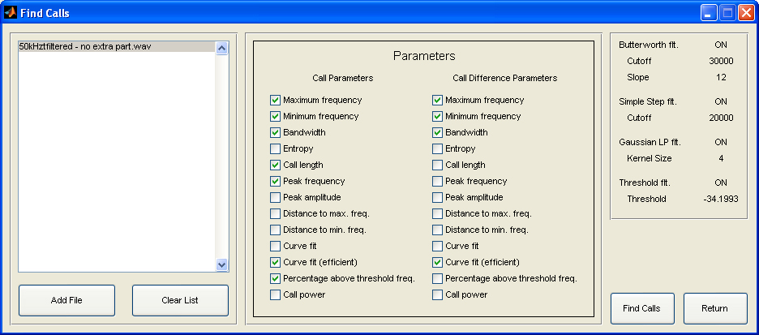
Figure 3. The main find calls screen

The first section on the left of the window enables file selection. Clicking on the Add File button will bring up a dialog box which allows the user to select the *.wav files which contain the USVs to be analysed. The added files will then be displayed in the list box ready to be filtered. The list of files can be cleared using the Clear List button.

The middle section of the window selects which parameters of the USVs the user would like to use in the PCA section of the program. All the parameters are extracted by the program, but only those selected by the user are used in PCA. This means that the parameters can be changed on this screen to change the ones used in PCA without having to go through the extraction process again.

The right hand side of the window displays the options selected to be used by the program during the filtering process. These can be changed in the preferences screen which is discussed in section 8 along with the relevance of each option to the filtering.

With calls added the Find Calls button can be pressed which starts the filtering, call isolation and parameter extraction process. This process can take a while with large files containing lots of call data, e.g. for a file of size 600Mb and 200 calls the process takes about 10 minutes. In order to help the user keep track of the process a progress bar will open, shown in Figure 4A. The first progress bar displays the progress of filtering and call isolation for each file. The second bar shows the overall progress for all of the files selected. The bottom section shows the spectrogram of the call shred currently being filtered.

Once this progress bar is complete a second one will open to display the feature extraction progress, shown in Figure 4B. This displays two bars with the top bar the progress for each file and the second the progress for all the files.

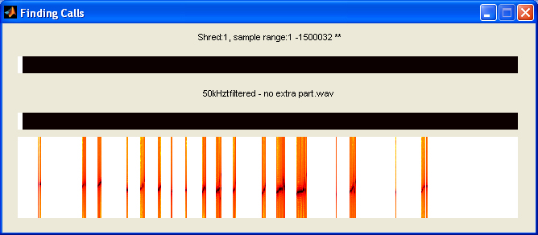
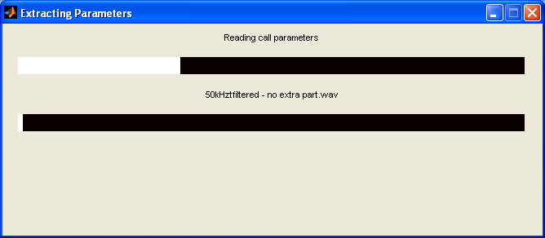
Figure 4. The progress bar for the filtering and call isolation and the progress bar for parameter extraction.

When all the progress bars have closed a pop up box will display for the user that the process is complete and the number of calls found, this is shown in Figure 5. Once this has popped up the user can press the Return button on the main Find Calls window and return to the main program screen, this will save all the data needed for the other sections.

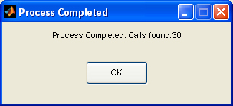
Figure 5. The pop up box indicating the filtering, isolation and parameter extraction is complete. Also displayed is the number of calls found during the process

Classify
With filtering carried out the next step is to classify the calls this can be done by clicking the Classify button on the main screen. Although this is not necessary, as all calls are automatically classified as Other. The advantage of this screen is that it allows the user to pre-classify all the calls according to their own classification parameters which they can use the letters A-H and Other and use this to see if groupings match up in PCA.

The classification screen can be seen in Figure 6. The screen is split up into different sections. The left hand side section contains 2 spectrograms, the top one shows the normal spectrogram of the call being classified along with the parameters maximum, minimum and peak frequencies if the Display Parameter checkbox is checked. Also to the left of this spectrogram is a normalised amplitude profile of the call spectrogram. Underneath this is the log spectrogram of the call which has its values calculated by taking the base 10 logarithm of the normal spectrogram.

Each call can be classified by selecting the corresponding radio button in the Classify Call box. This can be changed at any time although only one classification can be selected.

The File Info box displays information about the current files and project along with the current call. Including the total number of calls found, which call is being classified at the moment, what the call is classified as, which file the call came from and the position in the file that the call starts, in seconds. The box also contains the Display Parameters checkbox which as well as displaying the 3 parameters mentioned above on the normal spectrogram also displays the call length, percentage of call above the f12 threshold (see section 8) and the mean error in the curve fit.

The box in the top right hand corner allows the user to cycle through the calls, going to the next or previous call using the Next and Previous buttons respectively. Particular calls can also be looked at by typing in the call number in the edit box below the Jump to call button then clicking the Jump to call button. The screen will then automatically refresh with the new calls spectrograms and data.

The classification information will then be saved, the window closed and the main program screen displayed when the Done button is pressed.

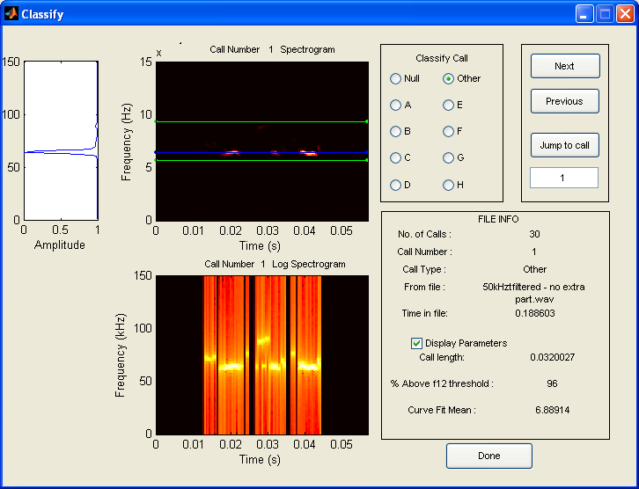
Figure 6. The main classification screen.

PCA
The PCA screen can be accessed after calls have been found, by clicking the PCA button on the main window. This will automatically carry out PCA on the calls found using the parameters selected on the Find Calls screen. Two windows will display when the button has been pressed the first, Figure 7, is the PC plot of the calls, the call number is displayed next to the data point. If the calls have been classified on the Classify screen into the categories A-H and Other, then these will be displayed in different colours as shown in the legend.

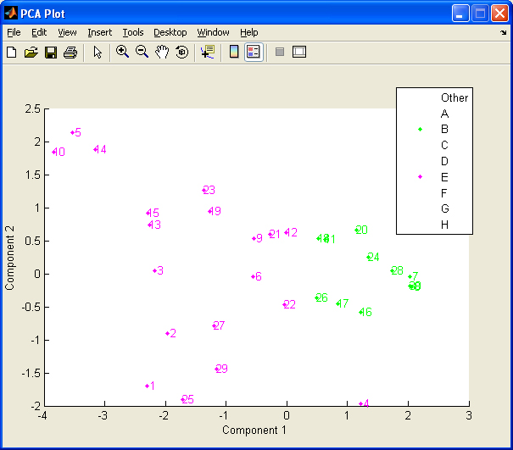
Figure 7. The window displaying the results of PCA

The other window which is brought up is the options window, Figure 8, which allows the user to choose how they would like the PC plot to be displayed. The checkboxes with classification names next to them allows the user to display only those calls checked; by default Null is not selected. A range of calls can also be selected using the two edit boxes. In order to update the PCA window to display the changes made the Go! button must be pressed. The other 2 checkboxes here are Hold Axes which allows the user to keep the same axes when changes are made, otherwise Matlab will only show the axes in ranges where there is data. Show numb… allows the users to remove the call numbers from next to the data points.

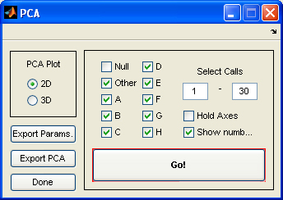
Figure 8. The option window for the PCA window.

The options window also lets the user export the parameters of all of the calls and also the PCA data which has been used in the PC plot. These both bring up dialog boxes which allow the user to save them as a .txt file.

The final box on the options window allows the user to change between a 2D and 3D PC plot using either the first 2 or first 3 principle components respectively. The 3D plot is shown in Figure 9. In order for the user to rotate the 3D plot in order to see the grouping properly the camera tool bar and then the 1st button on it must be selected, this is shown in Figure 9.

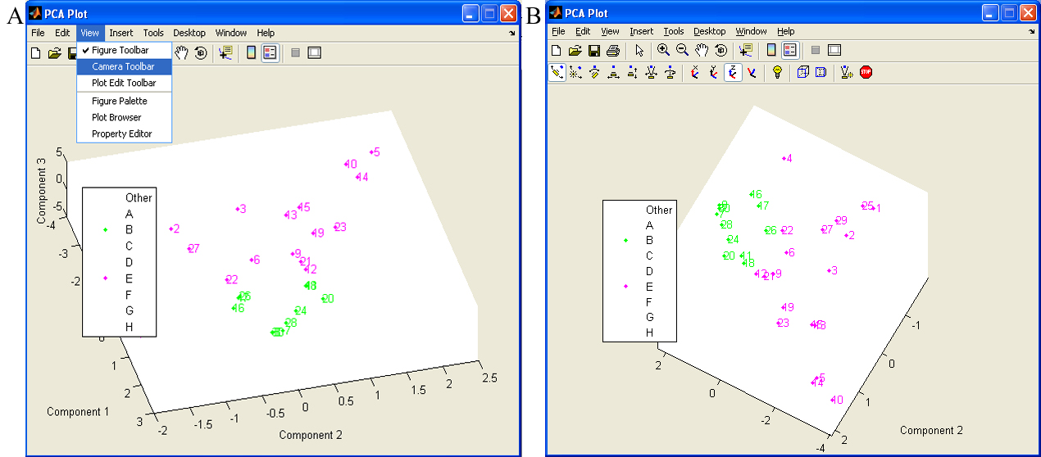
Figure 9. The PCA plot in 3D.
A – in order to rotate the plot the camera toolbar must be selected.
B – the first button on the toolbar should then be pressed to allow rotation.

Show Calls
The Show Calls button on the main screen is there to allow the user to quickly glance through all the calls spectrograms to check for any calls of interest. Clicking on the button brings up a window similar to that shown in Figure 10. This window displays up to 16 calls per window, if more than 16 calls have been found then there will be multiple pages of calls which can be cycled through using the Next Page and Previous Page buttons. The page number and total number of pages are displayed below these buttons.

Each spectrogram is titled with the call number and how it has been classified in the Classify section. The user can choose which classifications of calls to be displayed in show calls by selected them on the Preference screen as described in section 8. The types of calls selected to be shown are displayed on the right hand side of the screen.

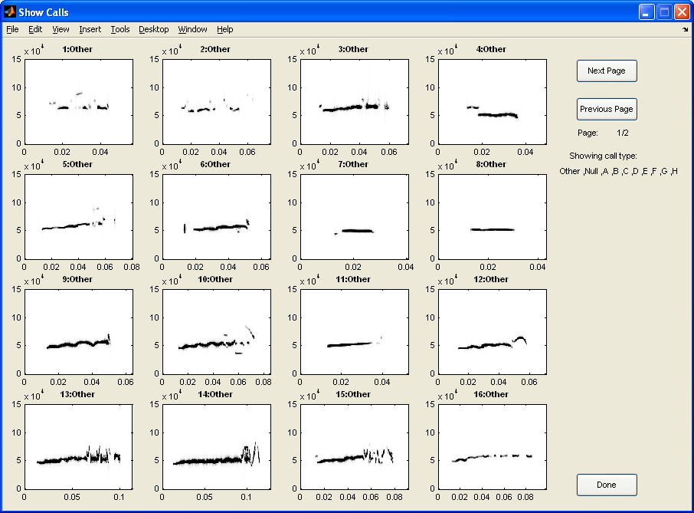
Figure 10. The show calls screen with all the call types displayed.

The screen can also be used to produce pictures of the calls if the user would like to keep a record of all the calls found and what their spectrograms look like. One caveat for this is that the user should not save the image as a Matlab fig as this can cause the program to stop working.

Markers
One of the two screens available before Find Calls has been carried out is Markers. This can be accessed by pressing the Markers button on the main screen. This will bring up the window shown in Figure 11. The purpose of this screen is to allow the user to select a set of marker calls which exemplify the type of call for each classification. These can then be shown on the PCA screen if the Use checkbox is checked, all can be selected or unselected by clicking the Use All Markers and Use No Markers buttons respectively.

For each classification of call A-H there is a New button which opens a dialog box for the user to chose a .wav file containing the marker call. This will then be loaded into the program and its spectrogram displayed. The parameters for each marker can be displayed on the spectrograms by checking the Show Parameters checkbox. The markers will then be saved and the screen exited by pressing Done.

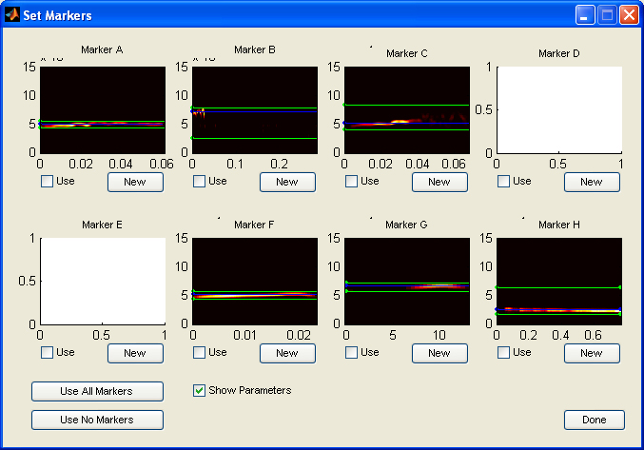
Figure 11. The marker screen showing the spectrograms and parameters of markers selected for a particular call type.

Preferences
The second of the screens accessible to any open project is Preferences, this is shown in Figure 12, and this can be brought up by clicking on the Preferences button on the main program window. The preference screen is there to allow the user to customise a number of aspects of the program as mentioned in previous sections.

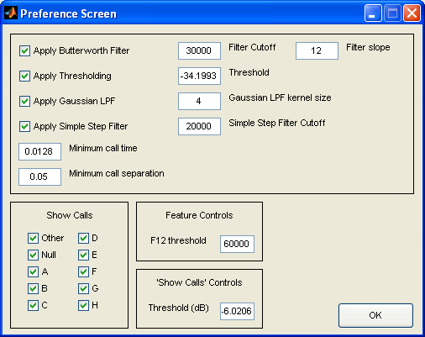
Figure 12. The preference screen.

The top section of the screen relates to the filtering of the waveforms and isolation of the calls. It allows you to set whether or not to apply the Butterworth filter, the dB level thresholding, the Gaussian Low Pass Filter or the simple step filter and the settings for each. The Butterworth filter cut-off should be changed depending on the calls being looked at, suggested settings are 30000 Hz for 50 kHz calls and 20000 Hz for 22 kHz calls. The filter slope is the order of the filter changing its response. The threshold level is the level in dB at which data below this is removed as being too quiet. The dB range of the program has 0 dB as its maximum with more negative numbers being quieter. The Gaussian low pass filter size is used in noise removal when filtered. The standard 4 pixel filter accounts for noise ‘specks’ of size 1.7 ms and 4.7 kHz. The simple step filter cut-off is the frequency in Hz below which data is removed, as it is not classified as a USV. The minimum call time and separation are the times which are used to isolate the calls and are both in seconds.

The Show Calls section allows the user to select which call types they would like to be displayed on the show calls screen, as explained in section 6. The ‘Show Calls’ Controls Threshold sets the threshold level for the spectrograms displayed in the Show Calls section enabling the user to change the display level of these spectrograms if calls are particularly quiet or loud.

Feature Controls includes the option to change the f12 threshold for the call parameter ‘percentage above f12 frequency’. The f12 threshold is the frequency at which is used to calculate the percentage of the call above it. The frequency is in Hz and can be changed by typing a new value in the edit box.

To save all of the changes to these settings, and close the window, the OK button should be pressed.

Program Flow

In order to give a basic overview of how the program works hierarchically a flow diagram is provided in Figure 13. The circle-crosses represent paths that require more two things to be completed before another part of the program can run.

Figure 13. Diagram summarising the flow of the program.

10. Notes
The following are a few notes as to how the program will react to certain inputs:

When leaving a particular window always do so by pressed the Return, Done or OK buttons as this ensures that the main window will reopen. With out this the program will shut down prematurely and data and results may be lost.

