LOLA Project – RLO brief.
Leanne Williams

Prokaryotic and Eukaryotic cells.
RLO 1

Learning Outcome

After working through this RLO you will understand the difference between prokaryotic and eukaryotic cells

Section 1:

Introduction

Every living thing is made up of cells, these are the smallest basic unit of all living organisms, from simple single celled organisms like bacteria and Amoeba; to complex, multicellular organisms like us. Our bodies are made up of around 50 million million cells!

Animation or still pictures of different organisms; bacteria, protocists, fungi, plants and animals

The invention of the light microscope was a massive break through in providing the evidence that all living things are made of cells.

Man looking down a simple microscope looking surprised/happy ?


Organisms can be divided into two categories; Prokaryotes and Eukaryotes depending on characteristics of the cell or cells they are made of. Prokaryotes are composed of prokaryotic cells and eukaryotes are composed of eukaryotic cells.

Section 2:

Prokaryotes

Prokaryotic literally means ‘before the nut or kernel’ referring to the nucleus of the cell. The genetic material is circular, it is neither organised nor contained within a specialised membrane. Bacteria are Prokaryotes and range in size from 0.2 – 2.0 µm.

Image of bacteria with flagella and nucleoid, can be moving around (?)
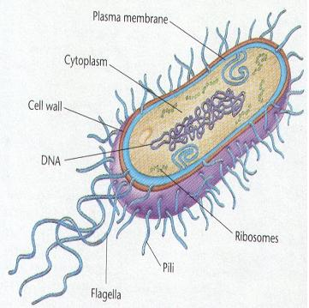

Whilst prokaryotic cells are smaller and less complex than Eukaryotic cells, there is no doubt that the success of prokaryotes has far surpassed any other living organisms that have since colonised the earth. In fact there are probably more bacteria on your skin than the entire human population of the planet!

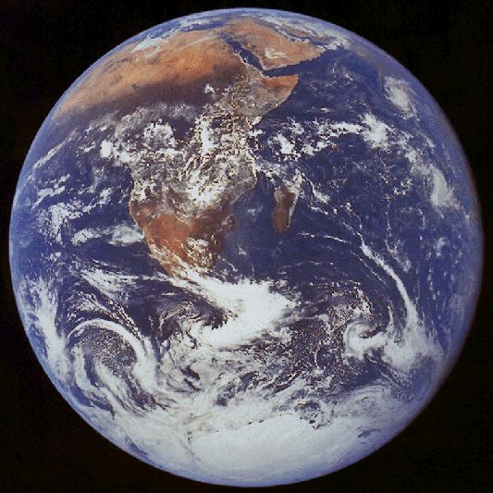

Section 3:

Examples of prokaryotes

There are many types of bacteria; some are directly beneficial to us as they help our digestive systems to function effectively (1), some play fundamental roles in global ecosystems such as decomposition and nutrient recycling. (2)

But some can be very harmful and cause disease, these are termed pathogenic bacteria, such as; Bacillus anthracis = Anthrax, Vibrio cholorae = Cholera and Mycobacterium tuberculosis = Tuberculosis

(1) Lactobacillus or someone eating a burger? Or image of digestive tract.
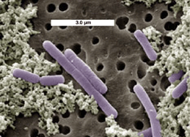

(2) Decomposed cow !
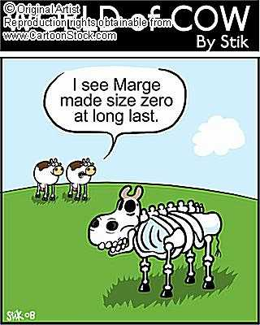

(3) Vibrio Cholorae
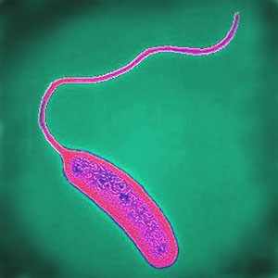

Section 4:

Eukaryotes

Eukaryotic means possessing ‘a true nut or kernel’. Here the genetic material is packaged into chromosomes and is enclosed by a specialised membrane, the resulting structure is called the Nucleus. Eukaryotic cells are much bigger; 10 – 100 µm and demonstrate a much more diverse and complex internal organisation than prokaryotic cells. Animals, Plants, Fungi and Protocists are all constructed of eukaryotic cells, ranging from single to multicellular organisms.

Section 5:

Examples of eukaryotes

An amoeba is a water and soil dwelling unicellular Protozoan.
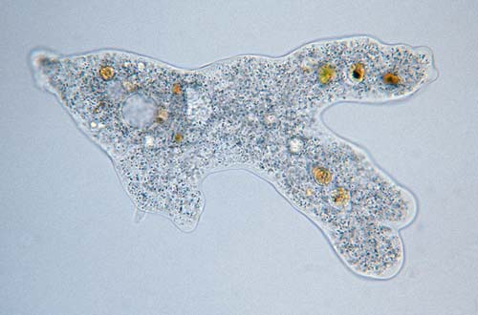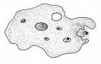

Fungi include your typical mushrooms but also include the likes of Tinea pedis which causes Athletes foot.
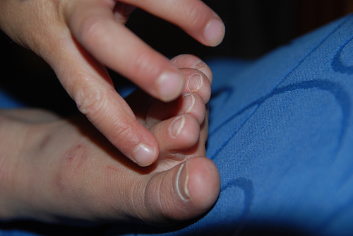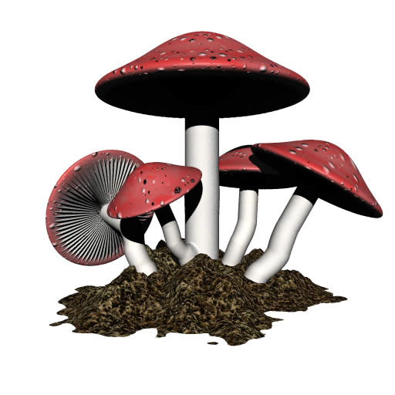

Plants range from single celled algae and the most delicate of flowers, to giant trees thousands of years old.
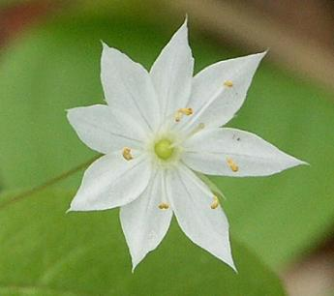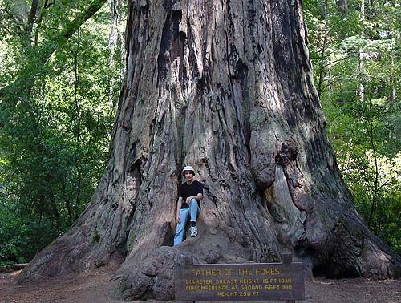

The diversity of animals include; insects, fish, amphibians, reptiles, birds and mammals.

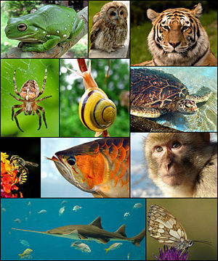

Activity 1

This activity will determine your understanding of how these two cell types differ.

Read the statements below decide which cell type they belong to, then drag and drop into the relevant column.

Prokaryotic cell | Eukaryotic cell
Surrounded by a cell membrane | Surrounded by a cell membrane
Genetic material is circular | Genetic material packaged into chromosomes
Genetic material is not bound by a specialised membrane | Genetic material enclosed by a specialised membrane
Little internal organisation | Complex internal organisation
Only unicellular | Make up unicellular and multicellular organisms.
Prokaryote | Eukaryotes
Bacteria | Animals
 | Plants
 | Fungi
 | Protoctists

I have put the correct statements in red straight into the table; they can simply be listed in a random order above or below the table.

Useful links

Sizes and scales in Biology RLO

www.cellsalive.com

http://en.wikipedia.org/wiki/Image:Relative_scale.svg

