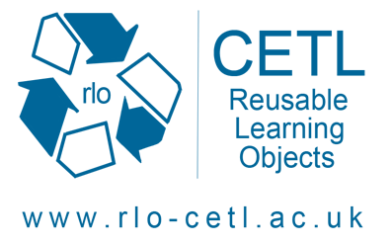
Shoulder Project
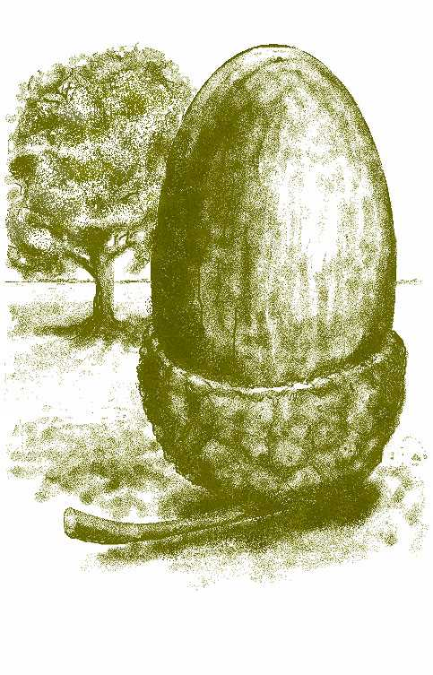

Supporting health occupations’ understanding of learning/intellectual disabilities, electronic resources

Dr Richard Windle
RLO-CETL
University of Nottingham
School of Nursing
Queens Medical Centre
Nottingham
NG7 2UH

0115 82 30866
Richard.windle@nottingham.ac.uk

Dear Student

I gives me great pleasure to invite you to participate in the e-learning workshop entitled “Shoulder – Supporting health occupations’ understanding of Learning/Intellectual Disabilities, Electronic Resources” on the 3rd April 2008 at Edgehill University, Ormskirk.

Please find attached some information that will help you to prepare for the workshop. You will also be given a more comprehensive information pack on the day that will provide details of the activities you will be undertaking as well as related information.

If you have any questions, please don’t hesitate to contact me using the details above.

I look forward to meeting you on the 3rd April.

Best wishes

Richard Windle

Shoulder Project

Supporting health occupations’ understanding of learning/intellectual disabilities, electronic resources

Aims

The aim of the workshop is to explore how students’ knowledge of the experiences of individuals with learning/intellectual disabilities can be developed into e-learning resources in the form of reusable learning objects to inform and challenge other health care professional students.

Who will be attending?

The workshop will be attended by approximately 35 learning/intellectual disabilities branch nursing students from across England, Wales, Northern Ireland and the Republic of Ireland.

The workshop will be facilitated by members of the Centre for Excellence in Teaching and Learning for Reusable Learning Objects (RLO-CETL) together with tutors from some of the institutions represented.

What will we doing?

The initial part of the workshop will allow us to explore the characteristics of reusable learning objects, their strengths and limitations and look at some current examples. For the majority of the day you will working in small groups to develop outlines for potential learning objects on the themes outlined above.

Examples of previous RLO development workshops run by the RLO-CETL can be found at the following website. http://www.nottingham.ac.uk/nursing/sonet/rlos/rlolist.php

These photos will give you an idea of the activities you will be engaged during the day.

Do I need any technical computer knowledge?

No technical knowledge or expertise is necessary. The workshop is about capturing your knowledge and experience and creating storyboards using A0 size posters. Media developers will be on hand to provide technical input if required.

Do I need to prepare anything before the workshop?

You don’t need to prepare anything before the workshop, but it will be helpful if you can find time to think about the sorts of issues you would like to cover in the e-learning resources. We will be seeking your ideas at the beginning of the workshop and forming groups around these ideas.

You don’t need to bring anything to the workshop, but if you have any materials that would help to support or illustrate you ideas it would be helpful to bring these along. Similarly, bring a list of any web-links that you think will be useful to your ideas. Internet linked computers will be available during the workshop day.

Reusable Learning Objects (RLOs) are small, interactive chunks of e-learning based around a single learning goal and usually representing about 15 minutes worth of learning. Don’t worry if you are not familiar with this concept as we will spend some time exploring them at the beginning of the workshop. However, it might be helpful to view some examples prior to the workshop. You can find a number of examples by going to the following link.

http://www.nottingham.ac.uk/nursing/sonet/rlos/

Location and Itinerary

The workshop will take place …Thursday April 3rd 2008……at Edge Hill University. You will be supplied with a campus map and room location nearer the date.

www.pontins.com/centres/southport/index.php

Travel to and from the accommodation is your responsibility……

You should arrive at the University for 9.30am on the Thursday.

The workshop will run until …4.00pm…

Lunch and refreshments will be served during the workshop.

Travel bursaries and accommodation costs

We are able to offer you a £50 travel bursary towards your travel costs for participation in the workshop This will be available after the workshop.

We are also able to pay for one nights accommodation as outlined below. This can either be used for the Wednesday or Thursday night. If you are planning to stay for both nights to attend the main conference day, you will be responsible for the costs of the remaining night.

Accommodation

Accommodation will be available as booked with Helen Laverty at Pontins.

After the workshop

The main output of the workshop will be a series of posters that outline or storyboard potential RLOs. These will be presented at the main conference on the 4th April. All conference attendees will have the opportunity to comment and feedback on the storyboards. Following this feedback a working group will identify which of the storyboard will be fully developed.

Workshop attendees will have the opportunity to participate in the ongoing development of the RLOs through a development workshop and discussion forum. Those contributing to developed RLOs will be fully credited on the final products.

Completed RLOs will be made available to all relevant courses within the UK and Eire. Their use will be fully evaluated within the institutions participating to the workshop.

Research

The workshop will be supported by a research project that focuses on the drivers, barriers, strengths and weaknesses of student-generated learning content, together with the perceptions of these materials by tutors and students.

For you, should you agree to participate, this will involve completion of/participation in a couple of questionnaires or focus groups during the development process.

You will be given more information about this, together with a consent form at the start of the workshop. You are under no obligation whatsoever to participate and your decision will in no way affect your involvement in the project.

Photographs

We generally take photographs during our workshops as a visual record of the process being undertaken. These will be placed on the project website and some may be used in articles used to publicise and disseminate the project. If you do not wish your photograph to be taken or used, please make us aware of this at the start of the workshop.

