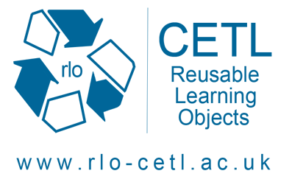
Shoulder Project
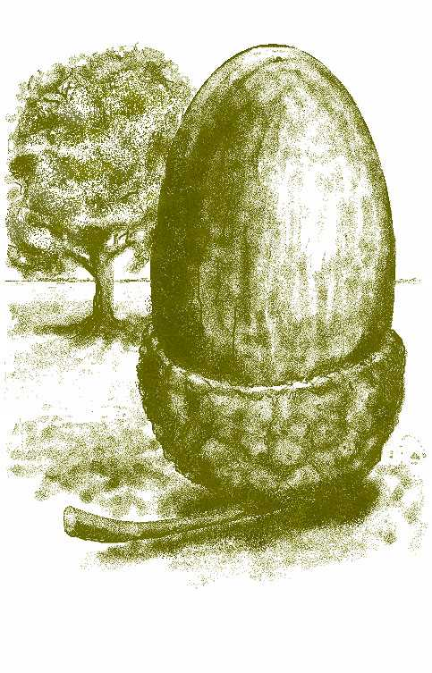

Supporting health occupations’ understanding of learning/intellectual disabilities, electronic resources

RLO development workshop
Thursday 3 April 2008-03-12
Edgehill University, Ormskirk

Timetable

09.30  10.00  10.20  10.50  11.10  11.40  12.20  12.30  13.30  15.00  15.15  15.45  16.00 | Tea, coffee, registration & questionnaire  Welcome, introduction to the project  What are Learning objects? Attributes and examples.  Choices. What will our RLOs cover?  Tasks and group assignment  Group task  Regroup  LUNCH  Continue with group work (on laminated A0 storyboards) in groups facilitated by roving presenters  COFFEE  Groups present storyboards  Next steps  DEPART

Presentation team
Richard Windle, Senior Lecturer in e-learning and RLO-CETL Local Academic Coordinator in the School of Nursing at the University of Nottingham
Heather Wharrad, Reader in Education and Health Informatics and Director of E-learning in the School of Nursing at the University of Nottingham
Mike Taylor, Developer at the School of Nursing at the University of Nottingham
Helen Laverty, Lecturer in Learning Disabilities Nursing at the School of Nursing at the University of Nottingham

Tutors from the participating institutions will help to facilitate group work

