**PEARLS Study**

**Proactive against reactive therapy for the prevention of lichen sclerosus exacerbation and progression of disease – a pragmatic, parallel group randomised controlled trial with embedded economic evaluation and process evaluation**

**IRAS: 1008267,** **version number 2.0, date 05-Feb-2024**

**Information Sheet for Children Aged 5-7 Years**

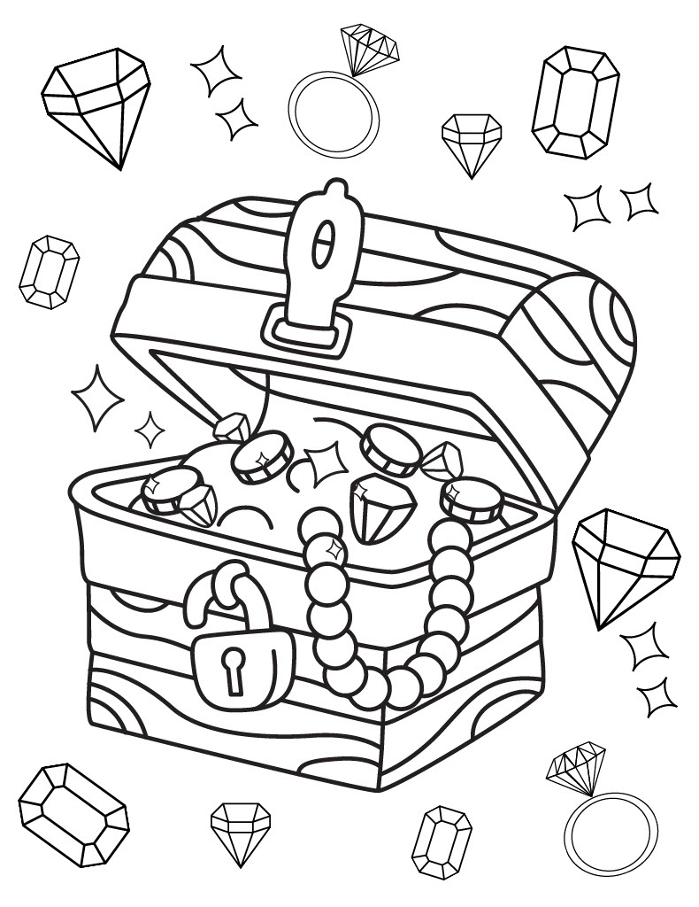

**Can you help me collect all the pearls of wisdom in this booklet? How many pearls can you find?**



|  |  |
| --- | --- |
| **Hello! We are seeing if you want to take part in our Research Study called PEARLS.**      **What is a Research Study?** | |
| A research study is what you do when you want to learn about something or find out something new! | |
| **What is this Research Study looking at?** | |
| We are doing the PEARLS study to find out which is the best way to use your steroid cream to treat the skin condition that you have. We will be asking 400 children and grown-ups to help us with our study.  We do not know whether people should use the cream all the time, or just when it is itchy and sore, so we are doing a research study to find out.! | |
| **What do I have to do if I take part?** | |
| If you wish to participate we will ask you to apply your steroid cream and collect information from you and your grown-ups to see if your skin gets better. We may ask you to apply your cream twice a week or only when you need it. We will then collect information if the chosen treatment helped you with your itchy, or sore, skin. | |
| **Do I have to say yes?** | |
| No – not at all. It’s up to you! Just say if you don’t want to join in. Nobody will mind! | |
| **Who can I ask about it?** | |
| Your grown-ups have been given lots of information but if you have any more questions, just ask them to call us! | |
| **Will the study upset or hurt me?** | |
| Sometimes the cream may make your skin sting. Tell the grown-ups about it. You should not have any other problems, but if you do, tell the grown-ups.  As part of the study, you will also have to visit a couple more times than you might normally visit. We will also need to look at your itchy or sore skin to make sure the treatment is helping you during the study. As part of this we will also check with yourself and your grown-up if it is ok to take pictures.  Don’t forget, this study will not change how you are taken care by your doctors or nurses!  We hope that the information we get from this study will help other children who have the same skin condition in the future. | |
|   **Please ask any questions if you need to!** | |

