**PEARLS Study**

**IRAS: 1008267, version number 1.0, date 08-Dec-2023**

**Participant Information Sheet for Children Aged 8-11 Years**

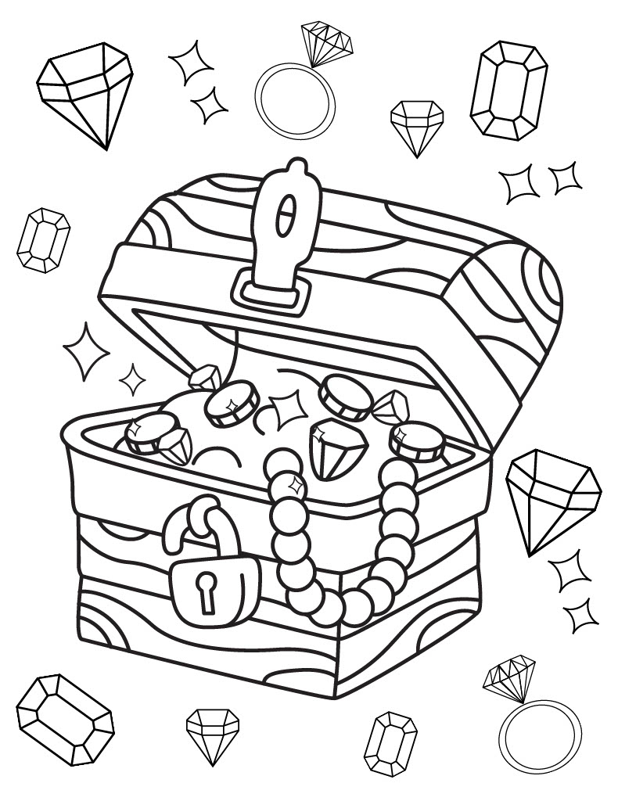

|  |  |
| --- | --- |
| **Hello! We are seeing if you want to take part in our Research Study called PEARLS.**  **What is a Research Study?** | |
| A research study is what you do when you want to learn about something or find out something new. We are researchers at the University of Nottingham, and we would like to invite you to take part in our study called PEARLS. | |
| **What is this Research Study looking at?** | |
| We are running the PEARLS study to find out whether it is better for patients with lichen sclerosus, an itchy or sore skin condition in the vulval area (private parts), to use treatment, such as steroid creams and ointments, regularly or only when needed. We hope that what we learn from this study will help other children, who have the same skin condition, in future.  We are asking if you would like to join this study as you have the type of itchy or sore skin condition that we are interested in.  In this study 400 people with this itchy or sore skin condition will be helping us. Some of them will be children or young people, like you, but adults with this skin condition can also take part. If you do want to take part, you will be asked to either use regular treatment or only use treatment when you have the itching. We won’t know which we’ll ask you to do until you join the study, as we will use a special computer programme to decide if you should use your treatment regularly, or only when you have symptoms. Once you’re in the study you should only use your steroid cream or ointment the same way until the study ends. Your care team will see how you get on over the next two years and report details back to the study team at Nottingham. | |
| **What will happen to me if I take part?** | |
| We will discuss any questions you or your grown-ups have with you. If you and your grown-ups are happy, we will ask you to apply your steroid ointment or cream and collect information to see if your skin gets better.  A doctor will also examine you and, if you and your grown-ups are happy for us to do so, we will take some pictures. This is to help us track your progress within the study.  Will we also ask you and your grown up to attend further hospital visits at 3, 6, 12, 18, and 24 months to allow us to follow your progress.   |  | | --- | | We will make sure that the research is being done properly. For this reason, we will keep your name, contact details and other information about you. All information about you will be kept safe and secure. People who do not need to know who you are will not be able to see your name or contact details. | | Do I have to say yes? | | No – not at all. It’s up to you!  Just say if you don’t want to join in. Nobody will mind! | | Who can I ask about it? | | Your parents, or grown-ups have been given lots of information but if you have any more questions, just ask them to call us! | | Will the study upset or hurt me? |   Sometimes, the cream may sting or be sore. If this happens to you, talk to the grown-ups, who helped told you about this study. You should not have any other problems, but if you do, make sure the grown-ups know about it. Don’t forget, this study will not change how you are taken care of by your doctors or nurses! | |
| **Thank you very much for reading this!**  **Please ask any questions if you need to!**  **Your local team can be contacted on the details below:**  **>Insert site contact details<** | |