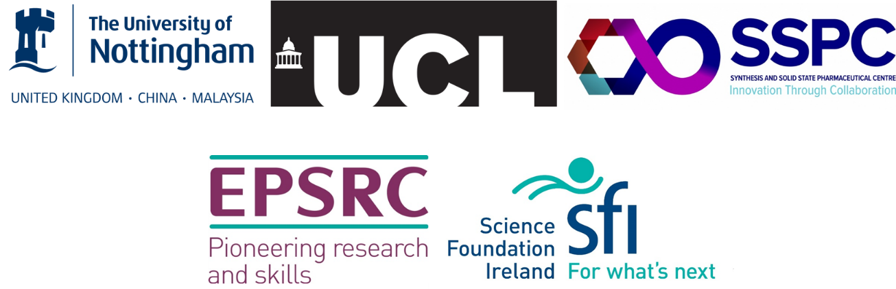

15 fully-funded 4-year PhD studentships in the EPSRC Centre for Doctoral Training in Transformative Pharmaceutical Technologies

Funded by the Engineering and Physical Sciences Council, Science Foundation Ireland and 19 industry partners, the EPSRC Centre for Doctoral Training (CDT) in Transformative Pharmaceutical Technologies provides world-leading training to prepare strategic-thinking scientists for high achieving careers in the pharmaceutical and healthcare sectors.

The Schools of Pharmacy at the University of Nottingham and University College London (UCL) are each offering six fully-funded studentships, commencing in September 2019. Aligned with these, the Synthesis and Solid State Pharmaceutical Centre (SSPC), Ireland, is recruiting for three fully funded studentships to commence in September 2019.

Websites:
https://www.nottingham.ac.uk/pharmacy/
https://www.ucl.ac.uk/pharmacy/
https://www.sspc.ie/

Why study with us?
- Fully-funded PhD studentships at leading UK and Republic of Ireland universities
- Extensive number of PhD projects in a wide range of research disciplines
- Joining a network of alumni in industry and academia
- Working in a unique open innovation environment between academia and leading pharmaceutical and healthcare industry partners.

What do we offer?
Doctoral level training in a unique multidisciplinary environment at the interfaces between chemical, engineering, computational, pharmaceutical and biomedical sciences. A comprehensive scientific and soft-skills training curriculum involves students undertaking 12-week training projects at both academic and industry sites before commencing their PhD research. The SSPC students also undertake a structured four-year doctoral programme,.

In addition, students participate in innovation and entrepreneurship activities, conference and colloquia events, team working and problem solving, and outreach activities, all with very close industry involvement. Our integrated university - industry partnership allows our students unrivalled access to the healthcare, pharmaceutical and clinical research expertise of our academics and industrial partners.

Who should apply?
Applicants should be interested in undertaking a highly multidisciplinary 4-year research training programme. Candidates should have, or expect to obtain, a first or upper second class degree, or non-UK equivalent, in pharmacy, chemistry, engineering, physics, biology, mathematics or related sciences or a relevant masters qualification.

Applications to the University of Nottingham and UCL are invited from UK and EU citizens who have been ordinarily resident in the UK for the 3 years immediately preceding the start of the programme. Please see our website for full details. SSPC studentships are open to UK and EU students and provide a stipend and full fees.

Funding
Studentships cover tuition fees and a tax free stipend for the duration of the four-year programme.

How to apply
For further information, or to apply, please contact:

Dr Claudia Matz (Claudia.Matz@nottingham.ac.uk) for the University of Nottingham

Ms Sarah Marks (s.marks.pharm@ucl.ac.uk) for UCL

Prof Anne Marie Healy (healyam@tcd.ie) for SSPC

Applications should comprise a single PDF file containing a CV (2 pages max) and a covering letter. Please review the full details on our website for full details before applying.

Application deadline: We will continue to accept applications until all places are filled. We will initially consider all applications received by 28 February 2019 for shortlisting and interview.

