Teacher Pack Activity 2 - Stick or Slide
Cover page
Learning outcomes
This activity demonstrates how difficult it can be to remove bacterial biofilms off surfaces. It is expected that the students will have a better understanding of:

1) What is a biofilm
2) Why it is more difficult to treat an infection once bacteria have formed a biofilm compared to single-cell bacteria

Link to curriculum
Fits into GCSE curriculum
GCSE ‘communicable diseases’ -
explain how communicable diseases (caused by viruses, bacteria, protists and fungi) are spread in animals and plants

- Scientific attitudes
- Discussion about clinically relevant problems in today’s medicine. Specifically, how biofilm formation can cause treatment issues in hospitals
- Experimental skills and investigations/Analysis and evaluation
- By using this as a practical experiment students can observe how easy it is to treat single cell bacteria compared to a fully formed bacterial biofilm. This can be translated into the issues observed in the healthcare industry.

Equipment needed
You will need:
- Hair gel (biofilm)
- Metal ball bearings or rice (bacteria)
- Paper or metal straws/Small water guns
- 2 Sections of tubing (eg. Soft drinks bottle)

Risk assessment
Provided within this teacher pack is also a detailed risk assessment of the activity highlighting any potential risks and hazards that could be associated to the activity. Please note this is an example only and any risk assessments should be independently assessed and reviewed.

Instructions for Teacher - Stick or Slide
Introduction Go through power point presentation on spread of disease and introduction to biofilms http://bit.do/superbiomaterials
The experiment
Option A Students working in pairs
Explain the students will be working in pairs.
Assign one student to each set of equipment –each student should have:
- A section of tubing (eg. Soft drinks bottle)
- A stacker box to prevent spillages
- Metal ball bearings or a handful or rice
- Small water gun/ biodegradable or metal straws

Additionally, one student should have some hair gel and the other should not.

- The student with hair gel will cover the base of their tubing with a layer of hair gel.
- Each student will then place metal ball bearings or rice into their tubing. It should be explained while doing this the difference between single-cell bacteria (the metal ball bearings/rice) and the biofilm (metal ball bearings/rice within the hair gel).
- At the same time, the students will use their water guns or blow down the straws to try and remove as many bacteria from their tubes as possible within an allocated time (suggested 1 minute).
- After the time has finished, they should see how many bacteria have been removed and compare this to the other student in the pair.
- They should then swap over and repeat the experiment.

Option B Class working together lead by teacher

As above but with student volunteers to try and remove the ball bearings/rice using the water pistols/ straws on the tubing with or without hair gel applied.

Discussion points

Students to answer questions at the end of their instructions followed by feeding back their results to the class.

Ask the class to think of locations where biofilms could present a problem (eg. Medical devices (such as catheters/any tubes inside the body), Forming on ships hulls, teeth, any areas where you need to keep an area sterile.

As a written activity or class discussion ask the students to answer the following questions:

- Which tubing was more difficult to clean with the water, and why was this?
- What methods could we try to prevent biofilm forming on surfaces? Antibiotics (but this raises the question of antimicrobial resistance), changing the surface to a non-stick surface)
- How could biofilms be problematic in hospitals? (Difficult to treat due to resistance to antibiotics and common cause of healthcare infections)

Instructions for students
Stick or Slide
Learning objectives
After this lesson you will have a better understanding of what is a bacterial biofilm, how they form and how difficult they can be to remove off of surfaces. You will cover:

- What is a biofilm made from
- Why a biofilm is much more difficult to remove compared to single-cell bacteria
- The link between biofilms and antibiotic resistance

You will need:
Hair gel (biofilm)
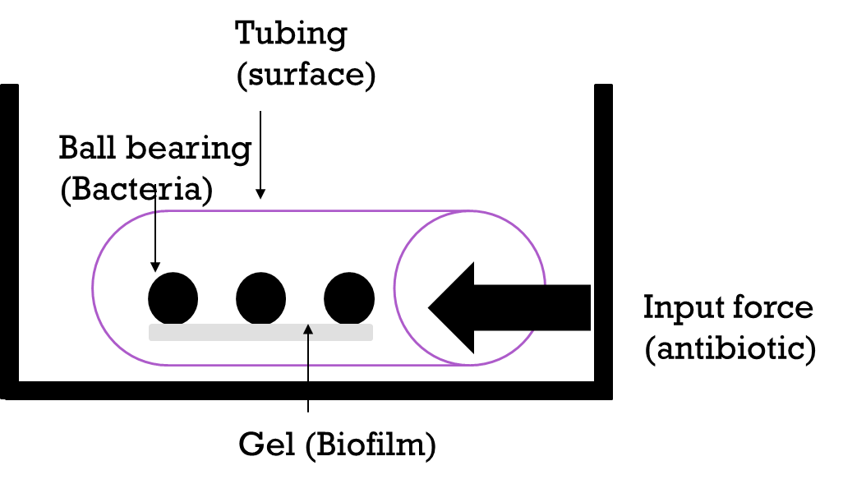
Metal ball bearings or rice (bacteria)
Small water guns or straws
2 Sections of tubing
Stacker Box

The Experiment
You will work in pairs, one for each tubing. You will work inside the provided box at all times to prevent spillage.
- One student will place ball bearings/rice onto their tubing to act as single-cell bacteria on the surface of a medical device.
- The second student will place hair gel onto the surface of their tubing along with the same metal bearings/rice. This will act as bacteria formed within a bacterial biofilm.
- If using water guns, each student will then fill up their water gun with water and place their tubing into a large plastic container (such as a stacker box) to avoid unnecessary spillages/mess.
- After a countdown each student will then use the water gun or blow down the straws to try and remove their bacteria/biofilm from the surface of the tubing (within a time limit of 1 minute).
- After the minute the students will compare the two sets of tubing to see which tubing has removed the most bacteria.
- The students will then swap over and repeat the experiment to see if they get the same result as the first time.

Please answer questions on the following page

You will then discuss in pairs and write answers to the following questions:

- Which tubing was more difficult to clean with the water/air, and why was this?

- What methods could we try to prevent biofilm forming on surfaces?

- How could biofilms be problematic in hospitals?

- Can you think of any other biofilms that you come across in daily life?

- How do biofilms contribute to antibiotic resistant bacteria?

