This is the title of the contribution which should be bold, Calibri, size 12 font.
You may use up to two lines for the title.
Firstname M. Surname1¹, Firstname M. Surname², Firstname M. Surname^{2,3}
¹Institution1, Address1
²Institution2, Address2
³Institution3, Address3

Introduction: This is the main text of your abstract which should use Calibri 11 font apart from the title. Indicate your references in the text as shown here [1]. This is another citation [2]. We recommend including the following sections, although we also note that there are often good reasons to deviate from this format: Introduction, Methods, Results, Discussion, Conclusions, Acknowledgements (optional), References. Please do not exceed 2 pages in length. Please keep the page margins and fonts the same as this template.
Methods: Describe the methods in this section. Describe the methods in this section. Describe the methods in this section. Describe the methods in this section. Describe the methods in this section. Describe the methods in this section. Describe the methods in this section.
Results: Describe the results in this section. Describe the results in this section. Describe the results in this section. Describe the results in this section. Describe the results in this section. Up to 5 figures or tables can be included but they must fit within the 2 page limit. They should be numbered with Arabic numbers (e.g., Fig. 1).
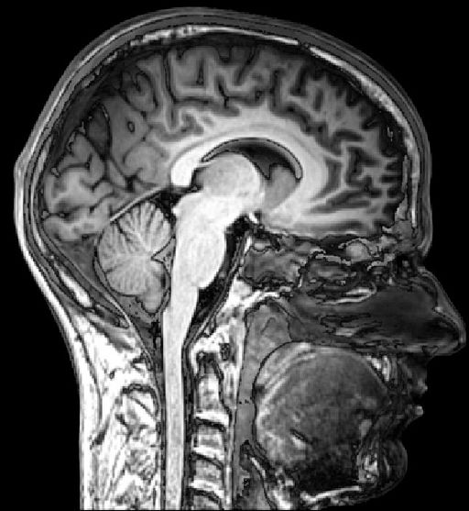
Fig. 1. Figure caption. (Maximum 500 characters per Figure or Table)

Discussion: The discussion section goes here. The discussion section goes here. The discussion section goes here. The discussion section goes here. The discussion section goes here. The discussion section goes here. The discussion section goes here. The discussion section goes here.
Conclusions: The main conclusions are described here. The main conclusions are described here. The main conclusions are described here. The main conclusions are described here. The main conclusions are described here. The main conclusions are described here. The main conclusions are described here. The main conclusions are described here. The main conclusions are described here.
Acknowledgements: (optional) Acknowledgements, if any, go here.
References
[1] E. M. Purcell, R. V. Pound, and N. Bloembergen Phys. Rev. 70, 986-987 (1946). (Calibri, 10)
[2] A. Abragam, The Principles of Nuclear Magnetism, Oxford University Press, New York, 1961.

