Using LIFT
for Dreamweaver

(A tool for identifying accessibility issues
in your web pages)

This guide introduces using LIFT for Dreamweaver on an example web site. The example site is full of typical errors that occur when you are using Dreamweaver to build a web site, or when you aren’t aware of the additional HTML coding that is required to ensure web site accessibility.

By following the exercises in the guide, you will have:
- located the bad example site and to copied its pages to you own computer;
- run the LIFT evaluation tool on the sample pages;
- interpreted the evaluation results;
- made the required changes to the page to improve accessibility by following the guidance in this document and in IS4004 – Accessibility and the Web;
- compared your changes with those available on the “better example” site;
- re-run LIFT to re-evaluate your improved page.

Finding a page to evaluate

- Open Internet Explorer and navigate to http://www.nottingham.ac.uk/~brzdw01/accessibility/bad/
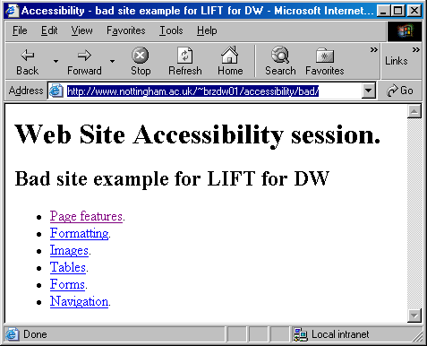
- Click on the first example in the list – Page Features.
This page includes issues that you will probably need to address on every page of your web site, especially if you have built the site using Dreamweaver.
- Save the file to your desktop.
- Open Dreamweaver, and open the file in Dreamweaver:

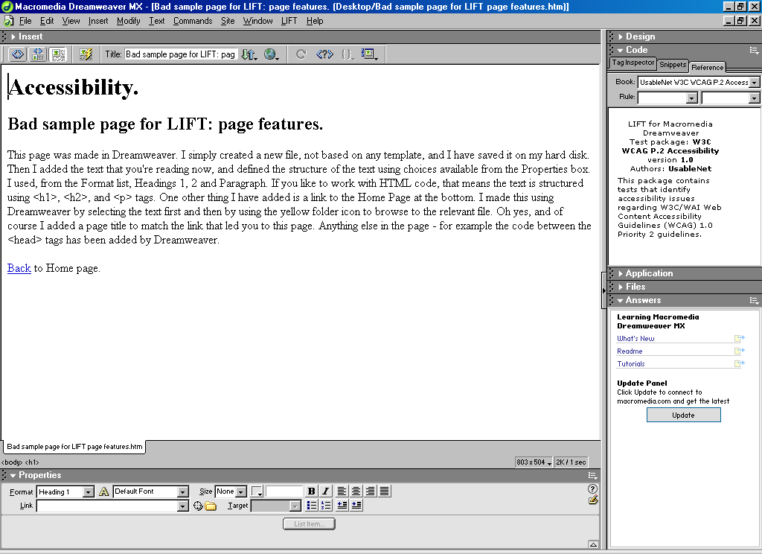

Running the LIFT evaluation tool on the page
- Make sure the Reference Panel is open (Window, Reference).
- From the LIFT menu, choose Evaluate…
- First select the Scope of the evaluation in the Page(s) drop down list - Click the Page(s): drop down list and choose Current document.
- Check that you are using the right Guidelines (W3C/WCAG 1.0) – Click the Guidelines: drop down list and choose W3C/WCAG 1.0
This is the first version of the W3C’s Web Content Accessibility Guidelines. Other options are more suited to complying with US law
- Click on Run.

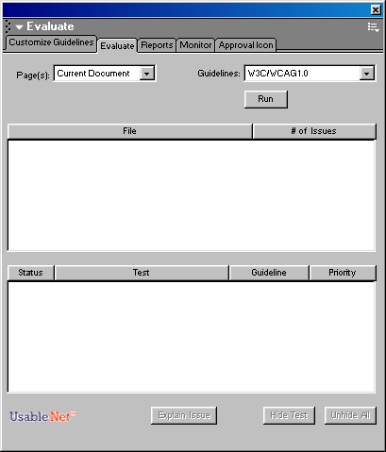
The results of the evaluation are listed underneath – there will be a number of issues to address.

Interpreting the results
The Results area includes 4 columns:

Status
Note how some issues are preceded by an X and others by a ?. Those preceded by an X are issues on which your page has failed – there are identifiable coding errors that you need to address. Those preceded by a ? indicate possible problems that you need to make a judgement about and make changes if necessary. These are not issues that can be “measured” in your code by any automated tool such as LIFT.
Test
The name of the test that has been applied and from which there is an issue for you to address
Guidelines
The number of the W3C WCAG guideline checkpoint that the test relates to.
Priority
What level priority the issue has (1 or 2) and therefore with what conformance level it is associated (A or AA).
Note that LIFT only tests for Priority 1 and 2 issues. Priority 3 issues are not reported.

Amending the page to achieve compliance
- Select the first issue on the list.
Note that:
- the relevant text and/or code (if visible) in the page is highlighted
- the Reference Panel displays the Test with a description of the issue and how to address it.

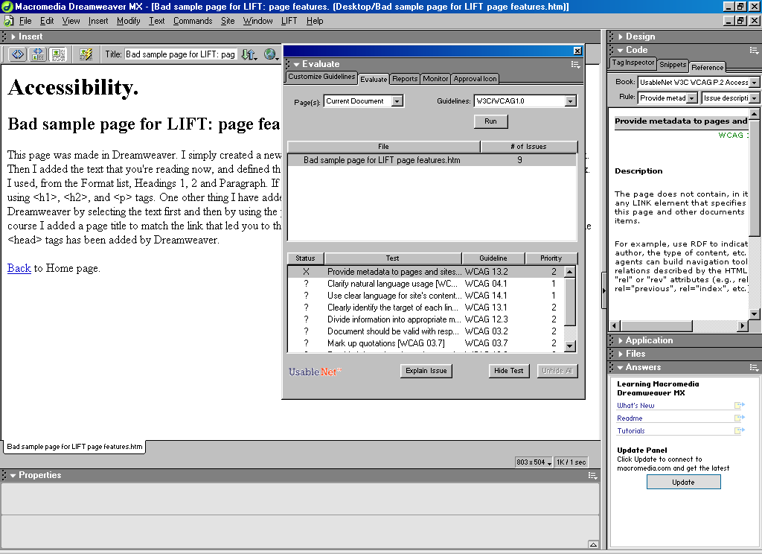

- Compare your results with those below.

The “Page features” page of the bad example site

The LIFT evaluation results for the Page features page are:

X | Provide meta data to pages and sites (C13.2, P2)  The <head> section of the page ought to include specified relationships between this page and other documents or information items in the site.
? | Clarify natural language usage (C4.1, P1)  Make sure you specify the document’s default language, and identify any sections that are in other languages.
? | Use clear language for site’s content (C14.1, P1)  Write clearly in a style appropriate to the web (see the SEDU seminars).
? | Clearly identify the target of each link (C13.1, P2)  Link text should be meaningful when read out of context.
? | Divide information into appropriate manageable groups (C12.3, P2)  Large amounts of text can be difficult to read in one block, so break it up into smaller chunks (see the SEDU seminars).
? | Document should be valid with respect to published grammars (C3.2, P2)  Make sure that the page contains valid HTML code by using an HTML validator.
? | Mark up quotations (C3.7, P2)  If you are using a quote from somebody, use appropriate tags to structure it.
? | Provide information about site organisation (C13.3, P2)  Your site should have some kind of site map.
? | Use last appropriate W3C technologies (C11.1, P2)  You should use the latest specifications of HTML, CSS etc.

- Use the guidance provided with each evaluation result to help you work out how to make the necessary changes to the page. There is guidance in the accompanying document Accessibility and the Web (IS4004) to help with relevant techniques. You can also refer to the Reference panel for links to more detailed guidance.

Changing the View in Dreamweaver
To fix the page you may need to change the HTML code. Click on the Show Code and Design Views button.

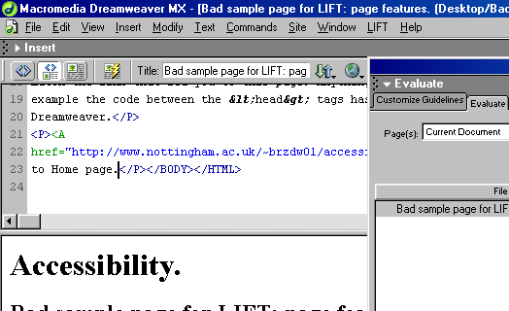
Show Code and Design Views

The Reference Panel - features
- The Book – indicates which reference source is in use. The appropriate source will be selected automatically when you evaluate a page.
- The Rule – indicates which rule in the book you want further information on. Again, when you evaluate a page and select a resultant issue, the appropriate rule will be automatically selected.
The Rule description – a description of the rule accompanied by examples and suggestions on achieving compliance. There are links to further resources where appropriate.

For more detailed explanations, click on the Explain Issue button in the Evaluate dialogue box to open a new browser window with further information from UsableNet, the makers of LIFT, and links to relevant technical details on the W3C site.

Don’t use the Hide Test button – this will prevent the highlighted test from being used in the evaluation.

Re-evaluate your page

to check that the highlighted issues have been adequately addressed.
Usually, you can expect the issues identified with an X to disappear if you have altered the HTML code appropriately. Issues marked with a ? will often remain as they are usually reminders for you to make a judgement, rather than identifiable coding errors. This does not mean that they are less important – just more difficult to measure using an automated tool such as LIFT.
- Check your amended page in the web browser to see what visual effects (if any) there are from your changes.

You can compare your changes with those incorporated in the “better example” site that you can find at:
http://www.nottingham.ac.uk/~brzdw01/accessibility/better/

I imagine your solutions will not be exactly the same, but there is usually more than one way to create the page that you want in an accessible format.

- When you are satisfied with your new page and the re-evaluation results, go back to the bad example site, and repeat the Evaluation, Interpretation and Amending process with the next page. You can use the sample results overleaf to monitor your progress.
By repeating on all pages, you will encounter the most common accessibility issues and have practice at rectifying them.

Evaluation results and required changes for the “bad example” site.

Below are the results of running the LIFT accessibility evaluation tool on the “bad example” site …
(available at http://www.nottingham.ac.uk/~brzdw01/accessibility/bad/)
with a brief description of issue and the changes that were made to produce the “better example” site …
(available at http://www.nottingham.ac.uk/~brzdw01/accessibility/better/).

Details of recommended techniques for achieving accessibility are included in the IS4004 document on Accessibility & the Web. The document was designed to accompany this guide and techniques are ordered according to the issues raised here.

The “Page features” page of the bad example site

The LIFT evaluation results for the Page features page are:

X | Provide meta data to pages and sites (C13.2, P2)  The <head> section of the page ought to include specified relationships between this page and other documents or information items in the site.
? | Clarify natural language usage (C4.1, P1)  Make sure you specify the document’s default language, and identify any sections that are in other languages.
? | Use clear language for site’s content (C14.1, P1)  Write clearly in a style appropriate to the web (see the SEDU seminars).
? | Clearly identify the target of each link (C13.1, P2)  Link text should be meaningful when read out of context.
? | Divide information into appropriate manageable groups (C12.3, P2)  Large amounts of text can be difficult to read in one block, so break it up into smaller chunks (see the SEDU seminars).
? | Document should be valid with respect to published grammars (C3.2, P2)  Make sure that the page contains valid HTML code by using an HTML validator.
? | Mark up quotations (C3.7, P2)  If you are using a quote from somebody, use appropriate tags to structure it.
? | Provide information about site organisation (C13.3, P2)  Your site should have some kind of site map.
? | Use last appropriate W3C technologies (C11.1, P2)

The “Formatting” page of the bad example site

The LIFT evaluation results for the Formatting page are:
(in addition to those issues already encountered)

X | Avoid deprecated features of W3C technologies (C11.2, P2)  The page contains tags that are no longer in the current specifications (probably <font> tags, and any other tag attributes such as align and color or bgcolor that specify visual effects rather than describe the structure of the document such as h1 or h2). You should remove these tags.
X | Use style sheets (C3.3, P2)  Style sheets, or CSS is the up-to-date alternative to using deprecated tags to achieve formatting effects. If you’re not familiar with writing stylesheets, use the instructions below to refer to an example stylesheet.
? | Colour should not be essential (C2.1, P1)  You are using colour – make sure that your message does not rely on that colour to be understood.

Using stylesheets

To help you correct the errors on this site, we have provided a stylesheet that you can use if you are not familiar with writing them yourself. Follow the instructions below to make your web page refer to that stylesheet for its formatting information.

- In Dreamweaver, press F10 to switch to the HTML source Code
- Click in the code immediately below the <head> tag and type in the <link> tag as shown below:
<html>
<head>
<link rel=”stylesheet” href=” http://www.nottingham.ac.uk/sedu/webforum/resources/css/examples/arial-red.css”>
</head>
This tag tells the browser where to find the stylesheet file for this web page. The href works as with any other link.
- Save the page.
- Preview your Home page in the browser to see the changes made by this file

You could try the alternatives too:
http://www.nottingham.ac.uk/sedu/webforum/resources/css/examples/arial-blue.css
http://www.nottingham.ac.uk/sedu/webforum/resources/css/examples/arial-green.css

For your own site, you would be advised to create your own stylesheet file and keep a copy in your own site. The link to it would then be a relative link rather than an absolute link, as are most of your links between files/pages in your own site.

Result of re-evaluation:
Note that on applying the external stylesheet a new issue arises:

? | Document should be valid with respect to published grammars (C3.2, P2)  Make sure that the external stylesheet uses valid CSS code by using a CSS validator.

If you are using abbreviations and acronyms, you should be aware that you could be violating a Priority 3 guideline (not checked by LIFT):

Specify the expansion of each abbreviation or acronym in a document where it first occurs (C4.2, P3)

The “Tables for layout” page of the bad example site

The LIFT evaluation results for the Tables for layout page are:
(in addition to those issues already encountered)

X | Avoid deprecated features of W3C technologies (C11.2, P2)  As with the formatting page, this has been triggered by the use of out-of-date elements such as align and width within the table’s structure tags.
X | Use percentage values for table sizes (C3.4, P2)  Where I specify table width, you should use relative units (percentage) not absolute units (pixels). This makes the table more flexible for users with varying size browser windows, screen resolution, text size etc.
? | Layout tables should make sense when linearised (C5.3, P2)  When the table is linearised (read out row by row), does the reading order make sense?

The “Tables for data (1) – complex table” page of the bad example site

The LIFT evaluation results for the Tables for data (1) – complex table page are:
(in addition to those issues already encountered)

X | Data table should have headers (C5.1, P1)  If the table contains data, the HTML code needs to identify the relationship between the column and row headings and the data. You can either change the code by hand or use LIFT’s table Fix Wizard to alter the code.

Note that on fixing the table, a new issue arises:
? | Avoid using structural markup for visual formatting (C5.4, P2)  This is a warning not to use the heading tags just to get the bold effect.

The “Tables for data (2) – simple table” page of the bad example site

The LIFT evaluation results for the Tables for data (2) – simple table page are:
(in addition to those issues already encountered)

X | Data table should have headers (C5.1, P1)  If the table contains data, the HTML needs to identify the relationship between the column and row headings and the data. As before, you can either change the code by hand or use LIFT’s table Fix Wizard to alter the code.

Note that on fixing the table, there are more issues than before:
X | Cell of data table should refer to headers (C5.1, P1)  Each cell of the table should refer to it’s respective header information.
X | Data table should have headers (C5.1, P1)  If the table contains data, the HTML needs to identify the relationship between the column and row headings and the data.

We believe that these extra errors arise because LIFT is assuming that the table should have row headers as well as column headers. In this case, you will have to use your discretion to evaluate whether your table needs further amendments or not.

And also, as before:
? | Avoid using structural markup for visual formatting (C5.4, P2)  This is a warning not to use the heading tags just to get the bold effect.

The “Images” page of the bad example site

The LIFT evaluation results for the Images page are:
(in addition to those issues already encountered)

X | Image should have valid ALT (C1.1, P1)  Image should have valid textual description in the “ALT” attribute.
? | Image might need valid LONGDESC (C1.1, P1)  A long description may be required if the image is complex.
? | Ensure sufficient contrast between foreground and background colours (C2.2, P2)  As with text on a coloured background, your images need to ensure sufficient contrast.
? | Use mark-up rather than images (C3.1, P2)  Where the image is used for elaborate fonts, CSS should be used instead.

Note that on adding the ALT information, there is a new issue:
? | Image should have equivalent ALT (C1.1, P1)  The ALT text you have provided must replace the function of the image.

The “Forms” page of the bad example site

The LIFT evaluation results for the Forms page are:
(in addition to those issues already encountered)

X | Add explicit labels to form controls (C12.4, P2)  This appears once for every form element which isn’t explicitly linked with its label.
? | Properly position implicit labels in forms (C10.2, P2)  Form labels should be to the left, or on top of the form element they refer to.

Further exercises
If you complete all the amendments for the pages on the bad example site, you might like to either:
- Copy some of your own web pages from to the computer and try running LIFT on those.
- Copy other pages from the Internet that are using effects that you might like to try yourself and run LIFT on those to check the accessibility of those effects / components.
- Follow up new areas that you might like to develop e.g. writing stylesheets or working with images. Please ask the tutor on guidance for where to start.

