Managing Page Content Efficiently

A number of methods are available to help you keep your maintenance time to a minimum whilst keeping your site content dynamic. You can to separate the web site management tasks from the content updating tasks by including text files in your web pages that are maintained elsewhere. You can take advantage of free news services to provide up-to-date content or you can plan ahead and programme a timed release of info on your site.

Separating web site management from content updating.
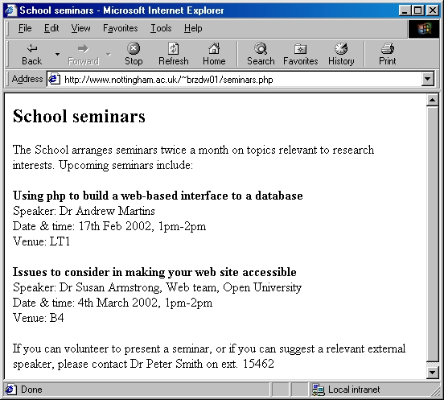
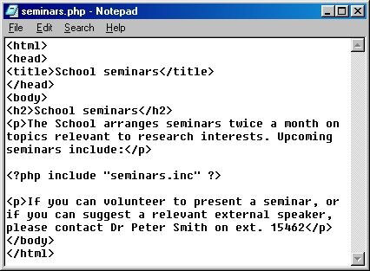
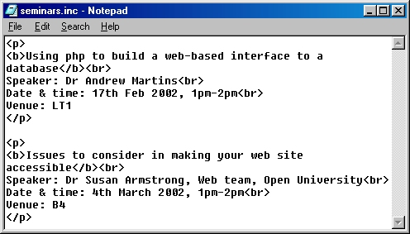
Why do it?
Separating the job of site design (your task) from the updating of information has a number of advantages:
those closest to the info gain a sense of responsibility and ownership for what is essentially a shared site;
you are relieved from the task of making simple text changes as and when other people request them;
there is less danger of mis-editing etc. that can happen when others are working on the whole web page.
How to do it?
Write the web page as normal, but without the changing content. Save the file with a .phtml or a .php filename extension
Write the changing content in another file. Save the file with a .inc extension.
Insert the following php command into the page where you want the other file to show:
<?php include "/home/username/path/filename.inc" ?>
Publish your page to the web server, and ask whoever is editing the text file to publish it to their part of the web server.
This page content, the up-to-date details, will change regularly, and is not very complex in its layout.

It would be possible for the member of staff who organises the events to edit this text in a separate file and to publish it themselves under their own username.
This page content, the background information, does not change often, and may well include some fairly complex code including navigation devices (menu buttons or sets of links etc.), images, tables to control page layout etc.

It would seem sensible for the web site manager to maintain the overall page and to include the details of the events from elsewhere.
seminars.inc - the included file

seminars.php - the main web page with the php command
What else can php do?
"PHP is a server-side, HTML-embedded, cross-platform scripting language" (Webmaster in a Nutshell p309). You can write scripts in php and include them within HTML code in your phtml file. When a user requests the file the script runs and the output (the HTML and the results of your script) are served to the user. The user only sees the result of the script, never the script itself. The web team are using php to build interfaces between web pages and databases such as the Prospectus and the Events database.
Some easier to implement uses might be:
Including files in your web pages
You could include a standard header and/or footer in your pages by using php's include statement as shown over the page. For those who don't use Dreameaver, this is an alternative to using Dreamweaver templates
Automatically updating your "page last updated" statement
You can get php to print out the date on which the file was last uploaded to the server - i.e. the date you last changed it. You can specify how that date is formatted too.
<?php print date( "d F Y", filemtime( $PATH_TRANSLATED )); ?>
Whenever you use the variable $PATH_TRANSLATED it is converted into the current filename when the programme runs. This means that you can put the same php statement in all of your pages and it will always print the date for the page that it is in. You could include the statement by putting it in a footer file that is itself included in everypage, or use it in a DW template.
using print causes the output of the following function to be printed to the page
the date function, used here to format a given date - see filemtime
filemtime is a function that retrieves the date when the file in brackets was last updated (or modified)
the letters between the inverted commas dictate how the date should be formatted (e.g. 13 February 2002 in this example rather than 13/02/02 etc.)
This script checks whether a particlar condition is met and, if so, carries out the first command. If not, the second command is carried out instead. This could be useful for outputting information based on certain dates etc.

Displaying information only under certain circumstances:
<?php
if (condition 1) {
print "phone Jane on ext. 52145";
} else {
print "phone David on ext. 52146";
}
?>

Some php references include:
http://www.phpbuilder.net/
a comprehensive site including articles, forums and code libraries
http://www.phpbuilder.com/manual/
lists all the functions and control structures etc. the programmers
Whitehead, Paul (2001) PHP: Your Visual Blueprint for Creating Open Source, Server Side Content. Hungry Minds Inc
this book has very clearly laid out uses of php, rather than being a book about how to write scripts from square 1.
Spainhour, S & Eckstein, R (1999) Webmaster in a Nutshell (2nd ed.)
This must-have reference has a section on php as well as good summaries of HTML, Javascript, web server details etc..
Using external new services
The BBC provide a news ticker covering various subjects that you can include on your web site. Go to http://www.bbc.co.uk/ to find out more.
Moreover.com (http://w.moreover.com/webmaster/) also provide a newsfeed service
The Guardian http://www.guardian.co.uk/distribution for Guardian news stories
QuickWebDev http://webdev.quickfound.net/free_tickers_index.html includes all sorts of help for web developers including a listing of free news content providers and new ticker providers.
FreeSticky http://www.freesticky.com provide content of all sorts (quizzes, quotes, jokes, tips etc)

