Accessible Page Formatting with Style sheets

Style sheets (CSS, or Cascading Style sheets) allow you to separate the structure of a web document from its formatting; your page is made with simpler HTML (no <font> tags etc.) and all the formatting instructions are in the style sheet. This makes your site more accessible to alternative browsers, such as screen-reading software.

Adding styles to your web pages
You can use styles in your web documents in one of three different ways, two are explained below:
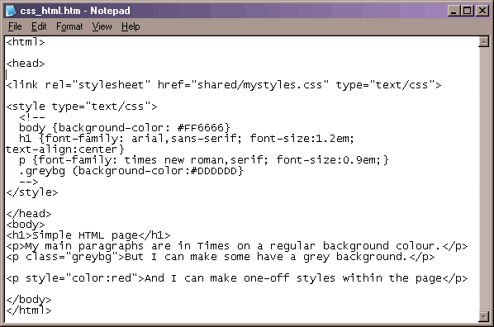
External (linked) style sheet
The web page refers to a separate file, the style sheet file, where the formatting for the page is defined. This style sheet can then be used by many web pages. In the href attribute of the <link> tag you can use a relative or absolute link to identify the style sheet (just like regular links).

Embedded style sheet
The styles to be used in the web page are defined within the head of the document and are therefore only available to the current document. This could be useful for styles exclusive to that document (a home page for example). The styles are defined within <style> tags. Comment tags ( <!-- and --> ) ensure older browsers do not display the contents of the <style> tags.

Inline style

How do they work?
When you write web pages you use <H1> and <p> tags etc. to structure your document and the browser (Netscape or Internet Explorer) uses its own style sheet to determine how to display these elements - <H1> is usually displayed in Times New Roman font, large font size etc.
One way to alter the formatting of your page is to use <font> tags and attributes of <p> tags (align etc.) in your HTML code. However, this contravenes the W3C accessibility guidelines, and is inefficient. An alternative is to use your own style sheets. The browsers use your style declarations to format the <H1> and <p> elements, rather than using their own default style sheets. You must use closing tags for <p> and <li> etc. or the style sheet will not work and you may not see anything on your page!

Style sheet syntax
selector
(the tag you are defining)
curly braces start and finish the declaration (a series of property+value pairs)
a colon separates the property and its value
a semicolon separates the property+value pairs
property
(the aspect of the selector that you want to define)
value
(the exact specification for the property)

P { font-size : 0.9em ; color: #000099 }

a:link when the link is unused e.g. a:link {color:#0000FF}
a:visited when the linked page has been visited a:visited {color:#FF00FF}
a:active whilst the link is active a:active {color:#FF0000}
a:hover with the mouse “rolled-over” the link a:hover {color:#0000FF; background-color:#CCCCFF}
An external stylesheet is a text file (filename.css) containing a list of all your selectors with their declarations.
Classes: adding complexity to your style rules
Q. What if I want some of my paragraphs to be different from others?
Q. What if I have a style that I’d like to use on more than one element: some paragraphs, a table cell etc.?
A. As well as using a stylesheet to redefine the formatting for all of your HTML tags, you can also define classes in your stylesheet – these are style declarations that can be applied to any element in your page.
HTML application:
<p class=”greybg”>Text here has grey bg</p>
<p class=”centerbd”>Text centered & bold</p>
<td class=”centerbd”>cell contents bold & centred</td>
Class declaration:
.greybg {background-color:#CCCCCC}
. centerbd {text-align:center; font-weight:bold}

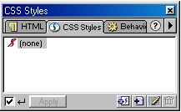
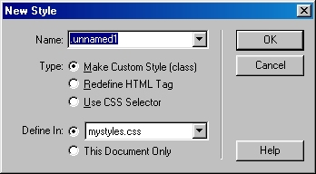
link to an external stylesheet / create a new external stylesheet by typing in a filename (must be filename.css)
add a new style
edit a style
choose type of selector: class, element or ID
choose whether to create in an external stylesheet, or embedded style
From the Window menu, choose CSS styles to open the CSS styles window
You can link to & create external stylesheets, and you can create & edit styles in external stylesheets or in embedded style sheets.
In DW MX note that you can be in Apply or Edit mode when working with styles.
Using stylesheets in DreamWeaver MX

To apply a style, select the element and click on the desired style in the CSS styles window

Browser compatibility issues
IE & Netscape have released versions at differing times with respect to the announcement of the CSS1 and then CSS2 standards. They also have different models of page structure (the Document Object Model) which means they apply styles differently. Test your pages in both browsers to check for unwanted effects.
Rules in conflict
Cascading
If you are using more than one style definition for an element (e.g. an external style sheet and an embedded style for a <p> tag), the one nearest the element will take precedence.
Inheritance
When elements are nested (e.g. all your elements within the <body> tag, or a <td> tag inside the <table> tag) the inner element inherits definitions set for outer element. The 2 main browsers (Internet Explorer & Netscape) use different models to describe the relationship between elements (forms, tables links etc.) in your document, and so inheritance of styles works differently in the 2 browsers.
Specificity
You can overwrite inherited styles. By specifically declaring a style for an element, you override any inherited style that conflicts with it.

Accessibility matters
In a nutshell:
Use simple HTML to structure your page and CSS for the formatting. Very importantly, make sure the units of measurement you use (e.g. for font size) are relative. Absolute values (e.g. point size or pixel) stop the user changing the text size in their browser, relative values (e.g. ems or %) don't. Finally, don’t use images for navigation buttons, use text and format it with style sheets.
Relevant guidelines & checkpoints from the W3C WAI:
3: Use markup & style sheets and do so properly
3.1 Avoid using images to represent text – use text and CSS
3.3 Use style sheets to control layout and presentation
3.4 Use relative rather than absolute units for property values
6: Ensure that pages with new technologies transform gracefully
6.1 Organise pages so that they can be read without style sheets
References
The W3C (the standards body for the web) has a web site on CSS - http://www.w3.org/Style/CSS/
CSS2 standards (acceptable properties & values) can be checked at http://www.w3.org/TR/REC-CSS2/
For further css references and tutorials try the webforum at http://www.nottingham.ac.uk/sedu/webforum/resources/css/

