

**Your Guide**

**to Living in Halls**

**2020/2021**

|  |
| --- |
| **Top tips for a safe**  **and enjoyable time**  **throughout your stay:** |

|  |
| --- |
| * Get to know your Residential Support team and Halls Management team. * We are all here to help you, please don’t hesitate to speak   to a member of team at Welcome Point locations.   * Respect staff and your fellow students by following the covid-19 guidelines and observing government legislation. |
| * Keep safe, keep valuables out of sight, always close your windows and lock your door when your room is unoccupied * Most importantly, enjoy yourself and embrace Hall life | |
| * It is a good idea to put important telephone numbers into your phone, for example Welcome Point, Duty Tutor and Security for an emergency      * If you are in your household you do not need to socially distance but please socially distance if you are not in your household | |

**Putting You First**

Our mission is to provide a great sense of community in a healthy, safe, clean and pleasant environment to enable students to learn, live and socialise.

During these extraordinary times, the University is working to ensure that we follow Government guidelines and advice in relation to Covid-19.

The University of Nottingham aims to provide you with quality accommodation along with efficient services delivered by our friendly staff. In return as one of our residents, you have a responsibility to make a positive contribution to your new Hall community by following regulations set out in this guide, being considerate and courteous to your fellow residents and by respecting our neighbours who also live in our nearby community.

**The Accommodation Code of Practice**

Where you live is a big part of your University experience, to protect you we are accredited by the Accommodation Code of Practice [thesac.org.uk](http://thesac.org.uk)



3

**A**

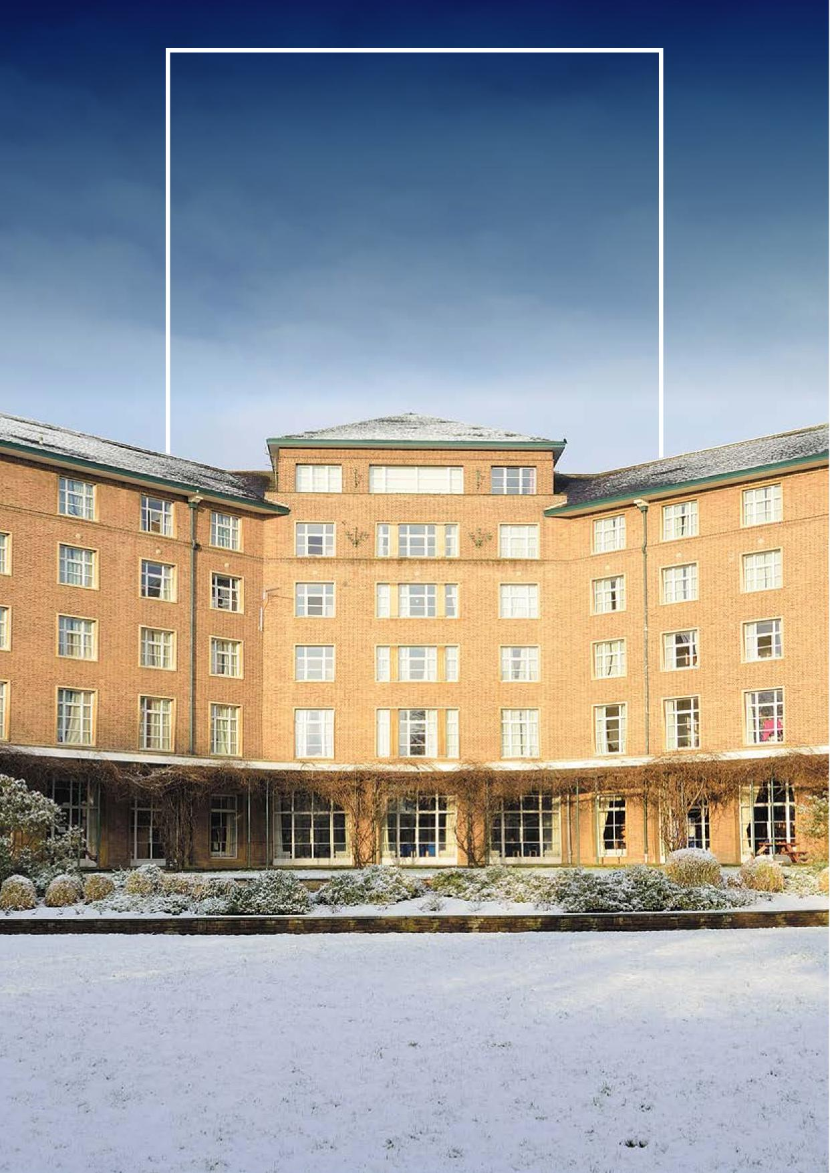

**Welcome to**

**The University of**

**Nottingham A-Z of**

**Catered Hall Living**

**Absence from Hall**

In the interest of fire and safety, residents are required to sign out online, if you intend to stay away from hall overnight. The link to do this will be sent to you and will also be displayed in the hall.

**Access to rooms**

During your stay, access is required by University staff and third parties under our control for the following: cleaning, cleaning checks, maintenance, sanitary bin replacement, for any emergency situation and as part of an ongoing investigation. Please refer to section 5 in the Halls Licence Agreement

**Accommodation room inventory**

Please complete the room inventory online within three days of your arrival or we will assume that everything is in order.

**Accommodation Services**

Located in the Portland Building the team are on hand to assist you through your booking process.

Further support is provided once you are here with queries and next year bookings.

Live chat: Nottingham.ac.uk/accommodation

e: [accommodation@nottingham.ac.uk](mailto:accommodation@nottingham.ac.uk)

**Address**

Please see our website for the address of your Welcome Point

**Animals**

No pets are allowed in Hall.

**B**

**Bars**

Campus bars are opened Monday-Saturday only.

Echo @ Derby Hall, University Park:

Lunch: 12pm-4pm

Evening: 6pm-10pm

Mooch: Students’ Union, Portland Building, University Park'

Vesper @ Willoughby Hall, University Park

Lunch: 12pm-4pm

Evening: 6pm-10pm

Latitude @ Hugh Stewart: Monday-Friday lunch only 12pm-4pm

Pizza Outlets:

Hemsley, University Park: 12pm-10pm Monday-Sunday

Terrazzo, Jubilee: 9am-10pm Monday-Friday,

12pm-10pm Weekend

Please note all bar opening times are subject to change.

**Barbecues**

These are only permitted via catering by filling in an Events Form.

**Bedding**

Please bring your own bedding with you to make your room more homely, alternatively the Online Store retails bedding packs for you to purchase.

**Bicycles**

Bicycle storage areas are available around the campuses. Bicycles are left at owner’s own risk and will require extra insurance cover. Bicycles are prohibited inside University buildings.

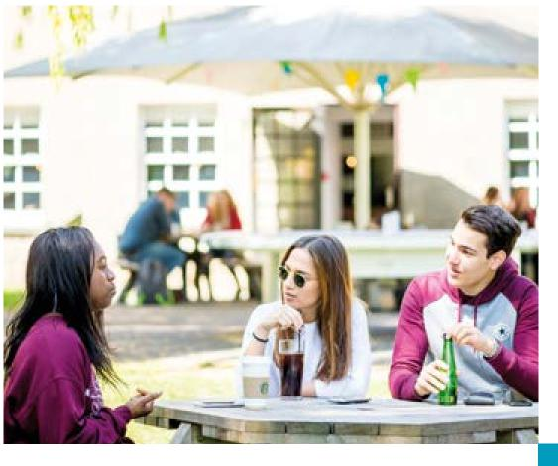

5

**D**

**Community**

The University of Nottingham is a community of over 44,000 students from over 150 countries with a range of backgrounds, beliefs, and identities. We are committed to promoting and providing a safe and respectful environment for everyone in our community. There are clear policies around dignity, respect, and discriminatory harassment. Bullying, threatening, or offensive behaviour are all seen as examples of misconduct which could lead to disciplinary action.

We believe that everyone deserves respect. You should give it and expect it from others. And if you feel you aren’t receiving it, you should let us know.

As part of our community you will be asked to behave in accordance with the community pledge and code of discipline.

**Complaints**

For any problems or issues you may have during your time in Halls, please don’t hesitate to speak to one of your Hall Management team, Warden, Deputy Warden and tutors.

Alternatively, you can also contact us by email [acc-feedback@nottingham.ac.uk](mailto:acc-feedback@nottingham.ac.uk) or BH-halls-catering@ [nottingham.ac.uk](http://nottingham.ac.uk) or by text 0780 0003 285.

The student University official complaints procedure can be found [nottingham.ac.uk/academicservices/](http://nottingham.ac.uk/academicservices/) currentstudents/complaints.aspx

If you require support in making a complaint, you can access help from the Student Union Advice Centre: [su.nottingham.ac.uk/advice](http://su.nottingham.ac.uk/advice)

**Counselling Service**

The University Counselling Service gives support to students by offering confidential, professional help with personal, emotional or mental health [problems.](http://problems.nottingham.ac.uk/counselling/index.aspx) nottingham.ac.uk/counselling/index.aspx

**Catered Halls**

Included in your package:

A daily variety of simple breakfasts Monday to Friday at your Hall. Breakfast hubs are opened from 7.30am-10.30am.

A daily variety of hot and cold brunch is on Saturday and Sunday at your Hall from 11.00am-12.30m

A weekly allowance Flexible Lunch Card transacted through your University card at numerous campus outlets any remaining balance will be wiped clear weekly.

A daily evening meal Monday to Sunday at your Hall from 5.00pm-7.30.pm

Alternate packed lunches may be available by prior arrangement

Consult with the catering team regarding any specific requirements, please speak with your head chef at your hall.

The catering will be provided during term time only, this will be also be extended in line with the revised accommodation contract dates at no additional charge

**Cleaning**

Communal bathrooms, public areas and pantries are cleaned Monday to Sunday with an extra touch point clean in the afternoon to comply with current Covid-19 Government guidelines. You must keep your room clean and reasonably tidy and take any rubbish and recycling from your room to the designated outside bin area. Cleaning materials will be made available for you to clean your bedroom and any bathrooms before use if you wish. Please ensure that you watch the safe use of cleaning chemicals video on arrival

**C**



6

**Damage / Decoration**

Any damage caused to your room or any University property will be charged to you as an individual.

You are not permitted to decorate or make any alterations to your room. The use of pins or nails is restricted to the noticeboard provided.

Fixing posters or anything else to the walls, doors, ceilings or window-frames is likely to leave a mark, even if you use things which are supposed not to mark. We will not allow marks from pins, tape, blu-tak and so on as fair wear and tear.

If there is damage in shared areas, we will use reasonable efforts to try and identify who caused it. If we cannot identify the culprit, we will spread the costs of repair or replacement among the occupiers who have access to that area of the Hall. We will not pass on the costs to residents if we reasonably believe that the damage was caused by an intruder.

You must notify the Halls Management Team as soon as you reasonably can (and in any event within 48 hours) after becoming aware of any damage. If you do not report damage and the damage becomes worse over time, you may have to pay for a replacement or major repair, when a simple repair should have been enough.

You must not remove any contents from the room, from the shared areas or from any other part of the residence.

**Departure**

If you have booked a 31 week licence then you need to vacate your room by 10.00 am the Saturday after the last day of term. Please ensure your room is left in a clear state, all rubbish deposited in bins and fridge is emptied. Keys are to be returned to your Welcome Point.

If you have booked a 39 week licence then you do not need to vacate your room until the last day of your booking and follow the above instructions.

**Discipline**

The Code of discipline is the expectations and conduct we set for all Registered Students and those in Hall Accommodation. It is important that you read this document:

<https://www.nottingham.ac.uk/governance/documents/code-of-discipline.pdf>

**Drugs**

Students are warned that the use or possession of illicit drugs is strictly forbidden in the Hall and its precincts and will result in disciplinary action being taken. The University operates a strict tolerance on drugs.

Repeat offenders found with Class B drugs will be referred to the Senate Disciplinary Committee and will face suspension from University accommodation by The University Assessor. Students found with Class A drugs will face immediate suspension from University accommodation and referral to the Senate

Disciplinary Committee.

Any student found to be using or supplying illicit drugs will be reported to the Registrar, University Assessor and Security who may inform the Police.

7

Tampering with fire equipment is a criminal offence, this includes the smoke detectors, which will result in a disciplinary meeting and a fine as well as the replacement/repair cost(s) of the appliance(s). Disciplinary action may be taken if any student activates the fire alarm through negligence.

Please also see Prohibited items

**First Aid**

There are first aid boxes available in each Welcome Point. At other times contact the Hall porter or call your residential support Team. The Security team is on duty 24 hours a day and can be contacted on 0115 95 13013 or in an emergency 0115 95 18888

More information about Places of Worship and Prayer Rooms on our campuses can be found on the web.

<https://www.nottingham.ac.uk/chaplaincy/home.aspx>

You have a responsibility to comply with electrical and fire safety requirements.

Only University owned and tested electrical appliances are permitted to be used in the Pantry areas of the Hall.

**Email address**

When you register with The University you will automatically be given an email address. Any Hall correspondence will be sent to this email address only.

**Events form**

Any student run events need to be approved by the Hall Management team, Residential support Team and Students’ Union. Please submit at least 14 days prior to guarantee it can take [place.](http://place.secure.jotformpro.com/form/42953188087971)

There are internal telephones located around the Hall

– please make a note of their locations. It may be useful to programme these numbers into your mobile phone.

Emergency services ambulance/fire/police call Security’s emergency number: (0115 95) 18888

**Emergency contacts (out of hours)**

Security 24 hours (0115 95) 13013

**Electrical items**

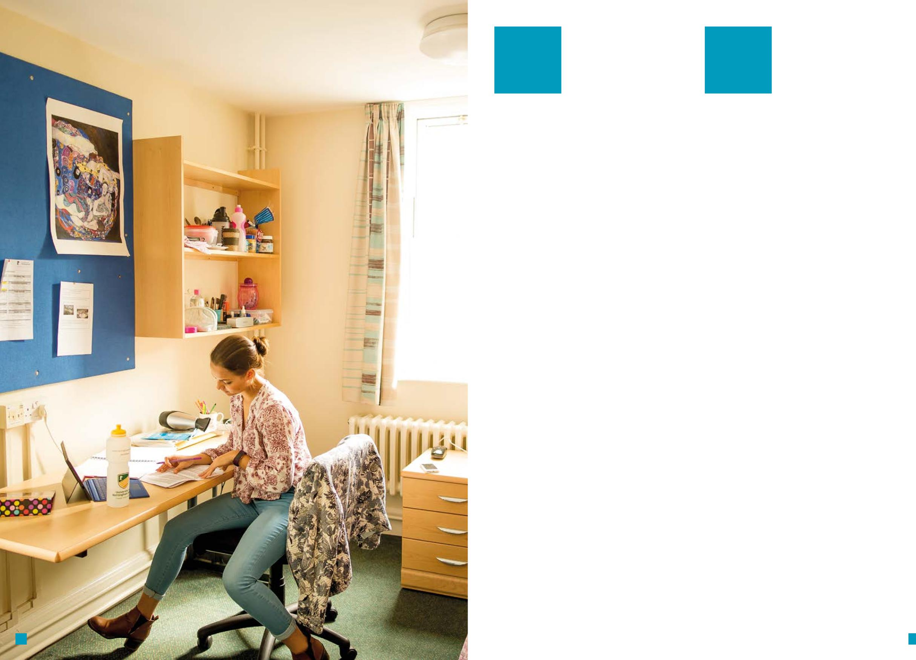

**E**

**F**

**Faith**

Whatever your background or faith, our University chaplains are here to offer spiritual and pastoral support. As well as supporting you in your faith, our chaplains can help you practice and explore your beliefs.

Our chaplains can also advise on:

○ where to worship in the local area

○ student faith societies

○ balancing your faith with student life

**Fire safety & regulations**

Fire procedures are detailed in your Hall, please ensure you familiarise yourself with these.

9

8

**H**

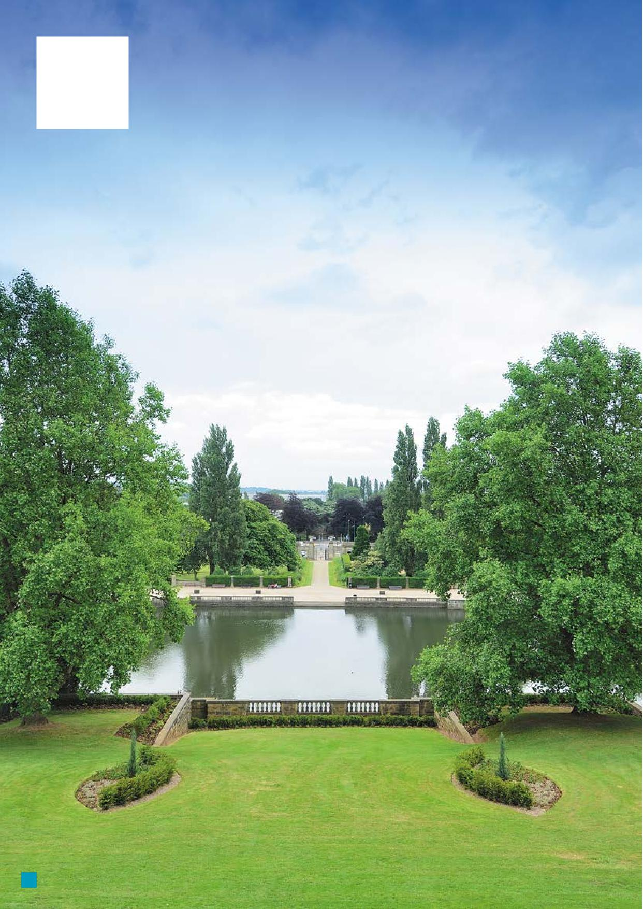

**G**

**GP service**

We recommend that you register at the health centre on campus. Further information is contained in the health section of Student Services web pages.

[nottingham.ac.uk/studentservices/support/health/](http://nottingham.ac.uk/studentservices/support/health/) index.aspx

**Grounds and local area**

The grounds of The University and your Halls are a fantastic asset to The University. University Park contains over 300 acres of landscaped gardens please enjoy them and keep them tidy. Ball games are prohibited on Hall grounds.

10

**I**

**Hall Management team**

**Illness and accidents**

All cases of illness or accident must be reported to a member of the residential support Team or a member of the Hall Management Team as soon as possible. If you are showing signs of covid -19 please complete the online form.

**Insurance**

Personal contents insurance is provided under The University block Hall scheme through Endsleigh. Please confirm your insurance prior to arrival.

**Internet and IT support**

Wi-Fi is available in all of the Halls. This is included in your accommodation fees.

You can contact the IT helpline between 8.00am-

6.00pm. An out of hour service is provided at

all other times. Telephone: 0115 95 16677

e: [student-it-helpline@nottingham.ac.uk](mailto:student-it-helpline@nottingham.ac.uk)

w: [nottingham.ac.uk/is/help](http://nottingham.ac.uk/is/help)

Problems with coverage or loss of connection should be reported to the Hall Management team.

IT services and facilities are governed by policies, standards and regulations (including Code of Practice for Users, Terms and Conditions, Fair Usage Policy and JANET Acceptable Use Policy). [nottingham.ac.uk/it-services/aboutus/policies.aspx](http://nottingham.ac.uk/it-services/aboutus/policies.aspx) [nottingham.ac.uk/it-services/security](http://nottingham.ac.uk/it-services/security)

The Hall Management Team is based in your Welcome Point. The team are responsible for the general running and operation of the Hall facility and provide specific services such as cleaning, maintenance, safety and the security of the Hall. Please email the team if you have any queries.

Email and contact numbers are displayed on the notice board in your room.

The Welcome Point is open:

Monday to Friday, 8.00am-6.00pm during term time.

There will be a Duty Manager available to contact Monday to Friday 6.00pm – 10.00pm and on Saturday and Sunday 10.00am – 10.00pm.

**Hall Committee**

The Hall Committee is made up of student volunteers, elected by the residents of their halls to represent them as part of the Students’ Union.

**Health and safety**

Please report any health and safety issues you may have to your Welcome Point.

**Heating**

The building is environmentally controlled to provide a comfortable temperature whilst minimising waste. You can adjust your heating via the valve or thermostatic valve on your radiator.

11

**Hopper bus**

The University provides free hopper bus services that run from University Park to Jubilee Campus, Sutton Bonington Campus and King’s Meadow

**Missing persons**

If you notice an unexplained absence or a friend that has to stay away unexpectedly, please inform the residential support Team or Hall Management team immediately.

**Medical and disability conditions**

You may already have told The University about a disability or medical condition. Please come and talk to your Hall management team to allow us to assist you further and create a great environment for you. All information you give us will be treated with the strictest confidence. For further support please contact the University Student support services.

**Maintenance & repair**

Please report any maintenance issues to the Welcome Point and we will attend to it as quickly as possible.

Due to Covid-19 we will ask you to vacate your room until the maintenance has been completed.

**K**

**M**

**L**

**K**

**Leaving Hall early**

Should you decide to leave the university, please refer to section 14 of the Hall Licence Agreement. Please also refer to the University website and complete the relevant form once your suspension of studies has been agreed. If you are experiencing difficulties, please log your request and consult with the residential support team for further support.

There is an online facility for seeing when the machines are free [www.circuit.co.uk](http://www.circuit.co.uk)

There is a free phone number or email to contact the company directly, regarding the laundry machines. t: 0800 092 4068

E: service@circuitgroup.com

Laundry rooms are cleaned every day. Please report any issues to Circuit and the Welcome Point.

**Laundry**

The laundry rooms have washing machines and dryers which are operated by downloading an App, topping up with money and scanning the machines QR code.

**Keys**

It is very important that you take care of your room key. If you lose your key, please report this to your Welcome Point immediately and purchase a new key from the online shop.

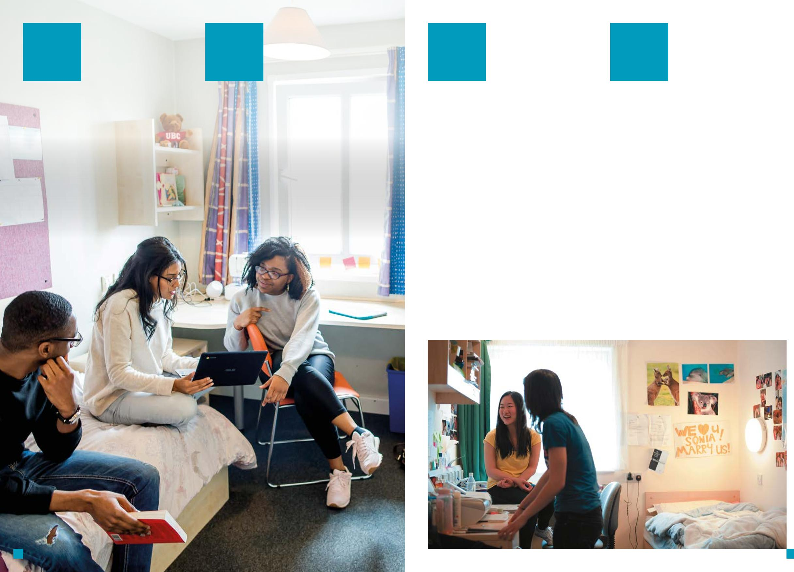

**J**

**Junior Common Room Hall Committee**

The JCR is a subordinate body of the Students’ Union. The aims of the JCR are to promote a community spirit in the Hall, provide a means of communication between students, other faces of the SU, Hall Management teams and the residential support Team, see Hall Committee.

12

13

**Residential Support Team**

The team are available for support and advice and can refer to other services as appropriate to ensure that students are well supported and the Hall functions as a community that benefits everyone.

The team will be making contact during arrivals week and contact numbers will be displayed in your hall.

**Rubbish and recycling**

**All** students are asked to empty their own bins by taking the contents to the bin store outside of the Hall. There are recycling facilities for you to use outside the Hall, please use them.

Please use the hand sanitiser provided.

**Post and parcels**

In line with Government guidelines we will only be accepting post and parcels from Royal Mail, you will need to collect these from your Welcome Point.

**Noise complaints**

Excessive noise will not be tolerated within the Hall and can affect others. If you experience excessive noise between 10.30pm and 8.00am please report this at the time it is happening by ringing the on-call residential support Team mobile number. Do not wait until the morning to report it. Excessive noise outside these times will not be tolerated. A Zero tolerance is applied during exams periods.

The use of electrical toasters, hotplates, kettles (apart from a travel), microwaves, cookers (or any cooking appliance or food preparation item), irons, extension leads (unless it is fused), decorative lights (LED lights are permitted), electrical under-blankets, lava lamps and heaters in study rooms within Hall is also strictly prohibited.

You are asked **not** to leave bags of rubbish in the corridors and pantries as this is a fire risk to you and to others.

**Print hub**

The University of Nottingham Print Service uses Multifunctional Devices (MFDs) which offer printing, copying and scanning. You can release your print or copy job at any MFD across The University (each Hall has this facility).

Please use the wipes provided to wipe down equipment before and after use.

**Prohibited items**

The use of candles, tea lights and incense sticks, shishas / bongs, e cigarettes or smoking in study bedrooms or any other part of the Hall and its precincts is strictly prohibited.

Over door hangers must not be used as they will obstruct the fire intumescent safety strip on the door and in the event of a fire, smoke could enter your room.

Food must not be cooked or prepared in study rooms. Illegal drugs must not be brought onto University property, this includes associated paraphernalia such as bongs.

The possession, use or discharge of any weapon, explosive or detonator or the discharge of any fireworks is forbidden.

We may remove any of the items listed above or anything else which is a hazard.

Further regulations on weapons and drugs can be found in **The University’s Code of Discipline.**

**Parking**

Visitor parking is available and parking permits/vouchers or pay and display tickets are required to be displayed on vehicles on University campuses between 9.15am and 4.00pm weekdays.

**P**



**N**

**Pantry**

There are pantries throughout the hall. Please keep these areas clean and tidy to avoid pests. The pantry bin is only for pantry waste, not bedroom waste. There is equipment available in each pantry for students to use (toaster, kettle, microwave), iron and ironing boards are available within the hall so there is no need for you to bring these items with you.

All complaints will be treated in the strictest confidence and disruptive/noisy residents may face disciplinary action.

14

**P**

**R**

15

**S**

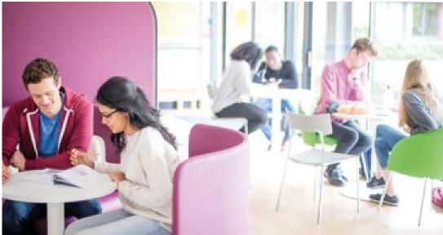

**Security**

The University employs its own in-house Security Team and uniformed security officers providing 24-hour security which provide secure and safe campuses for all.

**Smoking Policy**

The University operates a strict no smoking policy and smoking inside all buildings is strictly prohibited (including e-cigarettes). [nottingham.ac.uk/safety/documents/](http://nottingham.ac.uk/safety/documents/) smoking-policy.pdf

**Sports facilities**

The £40 million David Ross Sports Village on University Park offers an inspirational and accessible sports provision for all.

Our indoor and outdoor facilities include state-of-the-art fitness suites, three sports Halls, swimming pool, climbing and bouldering wall, 3G and sand-dressed pitches, water-based hockey pitch, over 40 grass pitches, three pavilions and a boathouse (students only). <https://www.nottingham.ac.uk/sport/davidrosssportsvillage/david-ross-sports-village.aspx>

Jubilee Sports Centre offers a variety of facilities including a sports Hall, squash courts, fitness suite and an outdoor 3G playing [field.](http://field.nottingham.ac.uk/sport/) <https://www.nottingham.ac.uk/sport/facilities/jubilee/index.aspx>

**Students’ Union**

Your Students Union is a student led independent charity and a very important part of student life. They campaign on issues that matter to you and provide entertainment, advice and trips. For more information visit [su.nottingham.ac.uk](http://su.nottingham.ac.uk)

16

**Students’ Union shop**

The Student's Union have partnered with SPAR for it's on-campus shops.

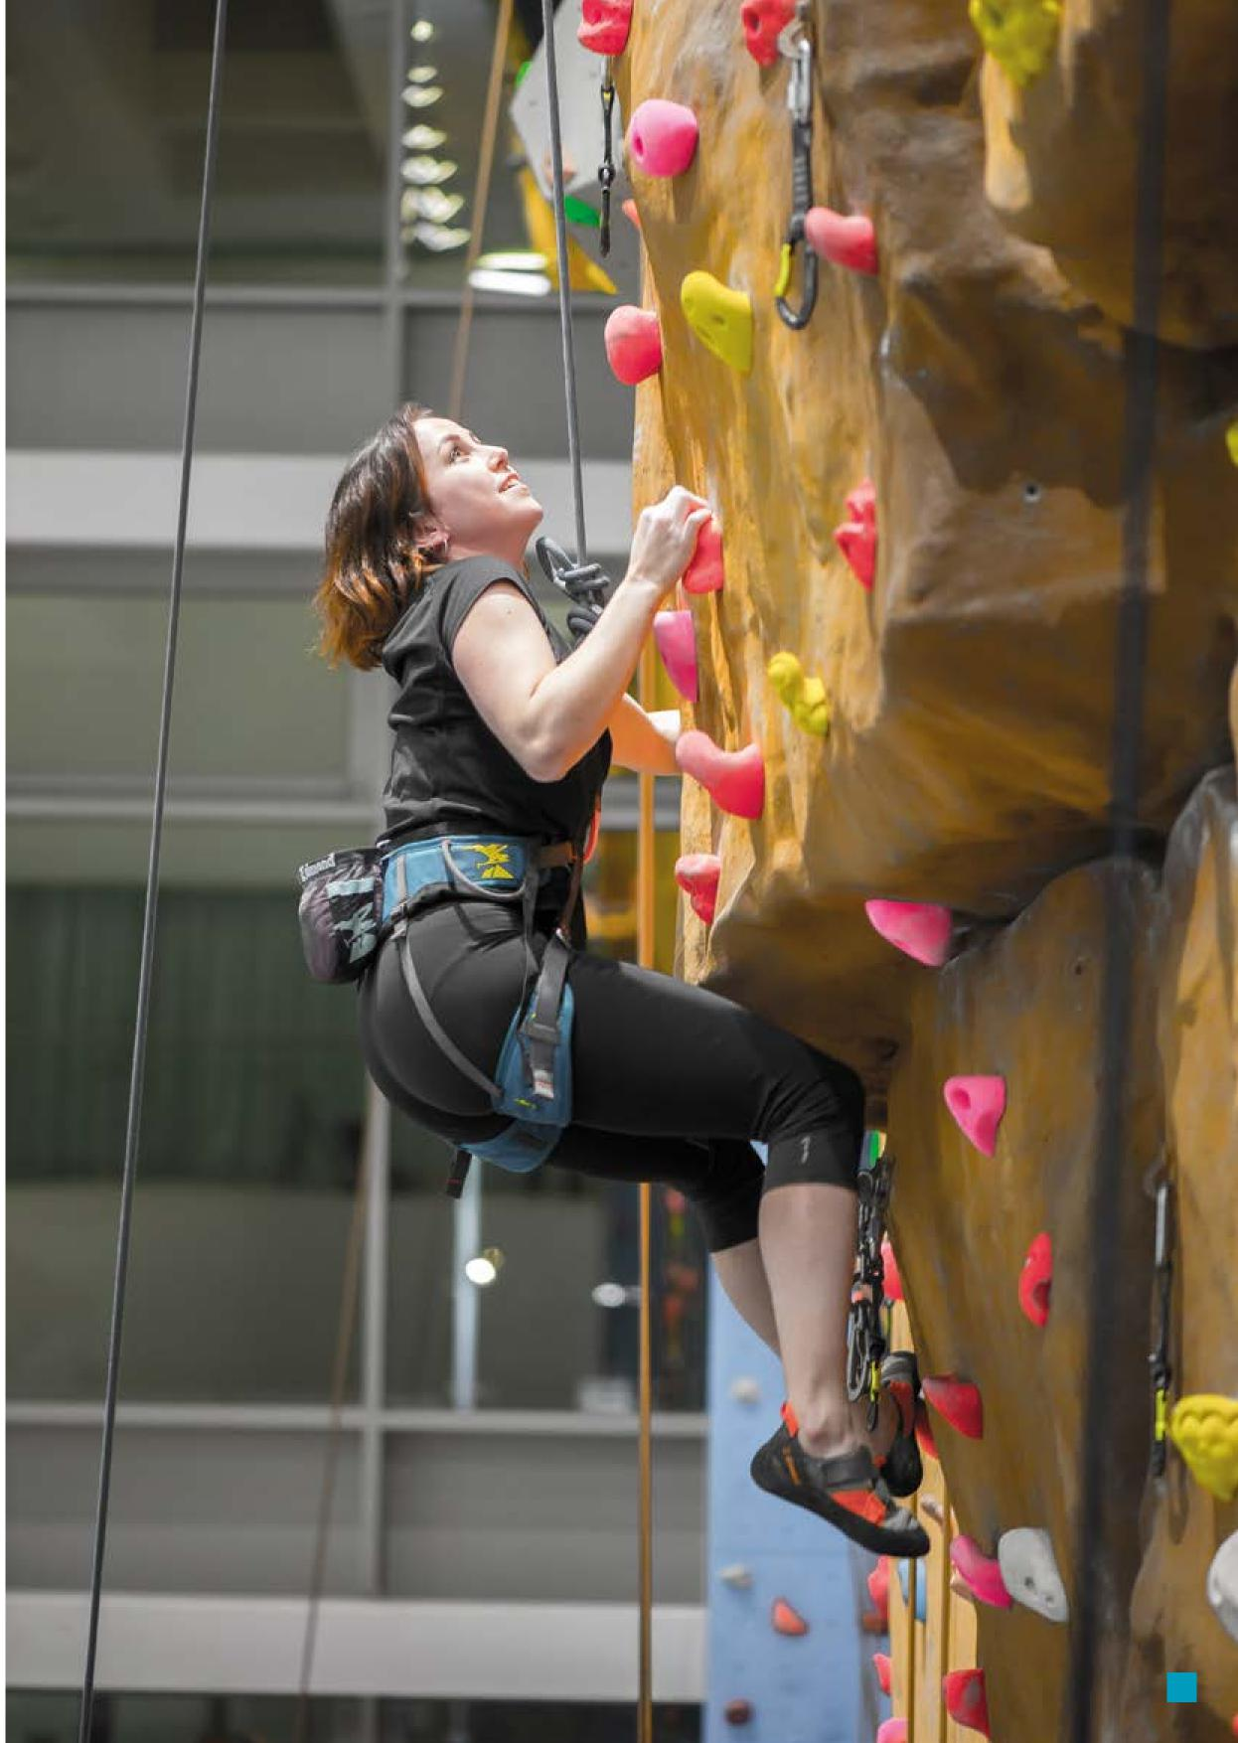

17

<https://www.su.nottingham.ac.uk/bars-and-shops/spar/>

**Student Service Centre’s**

Student Services offers a wide range of help and

support related both to your course and to the wider University experience. They help you with course-related matters, academic, finance and also signpost you for any disability and counselling services. Find out more: [nottingham.ac.uk/studentservices](http://nottingham.ac.uk/studentservices)

**Social & Study areas**

Social spaces are available in Hall, please follow the social distancing guidelines when using.

**Sustainability- Student Switch Off**

Residents can win prizes while reducing environmental impact with Student Switch Off- an energy saving and recycling competition.

Visit [studentswitchoff.org/unis/nottingham](http://studentswitchoff.org/unis/nottingham) for information on how to get involved in your hall.

**U**

**T**

**V**

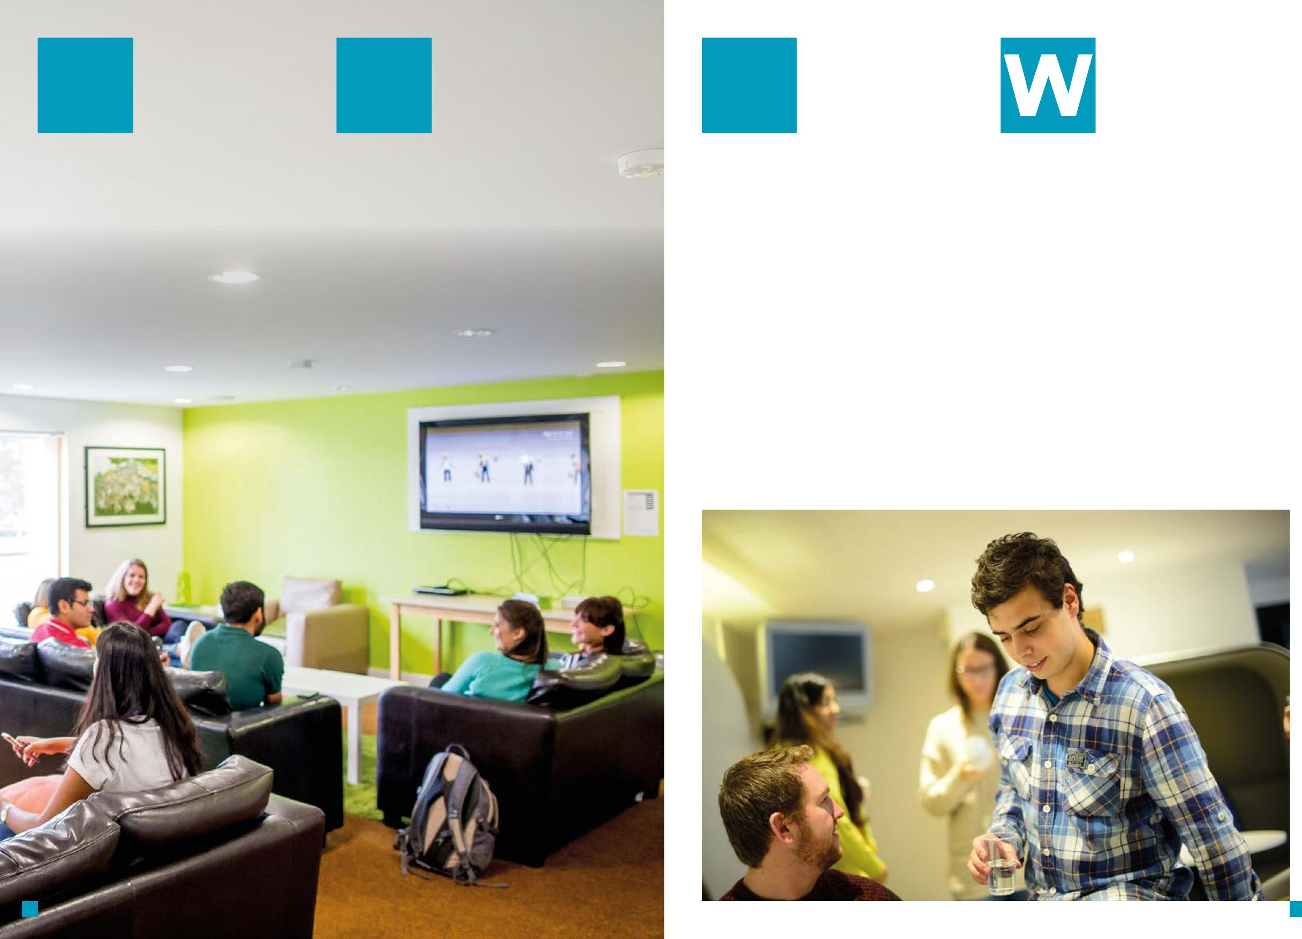

**Television**

There is a TV available in the communal area which is covered by The University’s TV licence. However, you will need your own separate TV licence if you watch your own TV in your room.

**Water**

The water from the taps in the bedrooms and pantries is suitable for drinking.

**University Card**

Look after your University Card – if lost it will cost you £15 to replace. Lost or damaged cards need to be reported to the Security Office at the rear of Hallward Library, University Park Campus.

**Visitors**

Due to the Government guidelines on Covid-19 visitors will not be allowed in halls. This will be reviewed throughout the year.

18

19



**Useful Contacts**

**Accommodation Services**

+44 (0)115 951 3697

[accommodation@nottingham.ac.uk](mailto:accommodation@nottingham.ac.uk)

**Health Centre, University of Nottingham**

+44 (0)115 846 8888

[www.unhs.co.uk/the-university-of-nottingham-health-service.aspx](http://www.unhs.co.uk/the-university-of-nottingham-health-service.aspx)

**International Office**

+44 (0)115 951 5247

[nottingham.ac.uk/InternationalOffice](http://nottingham.ac.uk/InternationalOffice)

**Student Services**

+44 (0)115 748 6500

[nottingham.ac.uk/StudentServices/index.aspx](http://nottingham.ac.uk/StudentServices/index.aspx)

**Students’ Union**

+44 (0)115 84 68800

[su.nottingham.ac.uk](http://su.nottingham.ac.uk)

Correct at time of publishing Aug 2020